

LAB#3 Frequency Response of Discrete-time signals and systems

Tan Nguyen

Hung Nguyen

Minh Le

Dr. Selim Awad

Due date: 06/20/03
SPRING/SUMMER 2003

University of Michigan – Dearborn

HONOR CODE:

We have neither received nor given aid in the presentation of this report.

Signatures:

Objectives:

- To explore the frequency response of discrete-time signals and systems.
- To discover how Fourier transform of finite and infinite duration sequences behave in the frequency domain
- To explore the frequency response of discrete-time systems.

Procedure(s)/Result(s):

(1) Consider the finite-length signal given by
y(n) = (u(n)-u(n-L))(-1)^{n}

a) Plot the sequence
b) Find the Fourier transform of the sequence, Y(e^{jω}) . Hint: Show that
Y(e^{jω}) =$\frac{\text{sin}(ω−π)L/2}{\text{sin}(ω−π)/2}e^{\frac{−j(ϖ−π)(L−1)}{2}},ω≠π$
Y(e^{jω})=L,ω=π

c) If L = 5 plot the magnitude and phase responses for - π ≤ w ≤ π . Determine the regular spacing (Δω) of the zeros of the magnitude response and the at ω = π component Y(e^{jπ}). What is the kind of this filter?
d) Plot the magnitude and phase responses of g(n) = y(n)*y(n). Note: g(n) is the convolution of y(n) with itself.
Answer:
1.b)
y(n)=x(n)z(n)
x(n)=u(n)-u(n-L)
z(n)=(-1)^{n}
X(e^{jw})=$\sum_{n=0}^{L−1}{(1)e^{−\text{jwn}}}=\sum_{n=0}^{L−1}{(e^{(−\text{jw})n}}⇒\text{use}\sum_{n=0}^{N}{α^{n}}=\left\{\frac{1−α^{n}}{1−α}\right.,α≠1,N,α=1$
X(e^{jw})=$\begin{aligned}\left\{\frac{1−e^{−\text{jwl}}}{1−e^{−\text{jw}}},e^{−\text{jw}}≠1→ϖ≠0 | \right.\end{aligned}$ $\begin{aligned}\left\{\frac{e^{−\frac{\text{jwl}}{2}}\left(e^{\frac{\text{jwl}}{2}}−e^{\frac{−\text{jwl}}{2}}\right)}{e^{\frac{−\text{jw}}{2}}\left(e^{\frac{\text{jw}}{2}}−e^{\frac{−\text{jw}}{2}}\right)} | \right.\end{aligned}$

X(e^{jw})=$\begin{aligned}\left\{\frac{\text{sin}\left(\frac{\text{wL}}{2}\right)}{\text{sin}\left(\frac{w}{2}\right)}e^{\frac{−\text{jw}(L−1)}{2}},ω≠0 | \right.\end{aligned}$

Y(n)=x(n)(-1)^{n}$⇒e^{jπ}=\text{cos}π+j\text{sin}π=−1⇒(−1)^{n}=(e^{jπ})^{n}=e^{jπn}$
Y(n)=x(n) $e^{jπn}$
Y(e^{jw})= X(e^{j(w-π)})=$\begin{aligned}\left\{\frac{1−e^{−j(w−π)L}}{1−e^{−j(w−π)}},ω≠π | \right.\end{aligned}$
Y(e^{jw})= $\begin{aligned}\left\{\frac{e^{\frac{−j(w−π)l}{2}}\left(e^{\frac{j(w−π)l}{2}}−e^{\frac{−j(w−π)L}{2}}\right)}{e^{\frac{−j(w−π)}{2}}\left(e^{\frac{j(w−π)}{2}}−e^{\frac{−j(w−π)}{2}}\right)} | \right.\end{aligned}$
Y(e^{jw})= $\begin{aligned}\left\{\frac{\text{sin}\left(\frac{(w−π)L}{2}\right)}{\text{sin}\left(\frac{(w−π)}{2}\right)}e^{\frac{−j(w−π)(L−1)}{2}},ω≠π | \right.\end{aligned}$

1c) The regular spacing (Δω) of the zeros of the magnitude response is: 0.70 rad/sec
At ω=π, Δω=0. This is an High Pass Filter (HPF).
Matlab Code:

%lab3
%#1a,c,d
n=[0:10]';
x=zeros(size(n));
index=find(n>=0 & n<5);
x(index)=1;

y=x.*(-1).^n;
w=[0:pi/1024:pi]';
Xspect=freqz(x,1,w);
Yspect=freqz(y,1,w);

magX=abs(Xspect);
phaseX=angle(Xspect);
magY=abs(Yspect);
phaseY=angle(Yspect);

g=conv(y,y);
Gspect=freqz(g,1,w);
magG=abs(Gspect);
phaseG=angle(Gspect);

figure(1)
subplot(3,2,1);
stem(n,x) ; %x(n) input signal
xlabel('n');
ylabel('Amplitude');
title('Problem #1A: x(n)');
grid on

subplot(3,2,2);
stem(n,y) ; %y(n) output signal
xlabel('n');
ylabel('Amplitude');
title('Problem #1B: Y(n)');
grid on

subplot(3,2,3);
plot(w,magX) ; %Magnitude plot of x(n)
xlabel('\omega');
ylabel('Amplitude');
title('Magnitude spectrum of x(n)');
grid on
axis([0,pi,0,8]);

subplot(3,2,4);
plot(w,magY) ; %Magnitude plot of y(n)
xlabel('\omega');
ylabel('Amplitude');
title('Magnitude spectrum of y(n)');
grid on
axis([0,pi,0,8]);

subplot(3,2,5);
plot(w,phaseX) ; %Phase plot of x(n)
xlabel('\omega');
ylabel('Radians');
title('Phase spectrum of x(n)');
grid on
axis([0,pi,-3,2]);

subplot(3,2,6);
plot(w,phaseY) ; %Phase plot of y(n)
xlabel('\omega');
ylabel('Radians');
title('Phase spectrum of y(n)');
grid on
axis([0,pi,-4,4]);

figure(2)
subplot(2,1,1)
plot(w,magG); %Magnitude plot of G(n)
xlabel('\omega');
ylabel('Amplitude');
title('Magnitude strectrum of g(n)');
grid on
axis([0,pi,-1,26]);
subplot(2,1,2)
plot(w,phaseG); %phase plot of g(n)
xlabel('\omega');
ylabel('Radians');
title('Phase Spectrum of g(n)');
grid on
axis([0,pi,-5,5])

Matlab Results:

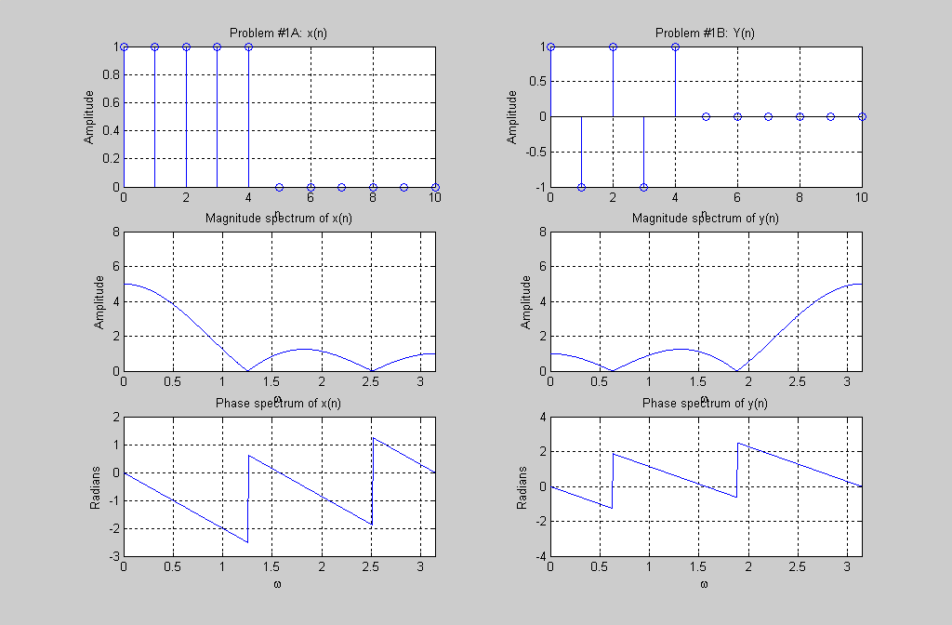
Figure 1 Problem #1a,b, and c
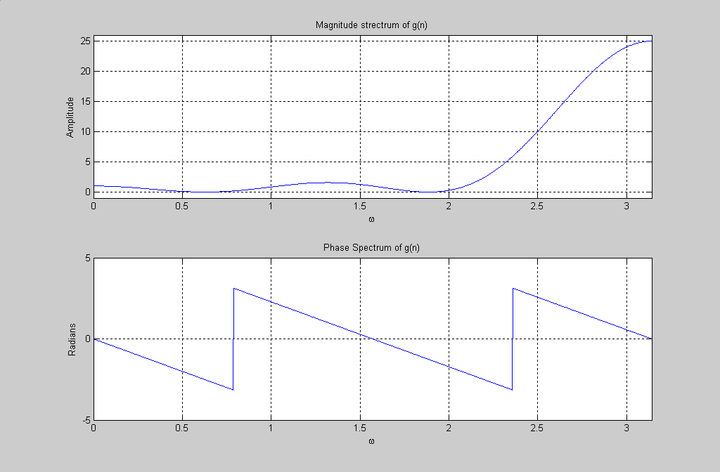
Figure 2 Problem #1d

(2) Suppose that a LTI has an impulse response given by
h(n) = δ(n) + δ(n-1) + δ(n-2) + δ(n-3 )+ δ(n-4) + δ(n-5) + δ(n-6) + δ(n-7) .
(a) Sketch h(n). Is this filter an IIR or an FIR filter? Find the difference equation of the filter.
(b) Determine whether the filter is stable and/or causal.
(c) Find the output of the filter, y(n) for an input given by
x(n) = u(n) – u(n - 3). Determine the energy of the output y(n).
(d) Derive an expression for the frequency response (magnitude and phase responses). Show that the group delay of this filter is constant. verify using Matlab.
(e) Determine the frequency response at ω = 0, ω = π/3, ω = π/2, and ω = π. What type of filter this might be (lowpass or hightpss)?

Answer:

2a) This is an FIR filter. The difference equation of the filter is
y(n)=x(n)+x(n-1)+x(n-2)+x(n-3)+x(n-4)+x(n-5)+x(n-6)+x(n-7)
2b) This filter is stable, since FIR filter are unconditionally stable and causal because y(n)=0 for all n<0.
2c) Simulated through Matlab; Energy = 64 joules
2d) H(e^{jw})=$1+e^{−jω}+e^{−j2ω}+e^{−j3ω}+e^{−j4ω}+e^{−j5ω}+e^{−j6ω}+e^{−j7ω}$
$\begin{aligned}\left|H(e^{jω})\right|=\sqrt{{\left(1+\text{cos}(ω)+\text{cos}(2ω)+\text{cos}(3ω)+\text{cos}(4ω)+\text{cos}(5ω)+\text{cos}(6ω)+\text{cos}(7ω)\right)}^{2}}+ \\ \sqrt{{\left(\text{sin}(ω)+\text{sin}(2ω)+\text{sin}(3ω)+\text{sin}(4ω)+\text{sin}(5ω)+\text{sin}(6ω)+\text{sin}(7ω)\right)}^{2}}\end{aligned}$∠H(e^{jw})=tan⁻¹$\left[\frac{−j\left(\text{sin}(ω)+\text{sin}(2ω)+\text{sin}(3ω)+\text{sin}(4ω)+\text{sin}(5ω)+\text{sin}(6ω)+\text{sin}(7ω)\right)}{\left(1+\text{cos}(ω)+\text{cos}(2ω)+\text{cos}(3ω)+\text{cos}(4ω)+\text{cos}(5ω)+\text{cos}(6ω)+\text{cos}(7ω)\right)}\right]$

∠H(e^{jw})= 0 at ω=0 & π through matlab as well as calculated.

2e) This is a Low Pass Filter (LPF). The frequency response taken at the listed intervals was found using Matlab, results are below. The listed values of ω were also verified by the calculator.

W_zero = 8 ⇒The frequency response at ω=0
W_pi_3= 0 ⇒The frequency response at ω=π/3
W_pi_2= 3.9430e-016≈0 ⇒The frequency response at ω=π/2
W_pi= 4.8986e-016≈0 ⇒The frequency response at ω=π

Matlab Code:
%lab3
%#2
clc
clear
b=[1, 1, 1, 1, 1, 1, 1, 1];
a=1;
w=[0:pi/1024:pi]';
grd=grpdelay(b,a,w);

n=[0:10]';
h=zeros(size(n));
ind=find(n>=0 & n<=7);
h(ind)=1; %h(n)

x=zeros(size(n));
ind=find(n>=0 & n<3);
x(ind)=1; %x(n)

y=conv(h,x);%y(n)

energy=0;
for i=1:length(n)
energy=energy+(y(i))^2;
end
energy %energy of y(n)

Num=[1,1,1,1,1,1,1,1];
Hft=freqz(Num,1,w);
magH=abs(Hft);
phaseH=angle(Hft);
phaseH

ind_zero=find(w==0); %w=0
w_zero=magH(ind_zero)
ind_pi_3=find(w==pi/3); %w=pi/3
w_pi_3=magH(ind_pi_3)
ind_pi_2=find(w==pi/2); %w=pi/2
w_pi_2=magH(ind_pi_2)
ind_pi=find(w==pi); %w=pi
w_pi=magH(ind_pi)

subplot(3,2,1);
stem(n,h);
xlabel('n');
ylabel('Amplitude');
title('Lab3, #2a - h(n)');
grid on
axis([0,10,0,1.5]);

subplot(3,2,2);
stem(n,x);
xlabel('n');
ylabel('Amplitude');
title('x(n)');
grid on
axis([0,10,0,1.5]);

subplot(3,2,3);
stem(y);
xlabel('n');
ylabel('Amplitude');
title('y(n)');
grid on
axis([0,20,0,8]);

subplot(3,2,4);
plot(w,grd);
xlabel('\omega');
ylabel('Samples');
title('Group Delay of the Filter');
grid on
axis([0,pi,2.5,4.5]);

subplot(3,2,5);
plot(w,magH);
xlabel('\omega');
ylabel('Amplitude');
title('Magnitude Response of Filter');
grid on
axis([0,pi,0,8]);

subplot(3,2,6);
plot(w,phaseH);
xlabel('\omega');
ylabel('Radians');
title('Phase Response of Filter');
grid on
axis([0,pi,-3,3]);

Matlab Results:
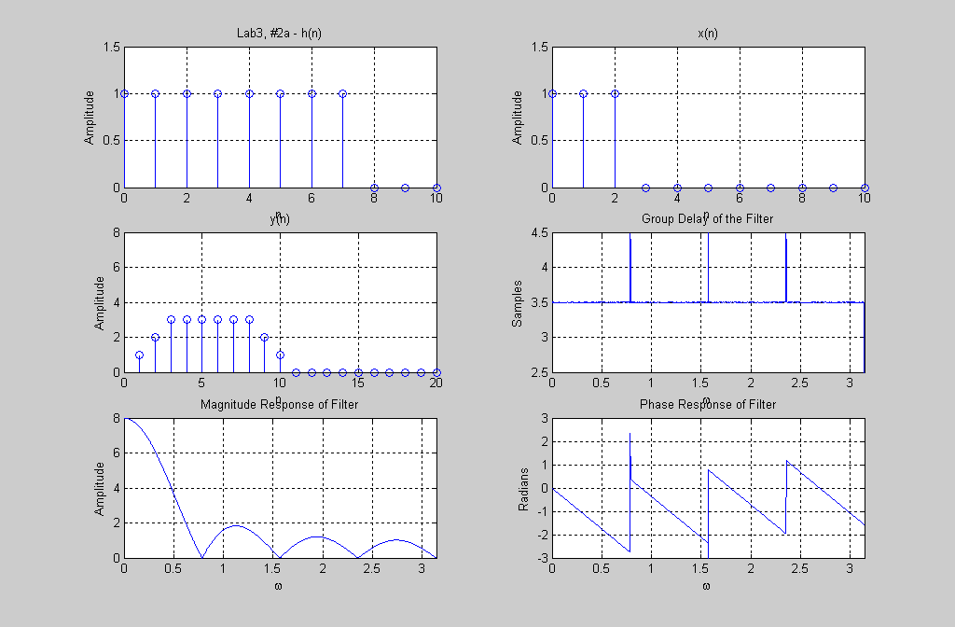

- Consider the signal x(n)=(-0.6)^{n}u(n).
  - Compute the Fourier Transform X(e^{jw}) using the command “freqz”. Make a plot of both the magnitude and phase versus ω over the range 0≤ω≤π.
(b) Determine the magnitude and phase by a direct evaluation of the formula, and then compare the results with the ones obtained from the command “freqz”.

X(e${}^{jω})$=$\frac{1}{1−0\text{.}6e^{−jω}}$

Matlab Code:
%lab3

%#3
clc
clear
b=[1];
a=[1,-.6];
w=[0:pi/1024:pi];
H=freqz(b,a,w);
magH=abs(H);
phaseH=angle(H);

X=1./(1+(-.6)*exp(-j*w));
magX=abs(X);
phaseX=angle(X);

subplot(2,2,1);
plot(w,magH);
xlabel('\omega');
ylabel('Amplitude');
title('Lab3, #3a-Magnitude Spectrum of x(n), using FREQZ command');
grid on
axis([0,pi,0,3]);

subplot(2,2,2);
plot(w,phaseH);
xlabel('\omega');
ylabel('Radians');
title('Lab3, #3a-Phase Spectrum of x(n), using FREQZ command');
grid on
axis([0,pi,-1,0]);

subplot(2,2,3);
plot(w,magX);
xlabel('\omega');
ylabel('Amplitude');
title('Lab3, #3b-Magnitude Spectrum of x(n)');
grid on
axis([0,pi,0,3]);

subplot(2,2,4);
plot(w,phaseX);
xlabel('\omega');
ylabel('Radians');
title('Lab3, #3b-Phase Spectrum of x(n)');
grid on
axis([0,pi,-1,0]);

Matlab Results:
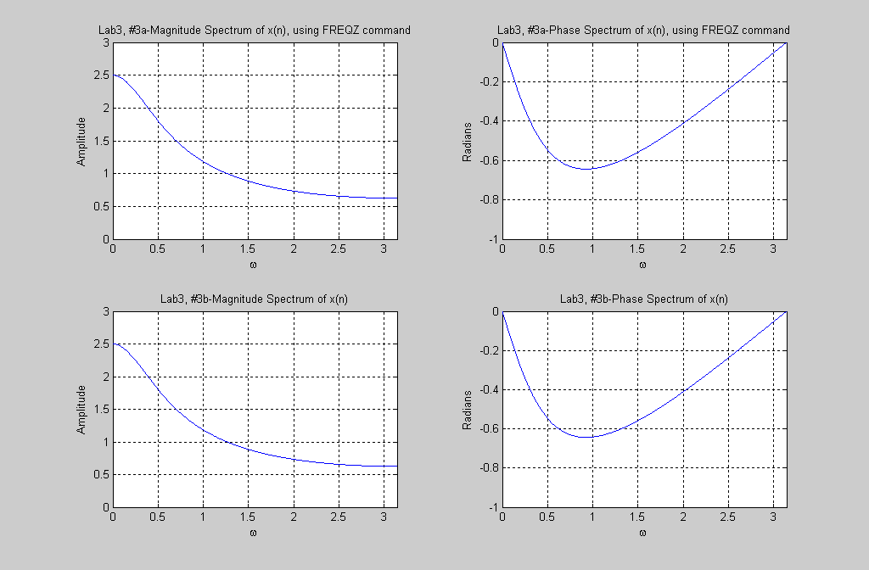

(4) Plot the magnitude and phase of H(e^{jω}) where w _{o} = 0.25π . Determine the type of filter (LP, HP, BP, or notch) it represents.
H(e^{jω}) =N(e^{jω})/D(e^{jω})
Where
N(e^{jω}) = (1-e^{-j(w - w} _{o}⁾) (1-e^{-j(w +w} _{o}⁾)
and
D(e^{jω}) = (1-0.8e^{-j(w - w} _{o}⁾) (1-0.8e^{-j(w - w} _{o}⁾). When does the magnitude response go to zero? Comment.

Matlab Code:
%lab3
%4
clear
w=[0:pi/1024:pi];
wo=.25*pi;
N=conv([1, -exp(j*wo)],[1,-exp(-j*wo)]);
D=conv([1,-.8*exp(j*wo)],[1,-.8*exp(-j*wo)]);
H=freqz(N,D,w);
magH=abs(H);
phaseH=angle(H);

mag_zero=H(w==wo);
mag_zero

subplot(2,1,1)
plot(w,magH);
xlabel('\omega');
ylabel('Amplitude');
title('Lab3,#4-Magnitude spectrum');
grid on
axis([0,pi,0,1.4]);

subplot(2,1,2)
plot(w,phaseH);
xlabel('\omega');
ylabel('Radians');
title('Lab3,#4-Phase spectrum');
grid on
axis([0,pi,-2,2]);

mag_zero =0

The filter is a notch filter.
The magnitude response goes to zero when ω=ω_{o.} When ω=ω_{o,} the numerator is zero.

Matlab Results:
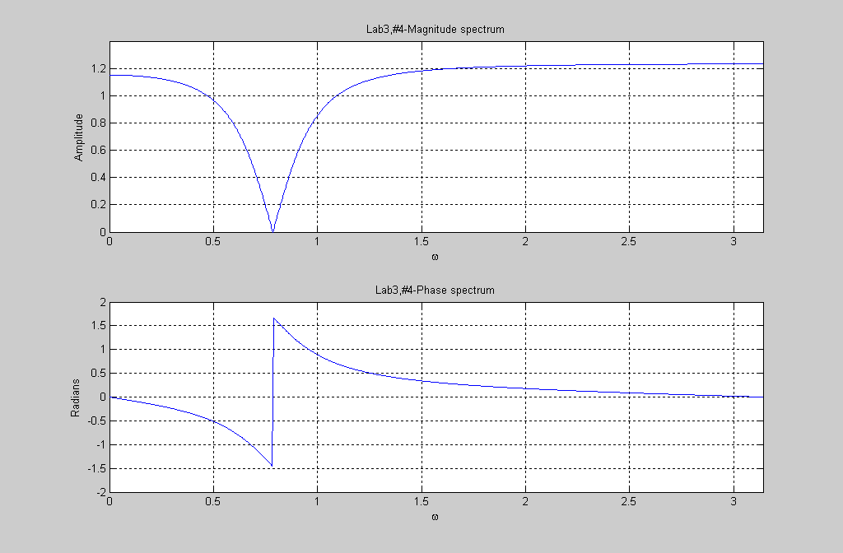

(5) Consider the system shown in Figure 1 with
H1(e^{jω}) = (0.287 - 0.447e^{-j ω})/(1 - 1.297e^{-j ω} + 0.695e^{-j2 ω}),
H2((e^{jω}) = (-2.142 + 1.145e^{-jω})/(1 - 1.069e^{-j ω} + 0.37e^{-j2 ω} ),
and H3((e^{jω}) = (1.856 - 0.63e^{-j ω})/(1 - 0.997e^{-j ω} + 0.257e^{-j2 ω}).
Find and plot the frequency response of the composite system. Also, plot the group delay. Is it linear or non-linear? Why?
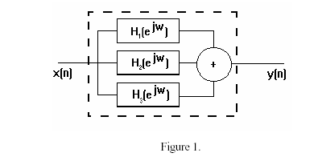
H1(e^{jω})=$\frac{N1(e^{jω})}{D1(e^{jω})}$, H2(e ^{jω})=$\frac{N2(e^{jω})}{D2(e^{jω})}$,H3(e ^{jω})=$\frac{N3(e^{jω})}{D3(e^{jω})}$

H1(e^{jω})+ H2(e ^{jω})+ H3(e ^{jω})=$\frac{N1}{D1}+\frac{N2}{D2}+\frac{N3}{D3}=\frac{N1D2D3+N2D1D3+N3D1D2}{D1D2D3}$
Matlab Code:

clear
w=[0:pi/1024:2*pi];
N1=[.287,.447];
D1=[1,-1.297,.695];
N2=[-2.142, 1.145];
D2=[1,-1.069,.37];
N3=[1.856,-0.63];
D3=[1,0.997,0.257];
a=conv(conv(D2,D3),N1);
b=conv(conv(D1,D3),N2);
c=conv(conv(D1,D2),N3);
Num=a+b+c;
Den=conv(conv(D1,D2),D3);
T=freqz(Num,Den,w);
magT=abs(T);
phaseT=angle(T);

grd=grpdelay(Num,Den,w);

subplot(3,1,1)
plot(w,magT);
xlabel('\omega');
ylabel('Amplitude');
title('Lab3-#5-Magnitude Spectrum');
grid on
axis([0,2*pi,0,10]);

subplot(3,1,2)
plot(w,phaseT);
xlabel('\omega');
ylabel('Radians');
title('Lab3-#5-Phase Spectrum');
grid on
axis([0,2*pi,-4,4]);

subplot(3,1,3)
plot(w,grd);
xlabel('\omega');
ylabel('Samples');
title('Lab3-#5-Group Delay of Filter');
grid on
axis([0,2*pi,-10,10]);

Matlab Results:

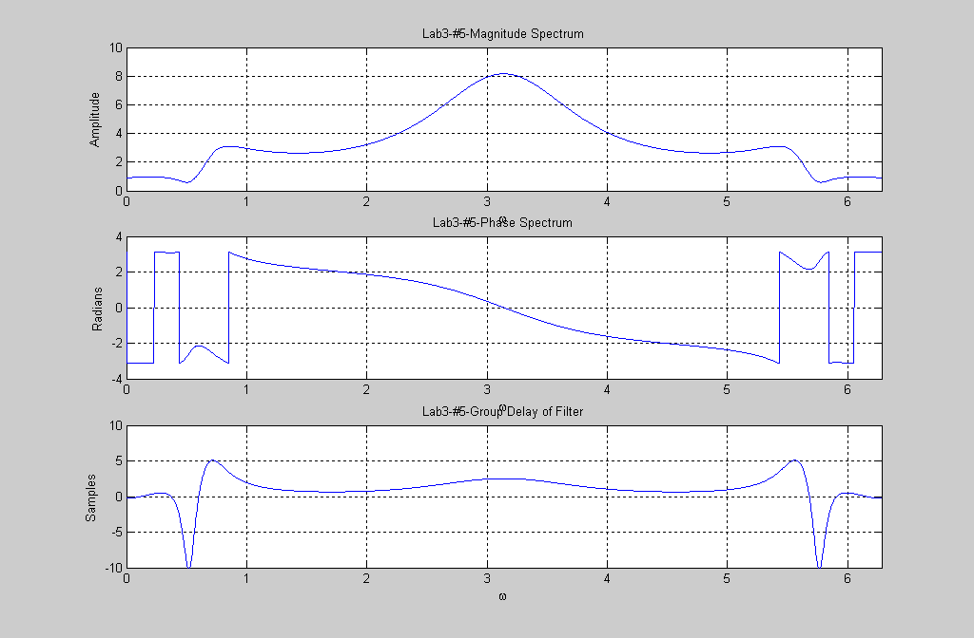

The group delay of the filter is non-linear since the phase response has an order greater than 2. This is because we find the LCM of the denominator by multiplying the three transfer functions together. We have third order filter.

(6) Plot the frequency response of the filter given by its frequency response
H(e^{jw} ) = 0.02426(1- e^{-jw} )⁴(0.8 + e^{-jw} )/
(1 + 1.0416e^{-jw} + 0.4019 e^{-j2w} ) (1+ 0.5661e^{-jw} + 0.7657 e^{-j2w} )(1+ 0.8e^{-jw} )
a) Plot the magnitude and phase response of the filter. What type of filter is it?
b) Plot the group delay in the passband only. Is the phase linear or non-linear? Explain.
c) Find the frequency, which corresponds to a magnitude response of - 22 dB.

Matlab Code:

clear
w=[0:pi/1024:pi];
N1=conv([1,-1],[1,-1]); %^2
N2=0.02426*conv(N1,N1); %^2*^2=^4
Num=conv(N2,[0.8,1]); %entire numerator
D1=[1,1.041,0.4019];
D2=[1,.5661,0.7657];
D3=conv(D1,D2);
Den=conv(D3,[1,0.8]); %entire denominator
T=freqz(Num,Den,w);
magT=abs(T);
phaseT=angle(T);

grd=grpdelay(Num,Den,w);

subplot(2,2,1);
plot(w,magT);
xlabel('\omega');
ylabel('Amplitude');
title('lab3-#6-Magnitude Spectrum');
grid on
axis([0,pi,0,1.3]);

subplot(2,2,2);
plot(w,20*log(magT));
xlabel('\omega');
ylabel('Amplitude in dB');
title('lab3-#6-Magnitude Spectrum in dB scale');
grid on
axis([0,pi,-600,20]);

subplot(2,2,3);
plot(w,phaseT);
xlabel('\omega');
ylabel('Radians');
title('lab3-#6-Phase Spectrum');
grid on
axis([0,pi,-4,4]);

subplot(2,2,4);
plot(w,grd);
xlabel('\omega');
ylabel('Samples');
title('lab3-#6-Group Delay of Filter');
grid on
axis([0,pi,0,10]);

Matlab Results:
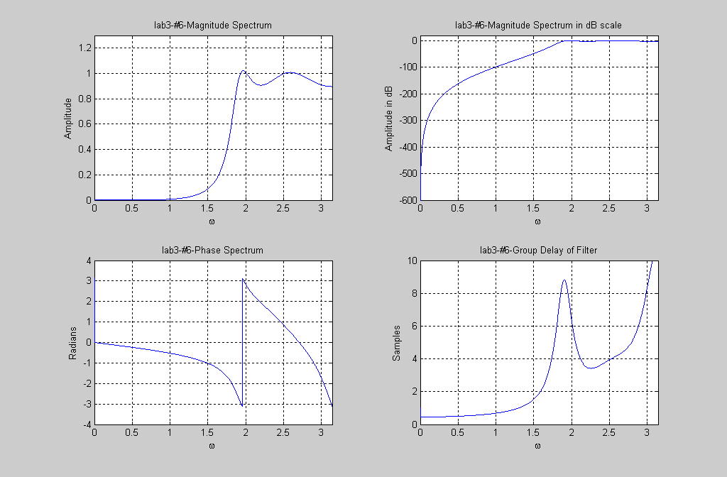
The filter is a High Pass Filter.
At ω=1.722 from the graph, the magnitude response is –22dB.
The phase is non-linear.

(7) A band limited input signal, composed of ten sinusoidal is given by
x(n)= $\sum_{0}^{\text{11}}{\text{cos}(k^{ω_{o}}(n−\text{128})),}$for n=0,1,2,…,255 , where w_{o}= π/ 128.
(i) Plot the magnitude of X(e^{jω}) and note the frequencies occupied by the input signal.
(ii) If x(n) is filtered by the filter:
H(e^{jw} ) = $\frac{9\text{.}\text{88}−\text{15}\text{.}6e^{−\text{jw}}+6\text{.}2e^{−j2w}}{1−0\text{.}\text{521}e^{−\text{jw}}+0\text{.}\text{121}e^{−j2w}}$
Plot the output y(n). Measure the advance of the envelope (in samples) and compare it to the average value of the group delay (of the filter) in the frequency band occupied by the input signal. Plot the magnitude spectrum of the output.
Matlab Code:

%lab3
%#7
clear
n=[0:255];
w=[0:pi/1024:pi];
wo=pi/128;
x=0;
for k=0:11
x=x+cos(k*wo*(n-128));
end
Num=[9.88, -15.6, 6.2];
Den=[1, -.521,.121];
H=freqz(Num,Den,n);

y=filter(Num,Den,x);
FTy=fft(y,n);
GD=grpdelay(Num,Den,w);

subplot(3,1,1)
plot(n,y,n,x);
xlabel('n');
ylabel('Amplitude');
title('Lab3-#7-y(n)');
grid on
axis([0,255,-10,20]);

subplot(3,1,2)
plot(n,abs(FTy),'r');
xlabel('n');
ylabel('Amplitude');
title('Magnitude Spectrum of y, Y(e^(jw))');
grid on
axis([0,255,0,15]);

subplot(3,1,3)
plot(w,GD);
xlabel('n');
ylabel('Samples');
title('Group Delay of Filter');
grid on
axis([0,pi,-7,1]);
zoom on;

Matlab Results:
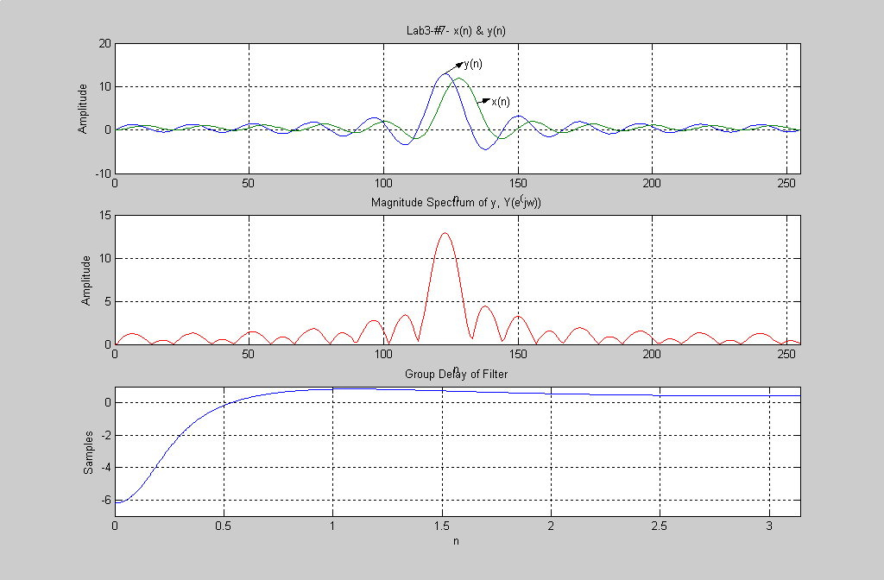

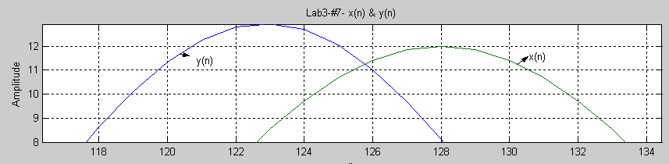
By zooming on the first plot as shown above, the advance of the envelope (difference between input and output) is estimated to be 4.65 samples.

