

LAB4# Introduction to simulation of signals and systems

Tan Nguyen

Hung Nguyen

Minh Le

Dr. Selim Awad

Due date: 07/23/03
SPRING/SUMMER 2003

University of Michigan – Dearborn

HONOR CODE:

We have neither received nor given aid in the presentation of this report.

Signatures:

Exercise #1

Use Simulink to simulate the system shown in Fig. 1 The system is composed of a sampled sine wave of unity amplitude, frequency f1 Hz, and initial phase shift of π/4 radians. The signal will be displayed on the scope. Assume that the sampling frequency (fsamp) is 10 kHz.

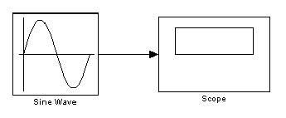
Figure 1

a) If f1 = 2 kHz, simulated the system with a time equivalent to 5 periods of the sine wave. Display the waveform on the scope and also export the data of the output to the Matlab workspace to plot the amplitude (discrete-time versus time in msec). Also, plot the amplitude versus the time index, n.
b) Change the f1 to 12 kHz and investigate the output signal. Compare to part a) and comment.
c) What is the apparent frequency of the output if f1 = 8 kHz?. Compare to part a) and comment.
d) For the above cases, give the digital frequencies and indicate if they have aliases in the range 0 < f < 5 kHz.

>> Fsamp=10000;
>> T=1/Fsamp;

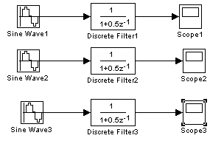
The frequency for Sine Wave 1 is 2 kHz, while Sine Wave 2 has 12 kHz, and Sine Wave 3 has 8 kHz frequency.

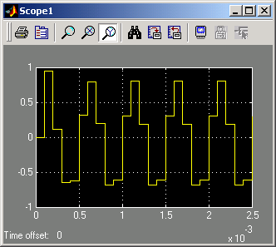
Discrete Filter 1 output

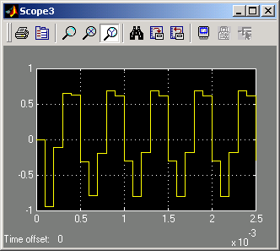
Discrete Filter 3 output

#2d)
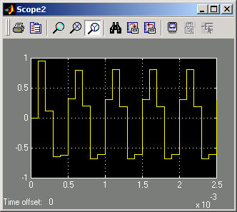
Discrete Filter 2 output

Discrete Filter 1: Digital Frequency = 0.4π
No aliasing
Discrete Filter 2: Digital Frequency = 2.4π = 0.4π
Aliasing exists; this gives the same as waveform as Discrete Filter 1
Discrete Filter 3: Digital Frequency = 1.6π = 0.4 π
Aliasing in phase reversal exists.

%#1a
figure(1)
Time=output1(:,1);
n=Time*Fsamp;
a=output1(:,2);
subplot(2,1,1);
stem(Time*2e3,a);
xlabel('Time in msec');
ylabel('Amplitude');
title('Lab4, #1a');
grid on

subplot(2,1,2);
stem(n,a);
xlabel('Time Index,n');
ylabel('Amplitude');
grid on
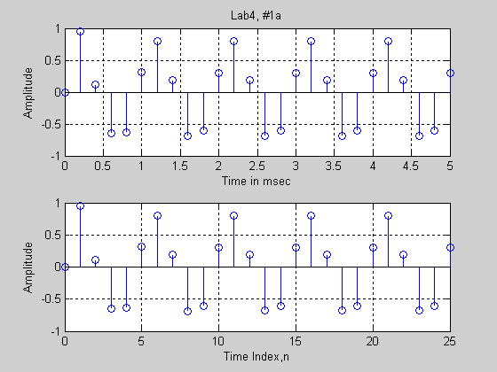

figure(2)
Time=output2(:,1);
n=Time*Fsamp;
b=output2(:,2);
subplot(2,1,1);
stem(Time*12e3,b);
xlabel('Time in msec');
ylabel('Amplitude');
title('Lab4, #1b');
grid on

subplot(2,1,2);
stem(n,b);
xlabel('Time Index,n');
ylabel('Amplitude');
grid on

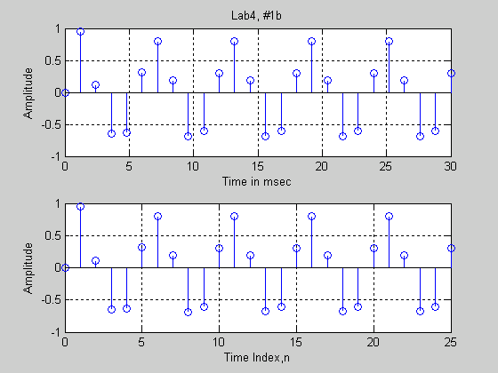

%#1c
figure(3)
Time=output3(:,1);
n=Time*Fsamp;
c=output3(:,2);
subplot(2,1,1);
stem(Time*8e3,c);
xlabel('Time in msec');
ylabel('Amplitude');
title('Lab4, #1c');
grid on

subplot(2,1,2);
stem(n,c);
xlabel('Time Index,n');
ylabel('Amplitude');
grid on

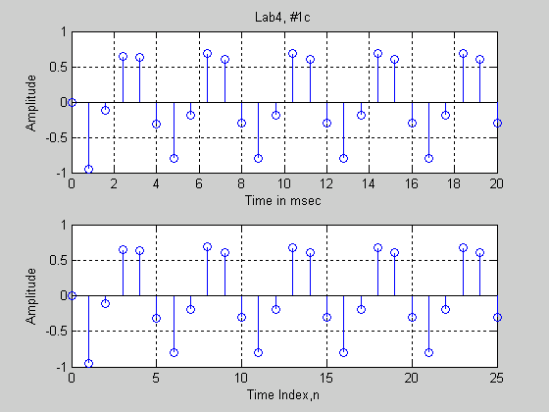

Exercise #2
Consider the digital filter given by the y(n) = 1.8 cos(pi/16) y(n-l) - 0.81 y(n-2) + 2 x(n) + x(n-1)
a) Using Simulink, assuming fsamp =10 kHz, and a simulation time of 2 msec, find the step response.
b) Determine the steady-state value, Go. Hence, plot the transient response, ytran. Hint: use the model shown in Fig. 2
c) If an input is a pulse equivalent to x(n) = u(n) –u(n-12), find the pulse duration in msec, and hence determine the pulse response. Hint: use the model shown in Fig. 3
d) For an input which is a sine wave of unity amplitude, frequency 1.6kHz and phase of π/3, as in part b), find the Transient and steady state.

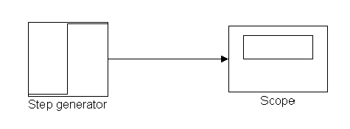
Figure 2

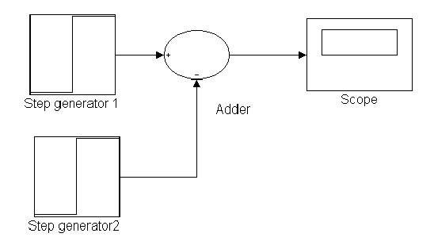
Figure 3

#2a)
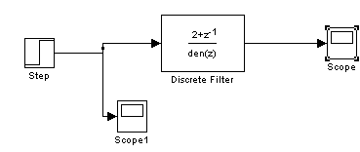

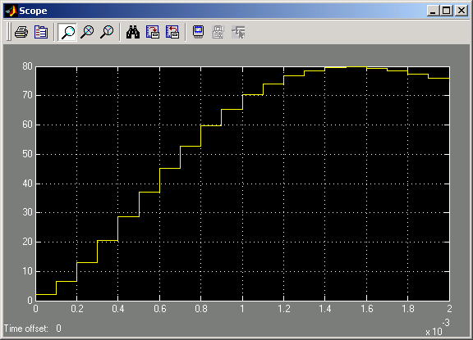

%#2a
Time=data2a(:,1);
n=Time*Fsamp;
step_resp=data2a(:,2);
subplot(2,1,1);
stem(Time*1e4,step_resp);
grid on;
xlabel('Time is msec');
ylabel('Amplitude');
title('Step Response');
subplot(2,1,2);
stem(n,step_resp);
grid on;
xlabel('Time_index,n');
ylabel('Amplitude');

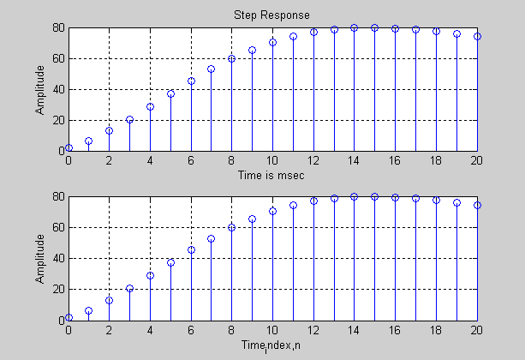

#2b)

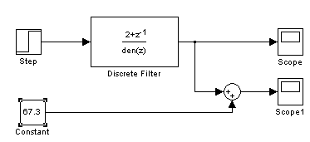

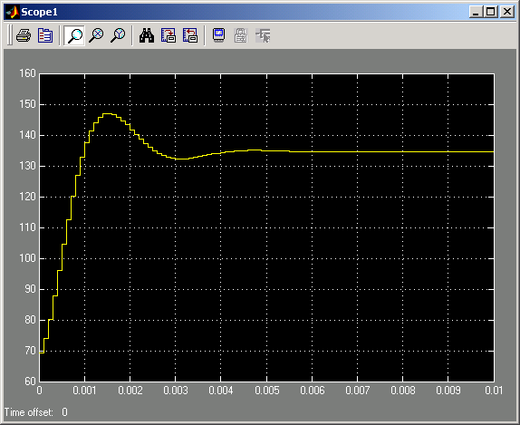

%#2b
Time=data2b(:,1);
n=Time*Fsamp;
trans_resp=data2b(:,2);
subplot(2,1,1);
stem(Time*1e4,trans_resp);
grid on;
xlabel('Time is msec');
ylabel('Amplitude');
title('Transient Response');
subplot(2,1,2);
stem(n,trans_resp);
grid on;
xlabel('Time_index,n');
ylabel('Amplitude');

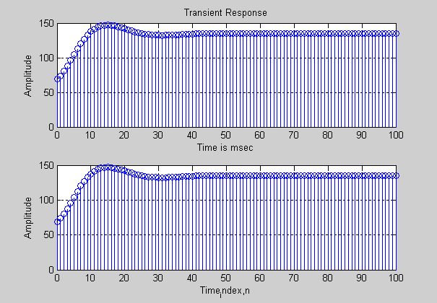

#2c)
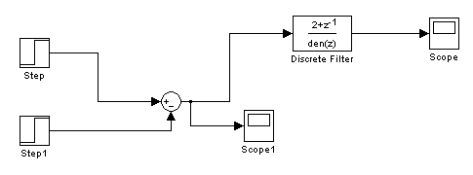

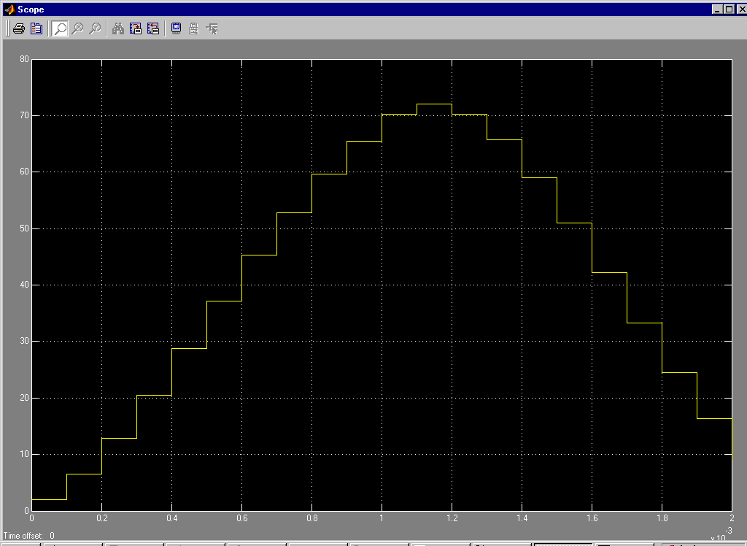

%#2c
Time=data2c(:,1);
n=Time*Fsamp;
pulse_resp=data2c(:,2);
subplot(2,1,1);
stem(Time*1e3,pulse_resp);
grid on;
xlabel('Time is msec');
ylabel('Amplitude');
title('Pulse Response');
subplot(2,1,2);
stem(n,pulse_resp);
grid on;
xlabel('Time index,n');
ylabel('Amplitude');

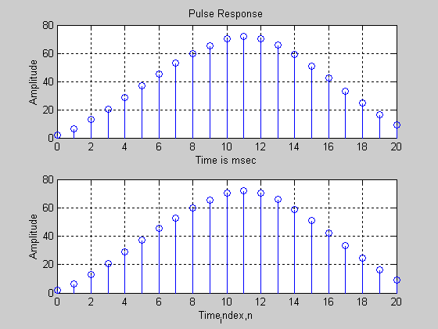

#2d)

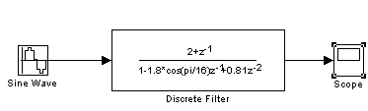

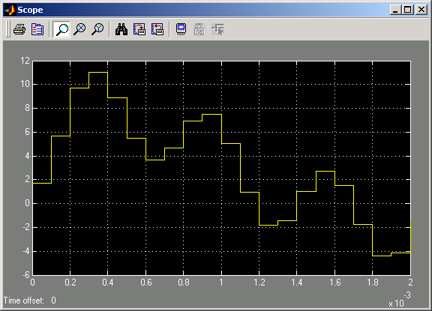

%#2d1
Time=data2d(:,1);
n=Time*Fsamp;
sine_resp=data2d(:,2);
subplot(2,1,1);
stem(Time*1.6e3,sine_resp);
grid on;
xlabel('Time is msec');
ylabel('Amplitude');
title('Pulse Response');
subplot(2,1,2);
stem(n,sine_resp);
grid on;
xlabel('Time index,n');
ylabel('Amplitude');

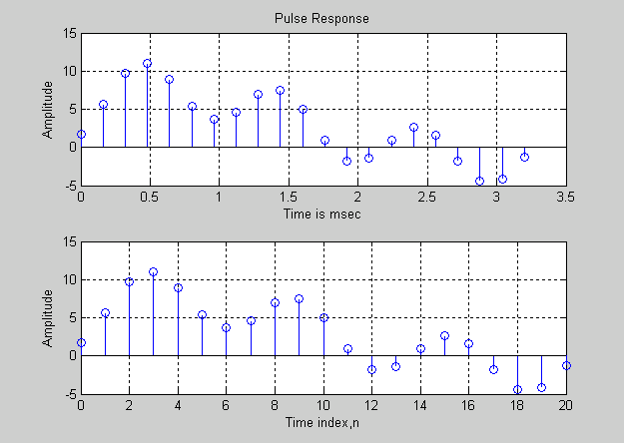

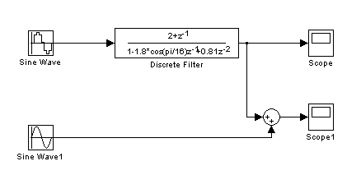

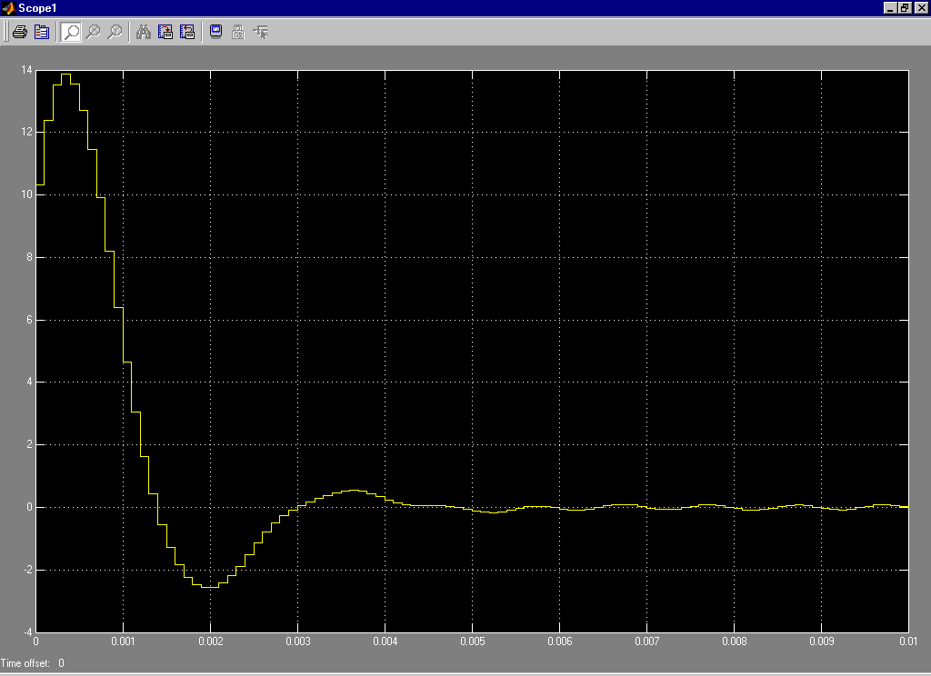

Time=data2d2(:,1);
n=Time*Fsamp;
sine_resp=data2d2(:,2);
subplot(2,1,1);
stem(Time*1e3,sine_resp);
grid on;
xlabel('Time is msec');
ylabel('Amplitude');
title('Transient Response');
subplot(2,1,2);
stem(n,sine_resp);
grid on;
xlabel('Time index,n');
ylabel('Amplitude');

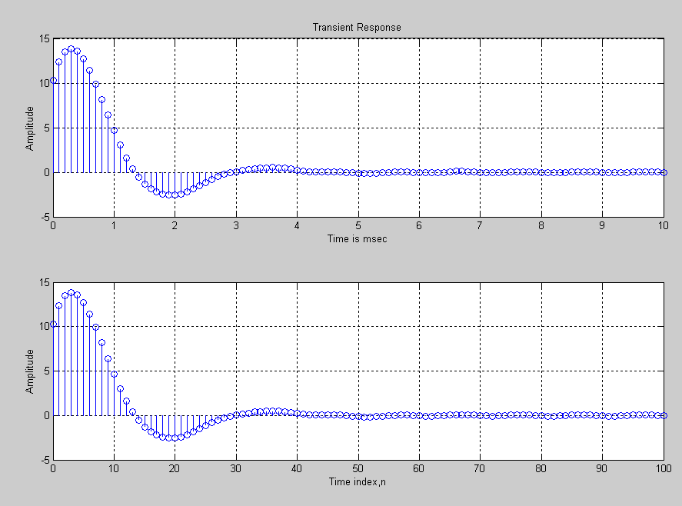

Exercise #3
It is required to design an anti-aliasing lowpass filter to filter out frequencies in the frequency band f > 5 kHz. The requirements are as follows:
The stop-band frequency, fs = 5 kHz and (stop-band attenuation) αs = 40 dB.
The passband attenuation, αp = 0.5 dB
Order of filter, n, cannot exceed 7.

a) Choose the approximation that gives the best results.
b) Determine the passband frequency fp.
c) Find the transfer function and hence plot the magnitude and phase responses of your design.
d) For your design, what will be the order of the filter you designed if Butterworth, Chebyshev or Elliptic filter approximations are used?
e) In order to test the anti-aliasing lowpass filter, construct the model shown in Fig. 4, which represents a part of a data acquisition system. Assume that the digital filter is given by the following difference equation: y(n) = -0.5 y(n-1) + 0.5x(n)+x(n-1). What is the type of this digital filter?
f) Simulate the model using Simulink for input frequencies f = 1 kHz, 2, KHz, 4 kHz, 6 kHz and 8 kHz. Verify that there is no aliasing. Investigate the different waveforms seen on the screen of the scopes and comment.

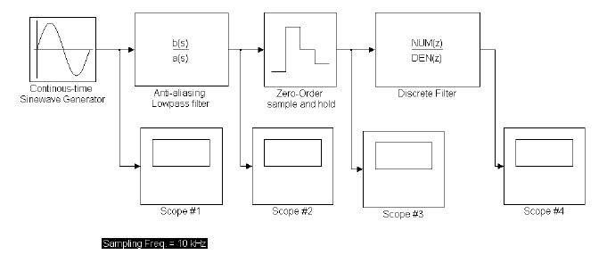
Figure 4

3a) The elliptic approximation is chosen.
3b) Using the m-file in the next page, f_{p} was found to be 4.4 kHz.

%#3c
fp=4.4e3; %Passband edge
fs=5e3; %stopband edge
ap=.5; %att. in passband
as=40; %att. in stopband
%Finding the parameters of the Elliptic filter
[N,Wn]=ellipord(2*pi*fp, 2*pi*fs, ap, as, 's')
%N is the order
%wn is the passband edge in radians/sec
%Finding the transfer coefficients
[Num,Den]=ellip(N,ap,as,Wn,'s')
f=[0:100:10e3]'; %freq. range 0 to 10kHz
H=freqs(Num,Den,2*pi*f); %Finding the freq.response
att=-20*log10(abs(H)); %Find the attenuation

%Butterworth filter
[Nbutter,Wnbutter]=buttord(2*pi*fp,2*pi*fs,ap,as,'s')
%Nbutter is the order
%Wnbutter is the passband edge in radians/sec

%Chebyshev filter
[Ncheby,Wncheby]=cheb1ord(2*pi*fp,2*pi*fs,ap,as,'s')
%Ncheby is the order
%Wncheby is the passband edge in radians/sec

subplot(3,1,1)
plot(f/1e3,abs(H));
xlabel('Freq. in kHz');
ylabel('Amplitude');
title('Magnitude response in linear scale');
grid on;

subplot(3,1,2)
plot(f/1e3,att);
xlabel('Freq. in kHz');
ylabel('Att in db');
title('Attenuation versus freq.');
axis([0,10,0,50]);
grid on;

subplot(3,1,3)
plot(f/1e3,angle(H));
xlabel('Freq. in kHz');
ylabel('Amplitude');
title('Phase response');
grid on;

>> lab4_3
N = 6
Wn = 2.7646e+004
Num =
1.0e+026 *
0.0000 0.0000 0.0000 0.0000 0.0000 0.0000 1.0814
Den =
1.0e+026 *
0.0000 0.0000 0.0000 0.0000 0.0000 0.0001 1.1455
Nbutter = 45
Wnbutter = 2.8360e+004
Ncheby = 13
Wncheby = 2.7646e+004

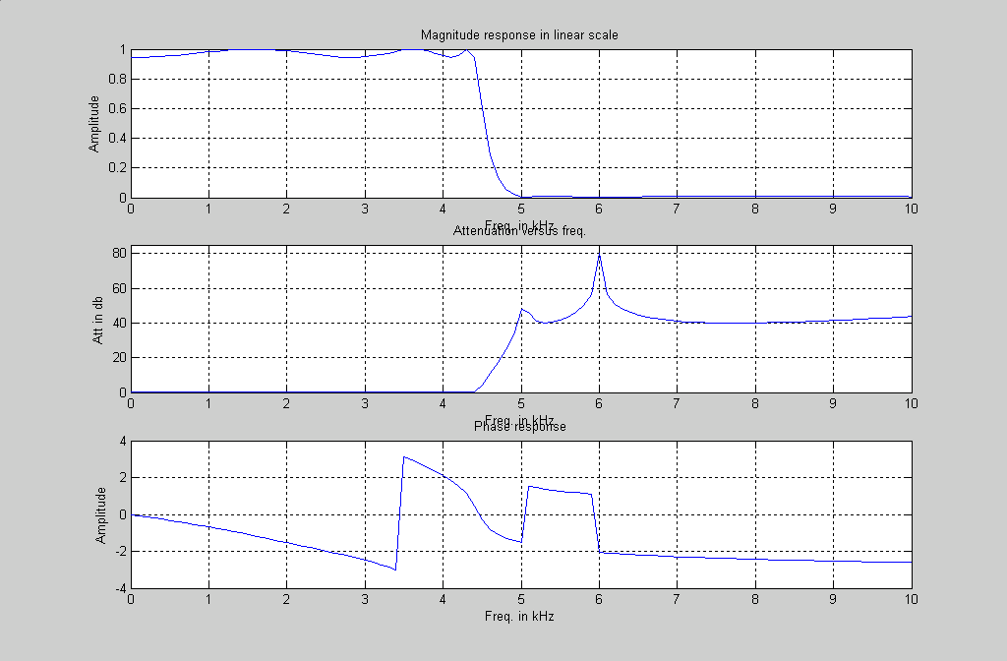

3d) From the matlab result of #3c we see that if a Butterworth filter is chosen, its order will be 45.
If a Chebyshev is chosen, its order will be 13.

3e)

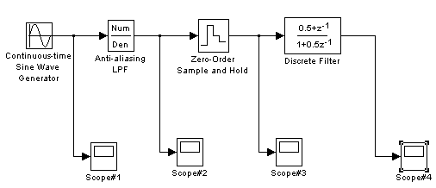

This digital filter is a low pass filter. This is verified by the Scope outputs. As the sine wave input frequency increases, the outputs decrease.
Outputs when the Sine Wave Generator has a frequency of 1 kHz:

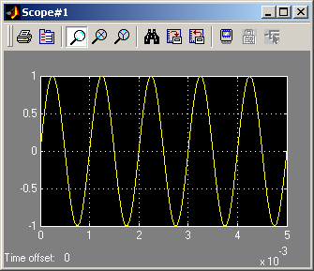

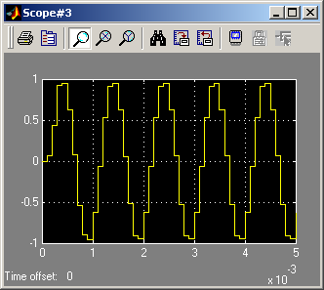

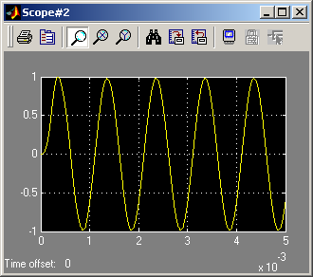

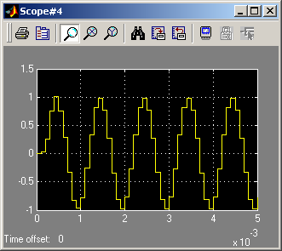

Outputs when the Sine Wave Generator has a frequency of 2 kHz:

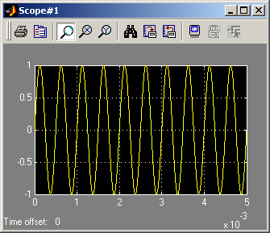
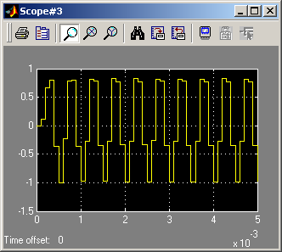

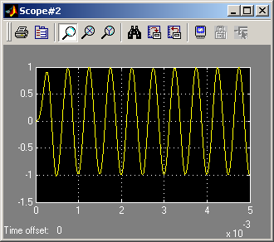
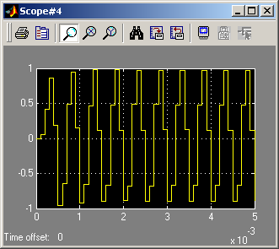

Outputs when the Sine Wave Generator has a frequency of 4 kHz.

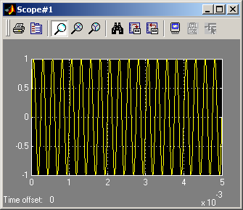
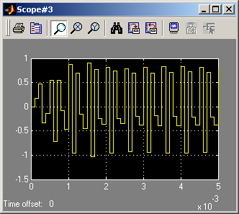

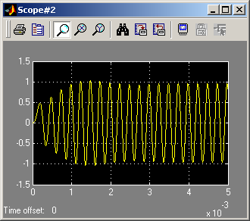
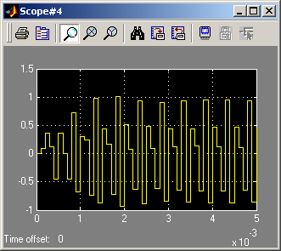

Outputs when the sine wave Generator has a frequency of 6 kHz.
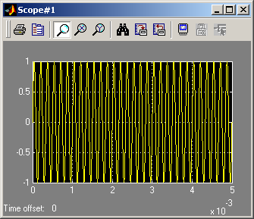
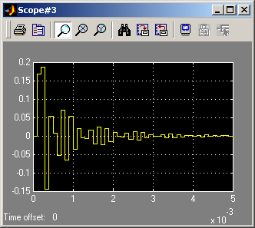

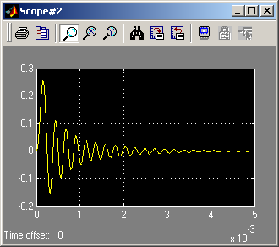

Outputs when the Sine Wave Generator has a frequency of 8 kHz:

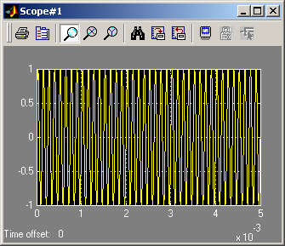

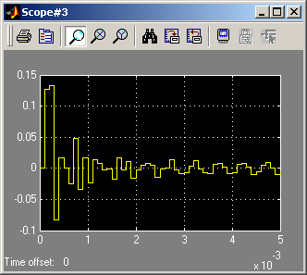

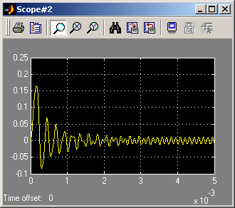

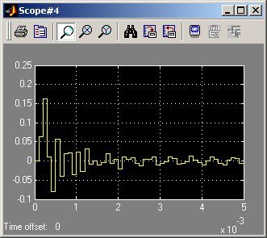

Exercise #4
In this exercise we would like to model an A/D converter with the following parameters:
- Number of bits is nb
- Full scale-level isVref = 5 volts (this means that the maximum range is + Vref)
- Sampling frequency of 10 kHz.
The model is shown in Fig. 5.

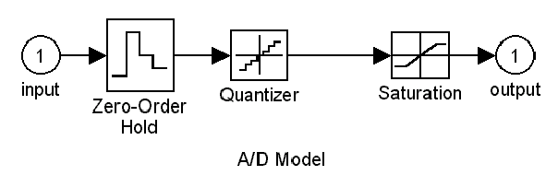
Figure 5

a) For the following values of the parameters model the A/D converter and plot the transfer characteristics.
- nb = 3 bits
- nb = 8 bits.
b) For an analog input sine wave of frequency 10 Hz and amplitude = Vref – . (quatization step), plot the output and the quantization noise signals for both cases of part a).
c) Calculate the quantization average power and hence the S/N ratio of the output signal.
Hint: Use about 5 cycles of the sine wave in order to calculate the average power.

#4a)

Fsamp=10e3;
T=1/Fsamp;
NB=8;
VREF=5;
delta=(2^(1-NB))*VREF;
l1=VREF-delta;
l2=-VREF;
amp=VREF-delta;

#4a continued
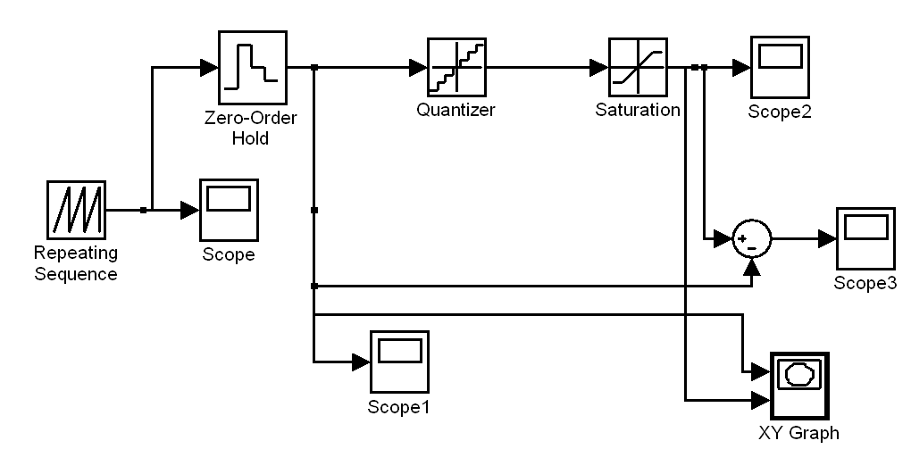

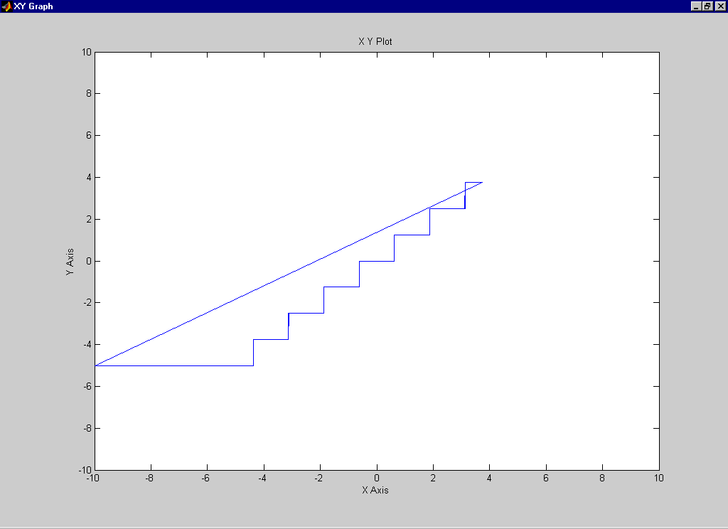

#4a continued

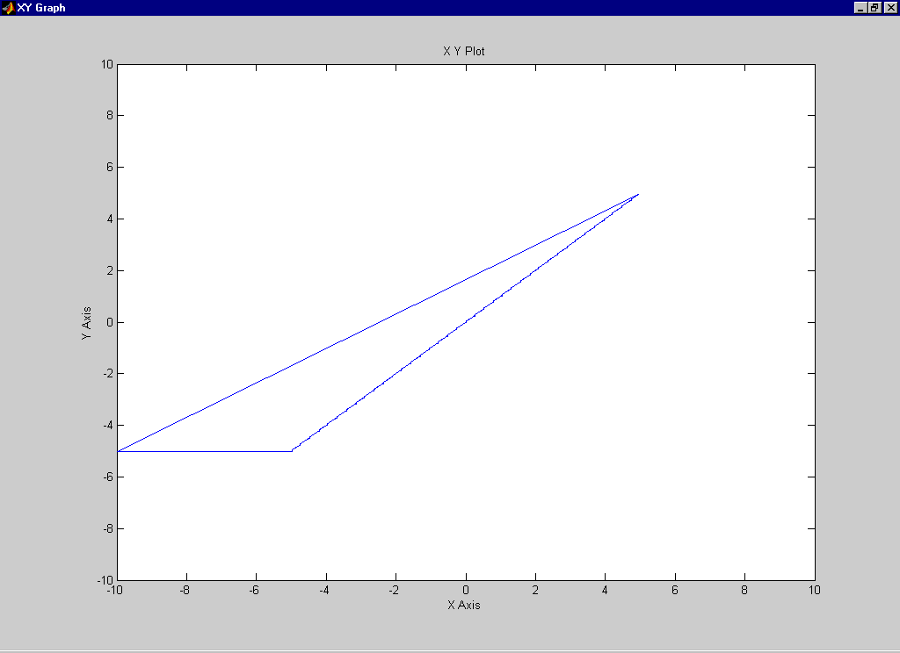

#4b)

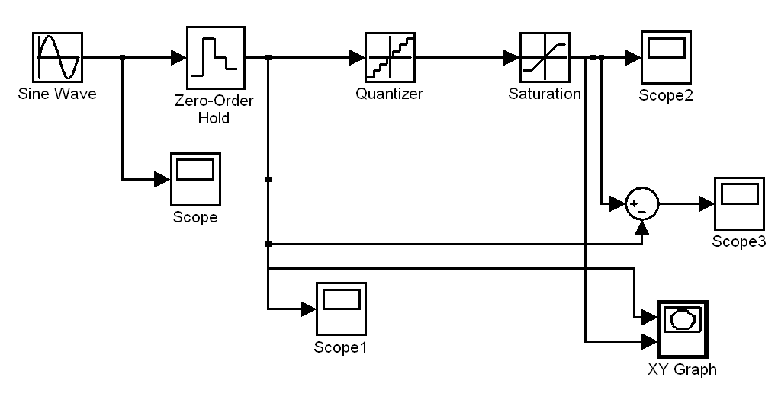

#4b continued

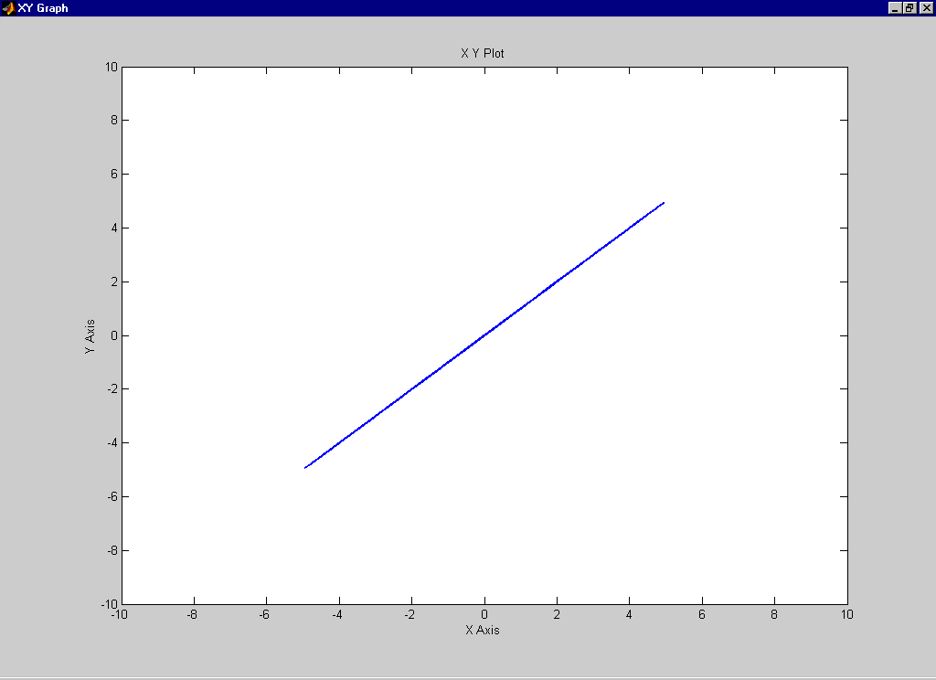

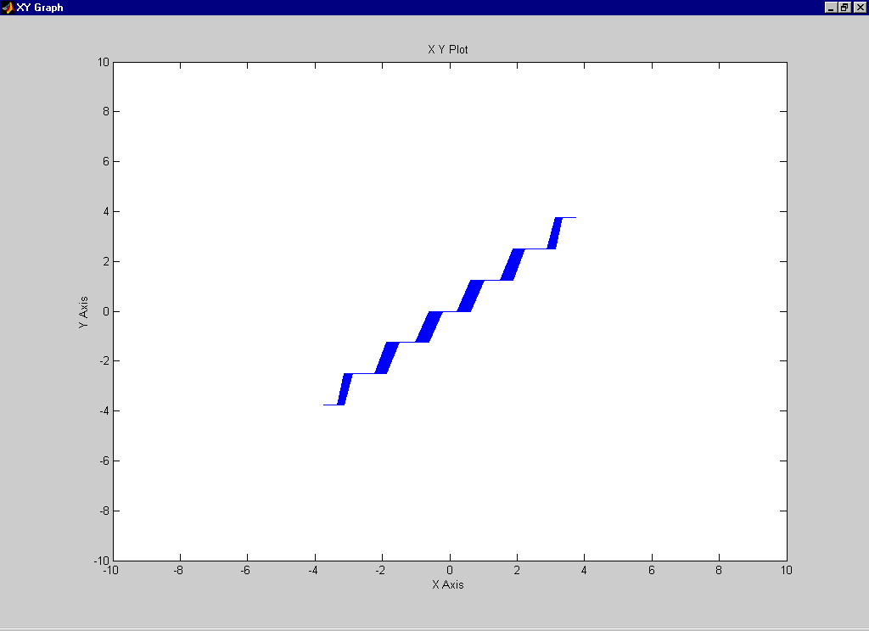

4c)

Time1=data4c1(:,1);
input=data4c1(:,2);
subplot(2,2,1);
plot(Time1*10,input);
grid on;
xlabel('Time is msec');
ylabel('Amplitude');
title('Input Sine Wave');
Pinput=mean(input.*input)
Pamp=((amp)^2)/2

Time2=data4c3(:,1);
quant=data4c3(:,2);
subplot(2,2,2);
stairs(Time2*10,quant);
grid on;
xlabel('Time is msec');
ylabel('Amplitude');
title('Output of Quantizer');

Time3=data4c4(:,1);
noise=data4c4(:,2);
subplot(2,2,3);
stairs(Time3*10,noise);
grid on;
xlabel('Time is msec');
ylabel('Amplitude');
title('Quantization Noise');

subplot(2,2,4);
hist(noise);
title('Histogram of Quantization Noise');
Pnoise=mean(noise.*noise)

S2N=Pinput/Pnoise

S2Ndb=10*log10(S2N)

diary on

Matlab Results:

Pinput = 6.9473
Pamp = 7.0313
Pnoise = 0.1152 Pnoise is the quantization average power.
S2N = 60.3162
S2Ndb = 17.8043 S/N ratio of the output signal is 17.8 dB.

diary off

