Assignment 2: Solving Difference Equations



ECE 480
Professor: Selim Awad
Term: Winter 2004

Prepared by:

Chris Musser
Ken Mayle
Vladi Gergov

I have neither given nor received aids in the preparation of this report:

_________________________________________________

_________________________________________________

_________________________________________________

Lab Overall Objectives:

- In this exercise we learn how to solve constant-coefficient difference equations using Matlab. Also, we investigate the response of systems to different kinds of inputs. .

Objective 1

- Consider the following difference equation:
y(n) = - 0.5 y(n-2) + 1.2 x(n) + 1.2 x(n-l) + 0.6 x(n-2).

  - Calculate the output y(n) by hand for x(n) = δ(n). What is this response called?

  - Use Matlab to verify the response. First, program the difference equation. Second, use the command "filter" to check your results. Plot the input and output responses versus n. %lab2

%#1b
clear;
%set the coefficients
a=[1,0,0.5];
b=[1.2,1.2,0.6];
%set the n vector size and generate a impulse @ 0
n=[0:60]';
x=zeros(size(n));
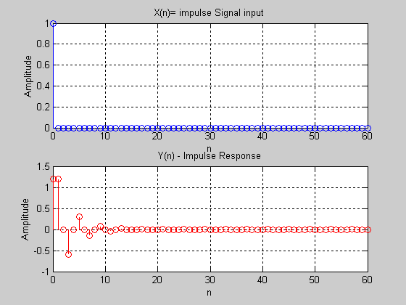
index=find(n==0);
Q1 Part B Graph
x(index)=1;
%find the impulse response
y=filter(b,a,x);
%plot the results
subplot(2,1,1)
stem(n,x,'b')
grid
xlabel('n')
ylabel('Amplitude')
title('X(n)= impulse Signal input')

subplot(2,1,2)
stem(n,y,'r')
grid
xlabel('n')
ylabel('Amplitude')
title('Y(n) - Impulse Response')

Find and plot the response of the system to a unit-step signal.
Hint: Plot just 60 points for simplicity.

%lab2
%#1c

clear;

a=[1,0,.5];
b=[1.2,1.2,.6];

n=[0:60]';
%generate unit step & find output
x=ones(size(n));
y=filter(b,a,x);

subplot(2,1,1)
stem(n,x,'b')
grid on
xlabel('n')
ylabel('Amplitude')
title('input signal,x')

subplot(2,1,2)
stem(n,y,'r')
grid on
xlabel('n')
ylabel('Amplitude')
title('output signal, y')

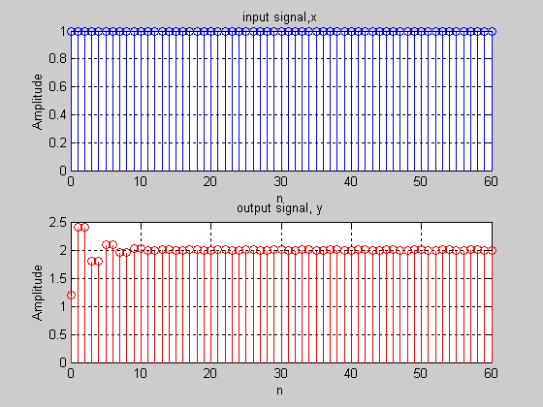

- For the system given by the difference equation:

y(n) – {1.8 cos(π/16)} y(n-l) +0.81 y(n-2) = 2 x(n) + x(n-1), find the step response (i.e., x(n) = u(n)). Use a long enough section of the input signal so that the output from the filter is nearly constant. Plot the step response and determine the constant level G0 as n → ∞.

- Determine the transient response yt(n) = y(n) - G0 and plot it for 0 < n < 60.

SEE GRAPH

- Find the energy of the transient response.

energy = 1.7396e+004

- After how any samples does the output reach steady state? Write a program to find the beginning of the steady-state period (end of transient period).

Nss = 40 ( our sample is at steady state at the 40th sample)

- Since the unit impulse signal d(n) is just the first difference of the step signal u(n), use the command "diff" to find h(n) (impulse response). One must note that the “diff” command reduces the size the vector by one.

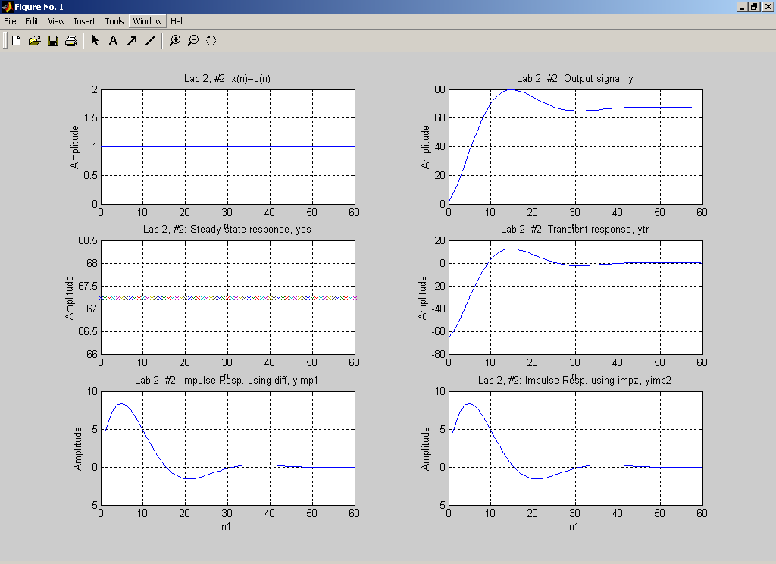

(3) For the system described by the following difference equation:
y(n) = 1.8 cos(π/16) y(n-l) - 0.81 y(n-2) + 2 x(n) + x(n-1)

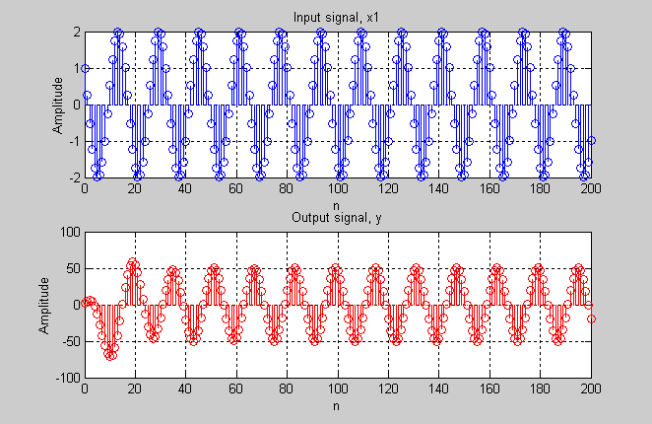

(a) Find and plot the response of the system to the input x(n) given by:
x(n) = 2.0 cos(0.125πn - π/3) u(n).
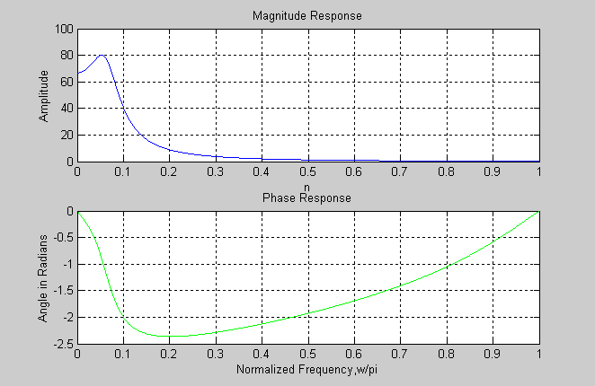

(b) Determine the steady state output and hence find the transient response. What is the transient response energy?

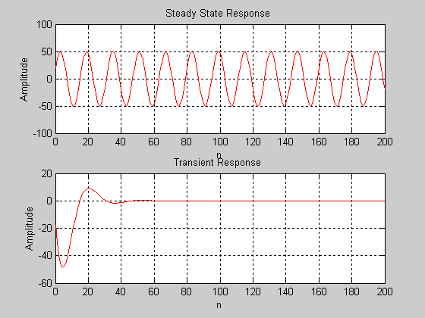
energy = 1.7396e+004
After how any samples does the output reach steady state? Write a program to find the beginning of the steady state response period (or end of transient response) Plot the transient response.

Nss = 45 – At our 45th sample, our output is at steady state.
Code for this objective, this would output all graphs at once (7)

%lab2
%#3

clc;
clear;

a=[1,-1.765,0.81];
b=[2,1,0];

w=pi/8;
%set wvec so that pi/8 is an actual point
wvec=[0:pi/1048:pi]';
%get the freq response
n=[0:200]';
H=freqz(b,a,wvec);
x=2*cos(w*n + pi/3);
%get the output, mag, phase
y=filter(b,a,x);
mag=abs(H);
phase=angle(H);
%plot the results
subplot(7,1,1);
plot(n,x, 'b');
grid ;
xlabel('n');
ylabel('Amplitude');
title('Input signal, x1');

subplot(7,1,2);
plot(n,y, 'r');
grid;
xlabel('n');
ylabel('Amplitude');
title('Output signal, y');

subplot(7,1,3);
plot(wvec/pi,mag, 'b')
grid;
xlabel('n');
ylabel('Amplitude');
title('Magnitude Response')

subplot(7,1,4)
plot(wvec/pi,phase, 'g')
grid;
xlabel('Normalized Frequency,w/pi');
ylabel('Angle in Radians');
title('Phase Response');
%find mag and phase of w which are %needed for y steady state
index=find(wvec==w);
mag_w=abs(mag(index))
phase_w=phase(index)
%find steady state and transient
yss=mag_w*2*cos(w*n+(pi/3)+phase_w);
ytr=y-yss;
%calculate the energy of the transient
energy=0;
for i=1:length(n)
energy=energy+(ytr(i))^2;
end
energy
%Find when transient ends and steady %state begins
for g=1:length(n)
if (abs(ytr(g))>.01*abs(yss))
N=g
end
end

Nss=N+1
%Plot results
subplot(7,1,5);
plot(n,yss, 'r');
grid;
xlabel('n')
ylabel('Amplitude')
title('Steady State Response ');

subplot(7,1,6)
plot(n,ytr, 'r')
grid;
xlabel('n');
ylabel('Amplitude');
title('Transient Response ');

