Introduction:

In this mini design project some of the fundamental concepts of processing wave files in Matlab are introduced.

The wave file used in this project was recorded using Windows Sound Recorder with the following settings:

Format = Pulse Code Modulation
Sampling Rate = 22,050Hz
Bits per Sample = 16
Recording Mode = Mono.

The contents of the wave file is a male voice saying the phase “We were away”, drawn out so that the vowel /IY/ in “We” and the diphthong /eI/ in “away” both have significant duration.
A diphthong is a gliding monosyllable that changes from one vowel and to another. It will be shown later that both vowels and diphthongs are Quasi-Periodic.
Question #1

Open the file in Matlab. Create a labeled plot of the signal versus samples. How many samples are in this signal?

figure(1);
[Y,FS,BITS]=wavread('wewereaway'); %extracts info on wav file
sound(Y, FS); % Play Orginial wave
plot(Y); % Plot Y verse Smaples
title('Orginial Wave Data');
xlabel('Samples n'),ylabel('Amplitude');
nsamples = length(Y)

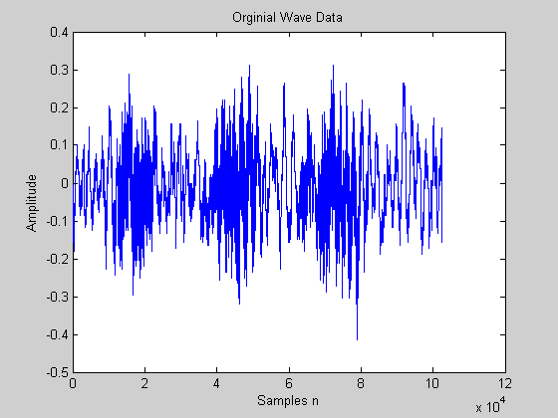

nsamples =

102544
Question #2

Create a labeled plot of the signal versus time. What is the duration of this signal?

n = [0:nsamples-1];
figure(2);
t = n / FS; % time
duration = max(t) % duration of signal in msec
plot(t,Y);
title('Orginial Wave Data');
xlabel('t Secs'),ylabel('Amplitude');

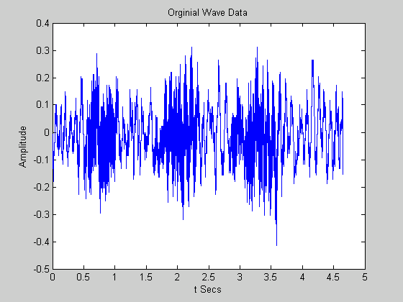

Duration =

4.6505 seconds

Question #3

Alter the signal so that its new sample rate is 11,025 Hz. How many samples are in this signal?

pause(5);
figure(3);
Ydec = decimate(Y,2); % Half as many samples
pause(5);
figure(3);
Ydec = decimate(Y,2); % Half as many samples
FSdec = FS/2; % Half the sample rate
sound(Ydec, FSdec, BITS);
ndecsamples = length(Ydec) % Number of samples in new signal
ndec = [0:ndecsamples-1];
tdec = ndec / FSdec; % time for new signal
plot(tdec, Ydec);
title('10,025 Hz Sampled Wave Data');
xlabel('t Secs'),ylabel('Amplitude');

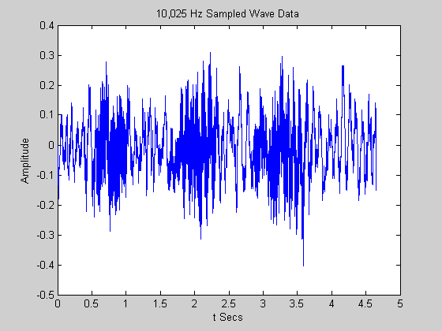

Number of samples =

51272 samples
figure(4);
plot(Ydec); % Plot new signal verses samples
title('10,025 Hz Sampled Wave Data');
xlabel('Samples n'),ylabel('Amplitude');

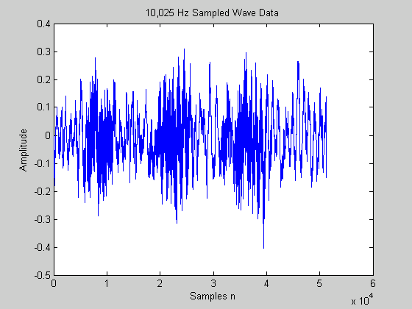

Question #4

Explain why a sampling rate of 11,025 Hz is still acceptable for this signal. For what type of sounds or signals might this sampling rate not be appropriate?

Voice max frequency is 5000 Hz.
Sampling frequency most be at least twice the highest frequency sampled
Since 11,025 is greater then 2*voice max freq. then no lose of data occurs

Any signals greater then 5512.5 Hz sampled will not be appropriate.
Examples: CDs
Question #5

Edit the signal and remove any background-noise, pause, silence, or clicks BEFORE and AFTER the signal. Include a labeled plot of the edited signal versus samples. How many samples are in this signal?

display('Select two end points to remove noise');
[xcoord, ycoord] = ginput(2);
xcoord = round(xcoord);
xcoord = sort(xcoord);
Z=Ydec(xcoord(1):xcoord(2));
nshortsamples = length(Z)
figure(5);
plot(Z); axis([0,nshortsamples,min(Z),max(Z)]);
title('Shortened Wave Data');
xlabel('Samples n'),ylabel('Amplitude');

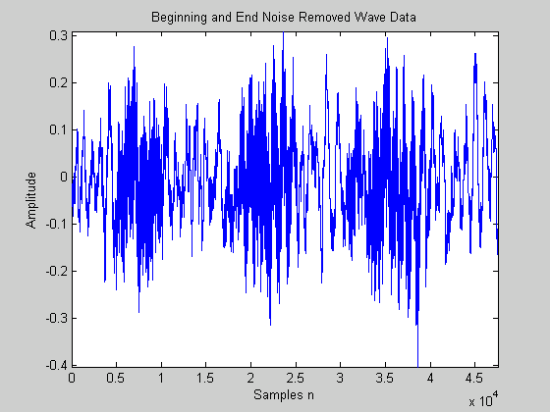

Number of Samples = 46084

Question #6

Save the edited 11,025 Hz signal to a new wave file. Play the signal back and compare the sound quality of the 11,025 HZ wave file to the original 220,050 Hz wave file. Explain what attributes have changed and how well you can perceive the differences with your ears.

wavwrite(Z, FSdec, BITS, 'weaway11025');
pause(3);
sound(Z, FSdec, BITS);

The second doesn’t seem as rich. As in, it sounds less “real”. We have less sampling of the data at 11,025 hz, hence it will not be as good of a reprensentation as the 22.050 hz file. It appears that relative higher frequency harmonics are not present.
Question #7

Again using GINPUT to select 2 points, the /IY/ utterance from “We” was selected from the signal and saved to the array IY, which was plotted verses samples.

From the 11,025 Hz "We were away" wave file, extract the utterance /IY/ from "We". Plot the utterance versus samples. How many samples are in this signal?

[Y,FS,BITS]=wavread('e'); %extracts info on wav file
sound(Y,FS,BITS); % Play Orginial wave
plot(Y); % Plot Y verse Samples
title('utterance /IY/ from We');
xlabel('Samples n'),ylabel('Amplitude');
nsamples = length(Y)

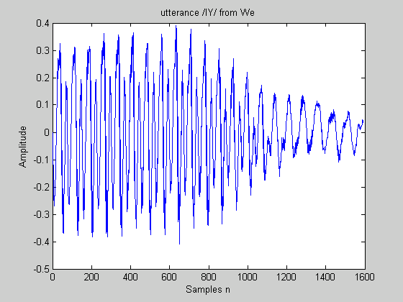

Number of Samples = 1591
Question #8

Zoom in on the /IY/ utterance. Does the signal look quasi-periodic? Plot two 'periods' of the signal. What is the approximate duration of one period in samples and in seconds? What frequency does this correspond to?

[Y,FS,BITS]=wavread('we'); %extracts info on wav file
sound(Y,FS,BITS); % Play Orginial wave
plot(Y); % Plot Y verse Samples
title('utterance /IY/ from We');
xlabel('Samples n'),ylabel('Amplitude');
nsamples = length(Y)
zoom
display('Select zoom in on IY to select quasi period');
pause;
[xcoord, ycoord] = ginput(5);
xcoord = round(xcoord);
IY_per_n(1) = abs(xcoord(1)-xcoord(2));
IY_per_n(2) = abs(xcoord(2)-xcoord(3));
IY_per_n(3) = abs(xcoord(3)-xcoord(4));
IY_per_n(4) = abs(xcoord(4)-xcoord(5));
IY_per_n_avg = mean(IY_per_n)
IY_per_t_avg = IY_per_n_avg / FS
IY_freq_avg = 1 / IY_per_t_avg

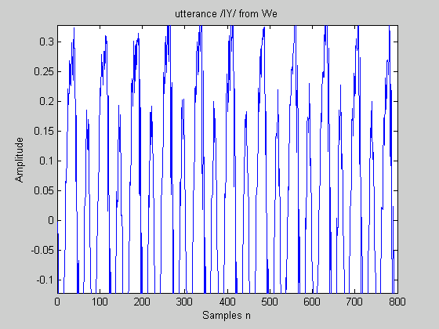
IY_per_n_avg =

68.2500

IY_per_t_avg =

0.0062

IY_freq_avg =

161.5385

9) From the 11,025 Hz "We were away" wave file, extract the utterance /eI/ from "away" . Plot the utterance versus samples. How many samples are in this signal?

[Y,FS,BITS]=wavread('y'); %extracts info on wav file
sound(Y,FS,BITS); % Play Orginial wave
plot(Y); % Plot Y verse Samples
title('utterance /eI/ from away');
xlabel('Samples n'),ylabel('Amplitude');
nsamples = length(Y)
zoom
display('Select zoom in on eI to select quasi period');
pause;
[xcoord, ycoord] = ginput(5);
xcoord = round(xcoord);
eI_per_n(1) = abs(xcoord(1)-xcoord(2));
eI_per_n(2) = abs(xcoord(2)-xcoord(3));
eI_per_n(3) = abs(xcoord(3)-xcoord(4));
eI_per_n(4) = abs(xcoord(4)-xcoord(5));
eI_per_n_avg = mean(eI_per_n)
eI_per_t_avg = eI_per_n_avg / FS
eI_freq_avg = 1 / eI_per_t_avg

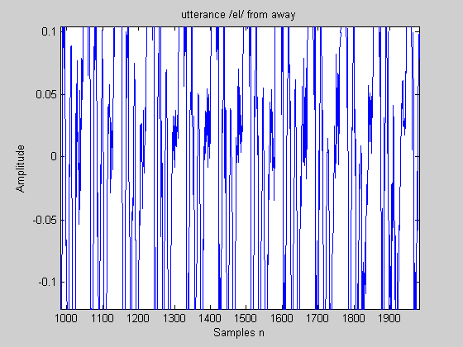
10) Zoom in on the /eI/ utterance. Does the signal look quasi-periodic? Plot four 'periods' of the signal. What is the approximate duration of one period in samples and in seconds? What frequency does this correspond to?

eI_per_n_avg =

89.5000

eI_per_t_avg =

0.0081

eI_freq_avg =

123.1844

11) Resample the original 22,050 Hz "We were away" wave file in Matlab using 8 bits. Compare the sound quality of the 8-bit signal to that of the 16-bit quality. Explain what attributes have changed and how much you can perceive the differences with your ears.

[Y,FS,BITS]=wavread('wewereaway'); %extracts info on wav file
sound(Y,FS,BITS);
pause
subplot(2,1,1);
plot(Y); % Plot Y verse Samples
title('Decimated Wave Data');
xlabel('Samples n'),ylabel('Amplitude');

Z = decimate(Y,2);
FSdec = FS/2;
sound(Z,FSdec,BITS);
subplot(2,1,2);
plot(Z);

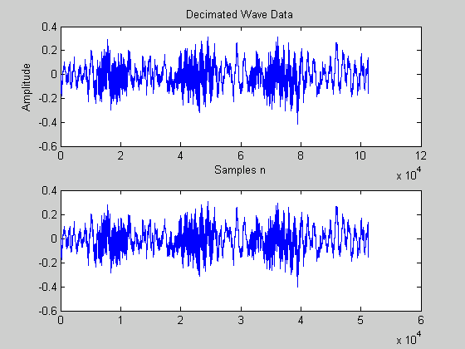

Decreasing the sampling frequency by two from 22,050 to 11,025 and comparing the two we noticed no quality loss and therefore we think it is sufficient to sample human speech at 11,025.
8 vs 16 Bit sound: Another factor which affects quality and file size is the bit depth.
16 bit sound is the best and 8 bit sound is half the size. 8 bit typically sounds noisier (hissy).

Conclusion:

From this project it was shown that the maximum frequency is 5,000 Hz and that the 11,025 Hz sampling rate is significant. The vowel and diphthongs were proven to be Quasi-Periodic. Techniques for removing noise and selecting speech items by hand were applied.

The following Matlab functions were introduced:

- wavread - used to read a wave file into an array.
- wavwrite – used to write a array to a wave file.
- playsnd – Plays a given vector.
- decimate – reduces the signal to a lower sampling rate
- ginput – selects N number of points from a graph using the mouse.

Record and save the phrases "We were away" and "She is Aware". Speak the phrases drawn out enough so that the voiced and unvoiced portions of the speech are apparent.

Use Sound Recorder with the following properties:
Format = Pulse Code Modulation
Sampling Rate = 11,025 Hz
Bits per Sample = 16
Recording Mode = Mono.

1) Open the "She is Aware " file in Matlab. Extract the word “She” and create a labeled plot of the
signal versus time.
2) Verify mathematically that 220 samples should be used to represent 20msec of speech sampled at 11,025 Hz.

( 11,025 samples / 1 sec )*( .02 sec ) = 220 samples

3) Create a function, avg_energy , to calculate the average energy for an array, where:
[ENERGY] = avg_energy( ARRAY, WINLENGTH )

ENERGY is the Average Energy output array
ARRAY is the input vector
WINLENGTH is the length of the moving window (even number of point)
Use a Hamming window to filter each analysis frame before calculating the energy. Move the window by WINLENGTH/2. If the length of the array is greater than a constant times WINLENGTH, ignore the extra samples at the end of the array (as shown in example code).

Include the Matlab code for your function. Test the function on the “She” speech signal with a window size of 220 samples. Include labeled subplots of “She “ and the average energy vs. time.

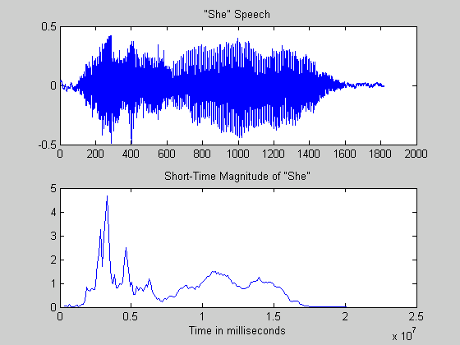

4) Create a function to calculate the average magnitude where:
[ENERGY] = avg_magnitude( ARRAY, WINLENGTH ) Use the same specifications as in 3 except ENERGY is the Average Magnitude.

Include the Matlab code for your function. Test the function on the “She” speech signal signal with a window size of 220 samples. Include labeled subplots of “She “ and the average magnitude vs. time.

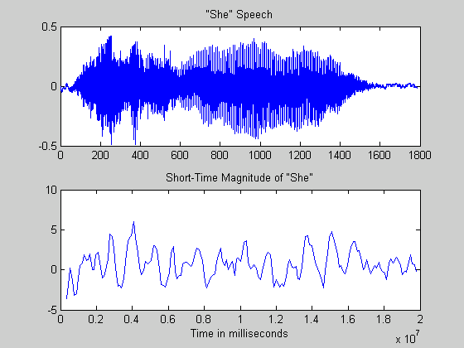

5) Comment on the difference between the results of the average magnitude and average energy calculations. Which algorithm is faster? Comment on the scales of the amplitudes. In your opinion, which algorithm “better” describes the amplitude properties of the signal? Define your criteria and explain why you chose this algorithm.

6) Create a function to calculate the zero crossings where:
[CROSSINGS] = zero_crossings( ARRAY, WINLENGTH )
CROSSINGS is the Number of Zero-Crossings output array
ARRAY is the input vector
WINLENGTH is the length of the moving window (even number of point)
Use a Rectangular window to filter each analysis frame before calculating the zero-crossings.

Move the window by WINLENGTH/2. If the length of the array is greater than a constant
times WINLENGTH, ignore the extra samples at the end of the array (as shown in examplecode).

Include the Matlab code for your function. Test the function on the “She” speech signal.
Include labeled subplots of “She “ and the zero-crossings vs. time.
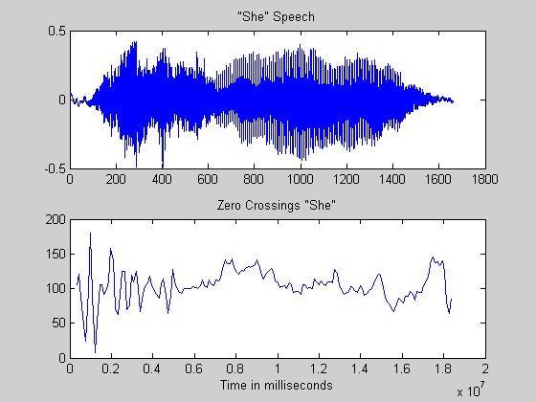

7) Edit the file “She is aware” and remove any noise, pause, or clicks before and after the signal.
Create subplots of the following signals vs. time:
1. The speech signal “She is aware”
2. The average energy of the speech signal
3. The zero-crossings of the speech signal

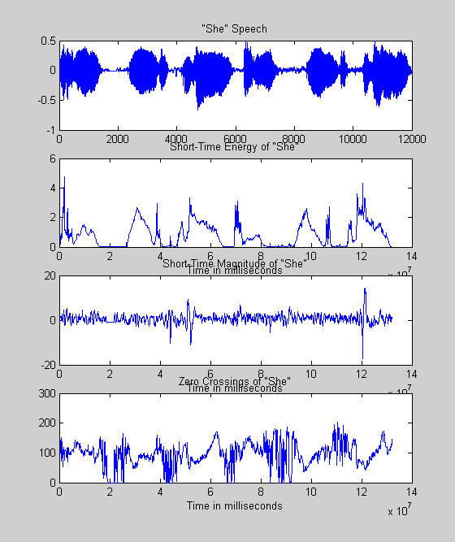

[Y,FS,BITS]=wavread('she_is_aware'); %extracts info on wav file

plot(Y); % Plot Y verse Samples
title('Orginial Wave Data');
xlabel('Samples n'),ylabel('Amplitude');

[xcoord, ycoord] = ginput(2); %this section of code extracts desired sound section
xcoord = round(xcoord);
xcoord = sort(xcoord);
IY=Y(xcoord(1):xcoord(2));
figure(7);
plot(IY);
title('IY Data');
xlabel('Samples n'),ylabel('Amplitude');
pause(3);
sound(IY, FS, BITS);
nIYsamples = length(IY) %

wavwrite(IY, FS, BITS, 'she'); %writes code to 'she.wav' (assuming you want she part)
pause(3); %gives a little pausy pause

infile='she';

spch=wavread( infile ); %extracts info on wav file, only need the array output

windowlength=220; %window length awad gave us
movewin=windowlength/2; %gives our window movement (50%)
fs=11025; %sampling frequency

avg_energy(spch,windowlength); %calls avg_energy function (must be named avg_energy - work dir)

energy=ans; %this is the output from the avg_energy function

avg_magnitude(spch,windowlength); %calls avg_energy function (must be named avg_energy - work dir)

magnitude=ans;

zero_crossings(spch,windowlength); %calls avg_energy function (must be named avg_energy - work dir)

zero_c=ans;

endspeech=length(spch); %length of the vector spch

tspch = [1:endspeech]/fs; %code awad gave us in slides for time vector
tspch = tspch*1000;

tenergy = [1:length(energy)];

tenergy = (windowlength+tenergy*movewin);

tenergy=tenergy*1000; %
subplot(4,1,1); % plot the crap
plot(tspch,spch);
title('"She" Speech'); %label the crap you plot
subplot(4,1,2);
plot(tenergy,energy);
title('Short-Time Energy'); %label the crap you plot
xlabel('Time in milliseconds') %label the crap you plot
subplot(4,1,3);
plot(tenergy,magnitude);
title('Short-Time Magnitude'); %label the crap you plot
xlabel('Time in milliseconds') %label the crap you plot
subplot(4,1,4);
plot(tenergy,zero_c);
title('Zero Crossings'); %label the crap you plot
xlabel('Time in milliseconds') %label the crap you plot

8) Edit the file “We were away” and remove any noise, pause, or clicks before and after the signal.
Create subplots of the following signals vs. time:
1. The speech signal “We were away”
2. The average energy of the speech signal
3. The zero-crossings of the speech signal

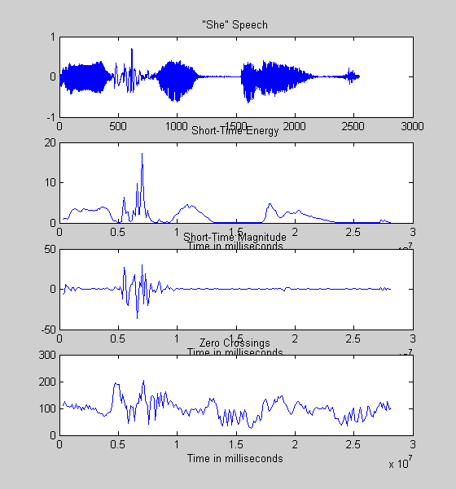

(basically the same code)

9) From your results in 7 and 8, describe how the energy and zero-crossings are related to voiced and unvoiced speech utterances.

Voiced sounds (vowels) caused by vibrations of the vocal cords, are quasi-periodic. The energy and zero-crossing plots shows us that voiced sounds have a lot of energy and not too many zero crossing. Unvoiced sounds (fricatives), on the other hand, are formed by forcing air through a constriction of the vocal tract at a high velocity. They also have a wideband spectrum resembling noise, which suggests that the zero crossings are a lot more than for voiced sounds and the energy is low.

