Assignment 4: Introduction to the simulation of signals and systems

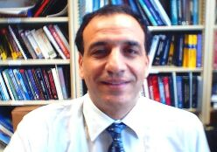

ECE 480
Professor: Selim Awad
Term: Winter 04

Prepared by:

Chris Musser
Ken Mayle
Vladi Gergov

I have neither given nor received aids in the preparation of this report:

_________________________________________________

_________________________________________________

_________________________________________________

