

Final Examination Extra Credit

Tan Nguyen

Dr. Selim Awad

Due date: 08/12/03
SPRING/SUMMER 2003

University of Michigan – Dearborn

HONOR CODE:

I have neither received nor given aid in the presentation of extra credit.

Signatures:

#1)
- We need a 2nd order Band Pass Filter (BPF)
Digital Filter Specification:
fo=$\sqrt{\text{fl}∗\text{fu}}=\sqrt{\text{36}∗\text{56}}=\text{43}\text{.}\text{68}\text{Hz}$ , BW=$\frac{2π(\text{fu}−\text{fl})}{\text{fs}}=$$\frac{2π(\text{53}−\text{36})}{\text{200}}=0\text{.}\text{17}π$
Center digital Frequency $⇒\text{wo}=\frac{2π\text{fo}}{\text{fs}}=\frac{2π∗\text{43}\text{.}\text{68}}{\text{200}}=0\text{.}\text{4368}π$
Now we need to find alpha and beta:
$β=\text{cos}(\text{wo})=0\text{.}\text{197}$, $\frac{2α}{1+α^{2}}=\text{cos}(\text{wo})=0\text{.}\text{860742}$ by using quadratic equation we find that $α$=1.75319, 0.57039, now find the poles for each $α$. Take one which gives the pole inside the unit circle $⇒α=0\text{.}\text{57039}$.
Find the poles and prove of stability:
Assume that the poles are complex $⇒\text{Zp}∧{\text{Zp}}^{}$ from the 2nd order of BPF transfer function, the poles are the roots of 1-$\begin{aligned}β(1+α)Z^{−1}+{αZ}^{−2}=0 \\ \end{aligned}$
$⇒$ (Z-Zp)(Z-Zp*). Therefore, Zp * Zp*=|Zp|^2 =$α$
$⇒$ |Zp|<1 implies to be inside the unit circle $⇒$$α<1$ for stability.
$⇒$Thus , we take $α$=0.57039
#1 b & c

Matlab Code:

%Tan Nguyen
%#1
%BPF second order IIR
w0=0.4368*pi; %digital center frequency
b=cos(w0); %the parameter called beta+-+
bw=0.17*pi; %the 3-dB bandwidth
%Find a (the parameter called alpha)
%sovle the quadratic equation
%(a*a +1)cos(bw)-2a=0
v=[cos(bw),-2, cos(bw)];
%coefficient of quad. equ.
a=roots(v);
%choosing the roots with mag. <1
if abs(a(1))<1
a=a(1);
else
a=a(2);
end
num=(1-a)*[1,0,-1]; %num vec. of transfer function
den=2*[1,-b*(1+a),a]; %den vec. of transfer function

figure(1);
freqz(num,den)

%Finding the difference equation using matlab
[Bdigital,Adigital]=bilinear(num,den,1)
Hz=tf(Bdigital,Adigital,1)

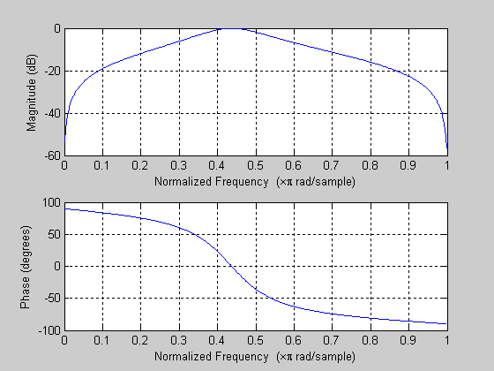

From matlab results, we have the 2nd order BPF that meet the requirement of wo=0.4368π and the BW=0.17π

Bdigital =
0.1631 -0.5437 0.1631
Adigital =
1.0000 -1.7361 1.3136

Transfer function:
0.1631 z^2 - 0.5437 z + 0.1631
------------------------------
z^2 - 1.736 z + 1.314

Therefore, the difference equation of the digital filter is as follow:

Y(n)-1.7361y(n-1)+1.3136y(n-2)=0.1631x(n)-0.5437x(n-1)+0.1631x(n-2)

#2
To answer part ( c ) which is the counter part of Ha(s) such that corresponding digital frequency of Ω1 is w1=0.5π. This means that we have to find the arbitrary T .
Calculation for arbitrary T as follow:

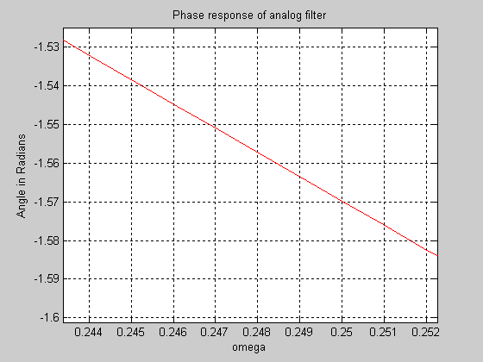
By Zooming Phase response of analog filter we see that, at the phase response of –90 degrees of analog filter ⇒π/2=1.57. The frequency Ω1=0.25π.
Now using Ω1=Ωa=0.25π,
Ωa=$\frac{2}{T}\text{tan}(w1/2)$,⇒T=$\frac{2}{0\text{.}\text{25}π}\text{tan}(0\text{.}5π/2)=2\text{.}\text{546}≈2\text{.}\text{55}$
Therefore, we have the arbitrary value of T=2.55.

Matlab:

N1 = [1 -5.792 9.14];
N2= [1 -4.2 11.487];
Nanalog = conv(N1,N2);
D1 = [1 5.792 9.14];
D2= [1 4.2 11.487];
Danalog = conv(D1,D2);

%Analog Transfer Function
H_s = tf (Nanalog,Danalog)

w=[0:pi/1024:pi];
HS=freqs(Nanalog,Danalog,w);
MagHS=abs(HS);
PhaseHS=angle(HS);

%Prewarping and warping
T=2.55;
%Design of Digital Filter using the Bilinear Trans.
%Finding the coefficient of DE of digital filter
[Ndigital,Ddigital]=bilinear(Nanalog,Danalog,1/T)
Hz=freqz(Ndigital,Ddigital,w);

%Finding the transfer function of digital filter
HDZ=tf(Ndigital,Ddigital,1)
MagHz=abs(Hz);
PhaseHz=angle(Hz);

%plot for each
figure(1)
subplot (2,1,1);
plot (w/pi, MagHS);
ylabel('Magnitude in dB');
xlabel('omega');
title('Magnitude Frequency response of analog filter');
grid on;

subplot (2,1,2);
plot (w/pi, MagHz);
ylabel('Magnitude in dB');
xlabel('omega');
title('Magnitude Prequency response of digital filter');
grid on;

figure(2)
subplot (2,1,1);
plot (w/pi, PhaseHS, 'r');
xlabel('omega');
ylabel('Angle in Radians');
title('Phase response of analog filter');
grid on;
axis([0,1.2,-4,4]);

subplot (2,1,2);
plot (w/pi, PhaseHz, 'r');
xlabel('omega');
ylabel('Angle in Radians');
title('Phase response of digital filter');
grid on;
axis([0,1.2,-4,4]);

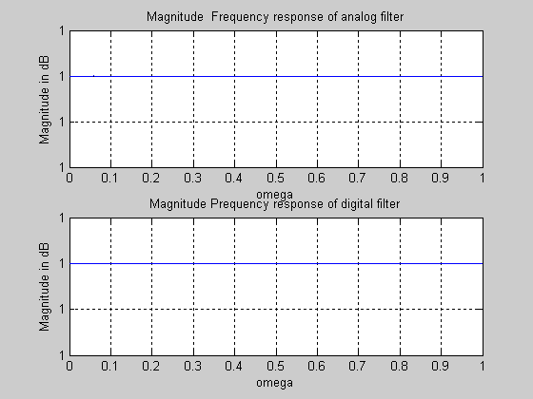

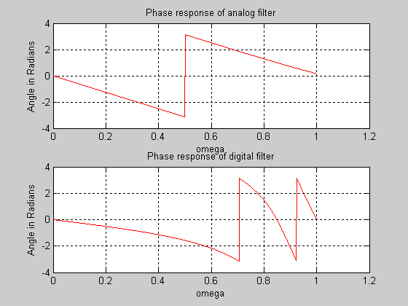

Transfer function:
s^4 - 9.992 s^3 + 44.95 s^2 - 104.9 s + 105
-----------------------------------------------------
s^4 + 9.992 s^3 + 44.95 s^2 + 104.9 s + 105

This is the analog transfer function resulting from Matlab.

From matlab we have the following transfer function and difference equation of the digital filter:

Ndigital =

0.2086 1.1970 2.6207 2.6047 1.0000

Ddigital =

1.0000 2.6047 2.6207 1.1970 0.2086

Transfer function:
0.2086 z^4 + 1.197 z^3 + 2.621 z^2 + 2.605 z + 1
------------------------------------------------------------
z^4 + 2.605 z^3 + 2.621 z^2 + 1.197 z + 0.2086

Therefore,

Y(n)+2.60471y(n-1)+2.6207y(n-2)+1.1970y(n-3)+0.2086y(n-4)=0.2086x(n)+1.1970x(n-1)+2.6207x(n-2)+2.6047x(n-3)+x(n-4)

===============================================================
#3)
a)
y(n)=-0.5y(n-1)+4x(n)
⇒Y(Z)=-0.5z^-1Y(z)+4X(Z) ⇒H(Z)=$\frac{4}{1+0\text{.}5z^{−1}}$
For a input x(n)=nu(n)
⇒X(Z)=-Z$\frac{d(1/1−z\hat{−1})}{\text{dz}}$⇒X(Z)=$\frac{Z}{(Z−1)^{2}}$
⇒Y(Z)=X(Z)H(Z)=$\frac{Z}{Z+0\text{.}5}$ $\frac{Z}{(Z−1)^{2}}$=$\frac{4Z^{2}}{(Z+0\text{.}5)(Z−1)^{2}}$
⇒$\frac{Y(Z)}{Z}=\frac{4Z}{(Z+0\text{.}5)(Z−1)^{2}}=\frac{A}{(Z−1)^{2}}+\frac{B}{(Z−1)}+\frac{C}{(Z+0\text{.}5)}$
⇒A=$\frac{4Z}{(Z+0\text{.}5)}$|_{Z-1}=, B=$\frac{d}{\text{dz}}\frac{4Z}{(Z+0\text{.}5)}|_{Z=1}=\frac{9}{8}$, C=$\frac{4Z}{(Z−1)^{2}}|_{Z=−0\text{.}5}=\frac{−9}{8}$
⇒Y(Z)/Z=$\frac{8/3}{(Z−1)^{2}}+\frac{9/8}{(Z−1)}+\frac{{−9}/8}{(Z+0\text{.}5)}$
⇒y(n)=$\frac{8}{3}\text{nu}(n)+\frac{9}{8}u(n)−\frac{9}{8}(−0\text{.}5)^{n}u(n)$
b)
Yss(n)=$\frac{9}{8}u(n)$, Ytr(n)=$\frac{8}{3}\text{nu}(n)−\frac{9}{8}(−0\text{.}5)^{n}u(n)$

c)Verify on matlab
Matlab:

%#3
b=[4];
a=[1, 0.5];
n=[0:150]'; %a column vectors
H=tf(b,a)
x=n;

%set location of ramp
index=find(n <0);
x(index)=0;

y=filter(b,a,x);

%Finding the steady state and transient
yss=y(end)
ytr=y-yss;

figure(1);
subplot(2,1,1)
plot(n,x,'b');
xlabel('Time-index, n');
ylabel('Amplitude');
title('X(n),Unit Ramp Input');
grid on

subplot(2,1,2)
plot(n,y,'r');
xlabel('n');
ylabel('Amplitude');
title('Y(n)-Ramp Response');
grid on

figure(2);
subplot(2,1,1);
plot(n,yss,'x');
xlabel('n');
ylabel('Amplitude');
title(' Steady state response, yss')
grid on;

subplot(2,1,2)
plot(n,ytr);
xlabel('n');
ylabel('Amplitude');
title(' Transient response, ytr')
grid on;

%general form-finding the boundary of transient/steady state response

Nss=0; stop=0; test_plus=0.01; test_minus=-0.01;

for i=1:length(ytr)-1
if test_minus<=ytr(i+1) & ytr(i+1)<=test_plus & stop==0
Nss=i;
stop=1;
elseif (test_plus<ytr(i+1)) | (test_minus>ytr(i+1)) & stop==1
Nss=0;
stop=0;
end
end
Nss

