
ECE 480 Digital Signal Processing
Professor S. Awad
Winter 2004

Computer Lab Assignment #2
Revised Copy
Nick Sitarski
Brandon Harris
Blaine Thompson

We have neither given nor received any unauthorized aid in this graded assignment.

____________________________________________________________________

_____________________________________________________________________

__________________________________________________________

Problem 1:
a)
y(n) = -.5y(n-2)+1.2x(n)+1.2x(n-1)+.6x(n-2)

n | x(n) | x(n-1) | x(n-2) | y(n-2) | y(n)
0 | 1 | 0 | 0 | 0 | 1.2
1 | 0 | 1 | 0 | 0 | 1.2
2 | 0 | 0 | 1 | 1.2 | 0
3 | 0 | 0 | 0 | 1.2 | -.6
4 | 0 | 0 | 0 | 0 | 0
5 | 0 | 0 | 0 | -.6 | .3
6 | 0 | 0 | 0 | 0 | 0
7 | 0 | 0 | 0 | .3 | -.15
8 | 0 | 0 | 0 | 0 | 0

The above graph gives the output for the first 8 values of n calculated by hand. The outputs are highlighted in red. The above response is an impulse response since x(n) is the impulse function.

b)
Matlab Code
a=[1,0,.5];
b=[1.2,1.2,.6];
n=[0:60]';
x=zeros(size(n));
x(1)=1;
y=filter(b,a,x);
figure(1),subplot(2,1,1),stem(n,x),grid on
xlabel('n'), ylabel('Amplitude'), title('Input Signal, X - Lab 2 Problem 1 Part B')
figure(1),subplot(2,1,2),stem(n,y),grid on
xlabel('n'), ylabel('Amplitude'), title('Output Signal, Y - Lab 2 Problem 1 Part B')

Graph
The below graph is for problem 1 part B. The top graph is the input and the bottom graph is the output.
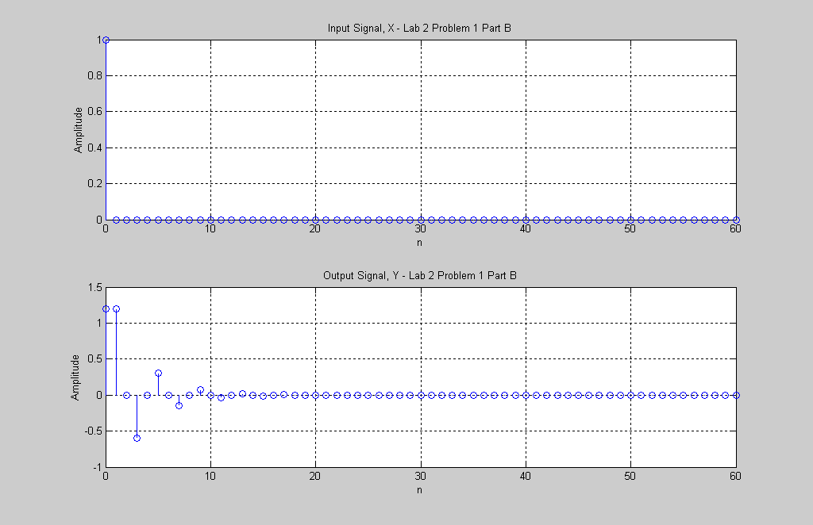

c)
Part c is simular to parts a and b, however, a step response is used instead of an impulse response.

Matlab Code
clear all
a=[1,0,.5];
b=[1.2,1.2,.6];
n=[0:60]';
x=ones(size(n));
y=filter(b,a,x);
figure(2),subplot(2,1,1),stem(n,x),grid on
xlabel('n'), ylabel('Amplitude'), title('Input Signal, X - Lab 2 Problem 1 Part C')
figure(2),subplot(2,1,2),stem(n,y),grid on
xlabel('n'), ylabel('Amplitude'), title('Output Signal, Y - Lab 2 Problem 1 Part C')

Graph
The below graph is for problem 1 part C. The top graph is the input and the bottom graph is the output.
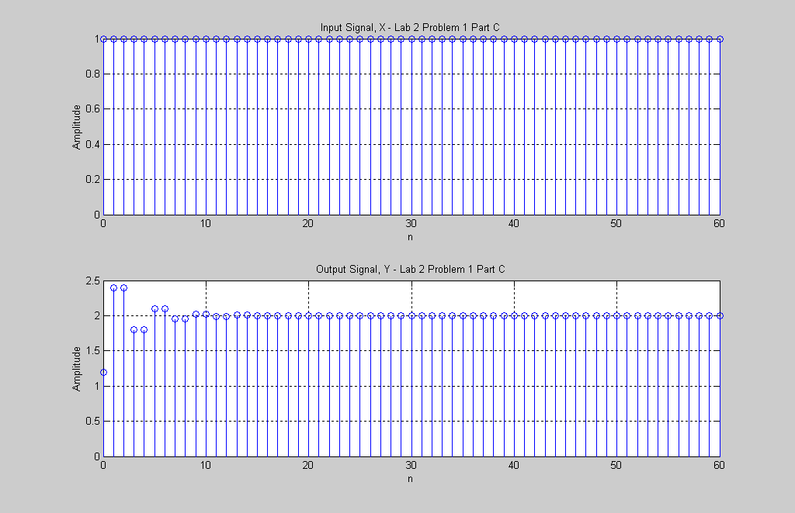
Problem 2:
Before performing parts a – d of problem 2 we ploted the input and output signals in discrete and continuous form. We would first like to show what the input and output graphs look like. We chose n to be 200 to be sure we reached a good steady state point.

Matlab Code
clear all
a=[1,-1.765,.81];
b=[2,1,0];
n=[0:200]';
x=ones(size(n));
y=filter(b,a,x);
figure(3),subplot(2,1,1),stem(n,x),grid on
xlabel('n'), ylabel('Amplitude'), title('Input Signal, X - Lab 2 Problem 2 Discrete')
figure(3),subplot(2,1,2),stem(n,y),grid on
xlabel('n'), ylabel('Amplitude'), title('Output Signal, Y - Lab 2 Problem 2 Discrete')
figure(4),subplot(2,1,1),plot(n,x),grid on
xlabel('n'), ylabel('Amplitude'), title('Input Signal, X - Lab 2 Problem 2 Continuous')
figure(4),subplot(2,1,2),plot(n,y),grid on
xlabel('n'), ylabel('Amplitude'), title('Output Signal, Y - Lab 2 Problem 2 Continuous')

Graph
The graphs below show the input and output to the system in discrete form. The second set of graphs show the same input and output in continuous form.
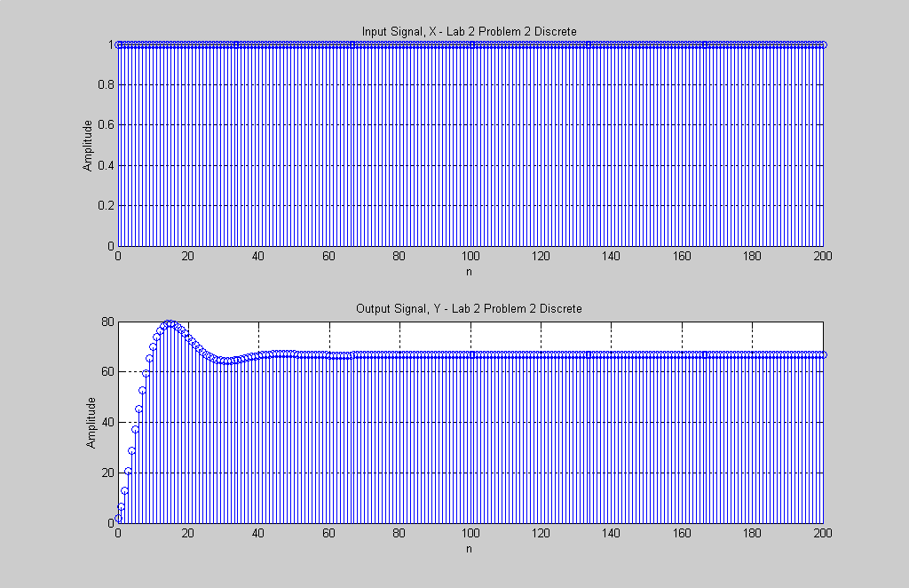
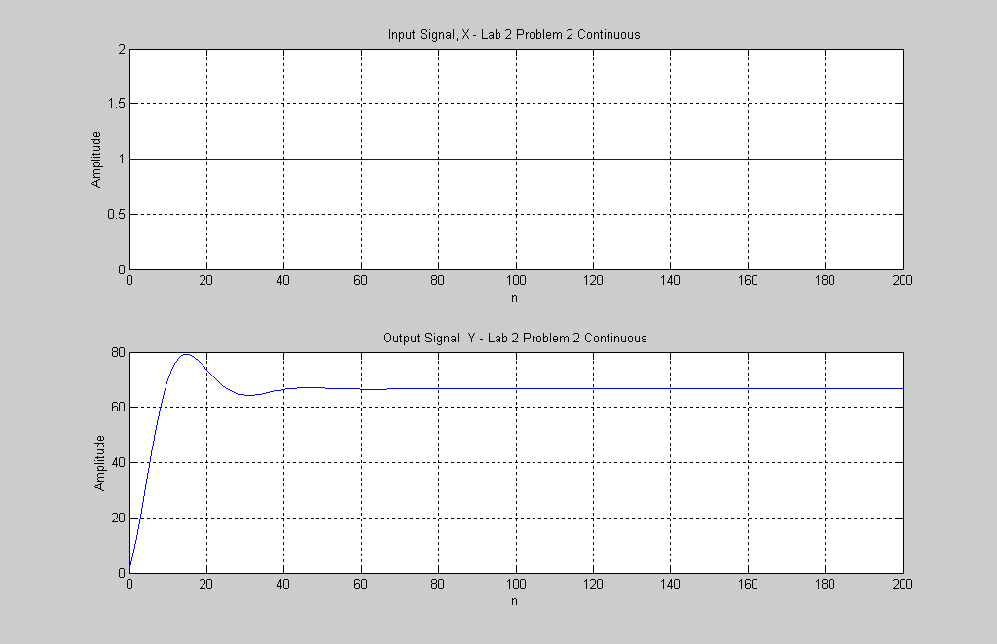

a)
In part a we determined the transient response, ytr = y – yss. We first plotted 0≤n≤60. Later we will determine exactly where the steady state starts and the transient stops.

Matlab Code
n2=[0:60]';
x2=ones(size(n2));
yss=y(end).*x2;
ytr=y(1:61)-yss %Limit YTR from 0 to 60 so matrix sizes match
figure(5),subplot(3,1,1),stem(n2,x2),grid on
xlabel('n'), ylabel('Amplitude'), title('Input Signal, X - Lab 2 Problem 2 a Input Discrete')
figure(5),subplot(3,1,2),stem(n2,yss),grid on
xlabel('n'), ylabel('Amplitude'), title('Output Signal, Y - Lab 2 Problem 2 a Steady State Output Discrete')
figure(5),subplot(3,1,3),stem(n2,ytr),grid on
xlabel('n'), ylabel('Amplitude'), title('Output Signal, Y - Lab 2 Problem 2 a Transient Output Discrete')
figure(6),subplot(3,1,1),plot(n2,x2),grid on
xlabel('n'), ylabel('Amplitude'), title('Input Signal, X - Lab 2 Problem 2 a Input Continuous')
figure(6),subplot(3,1,2),plot(n2,yss),grid on
xlabel('n'), ylabel('Amplitude'), title('Output Signal, Y - Lab 2 Problem 2 a Steady State Output Continuous')
figure(6),subplot(3,1,3),plot(n2,ytr),grid on
xlabel('n'), ylabel('Amplitude'), title('Output Signal, Y - Lab 2 Problem 2 a Transient Output Continuous')

Graph
The following graphs will show the input, yss, and ytr for 0≤n≤60. First we will show discrete graphs followed by continuous graphs.
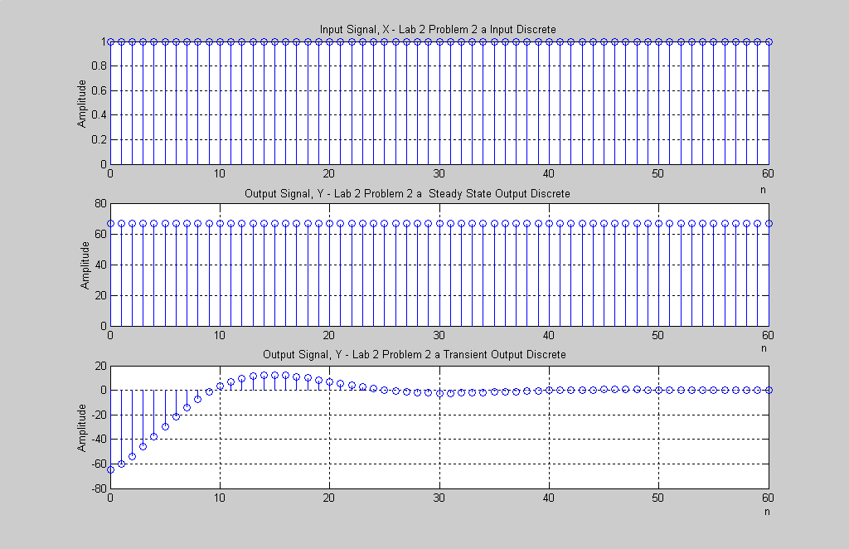

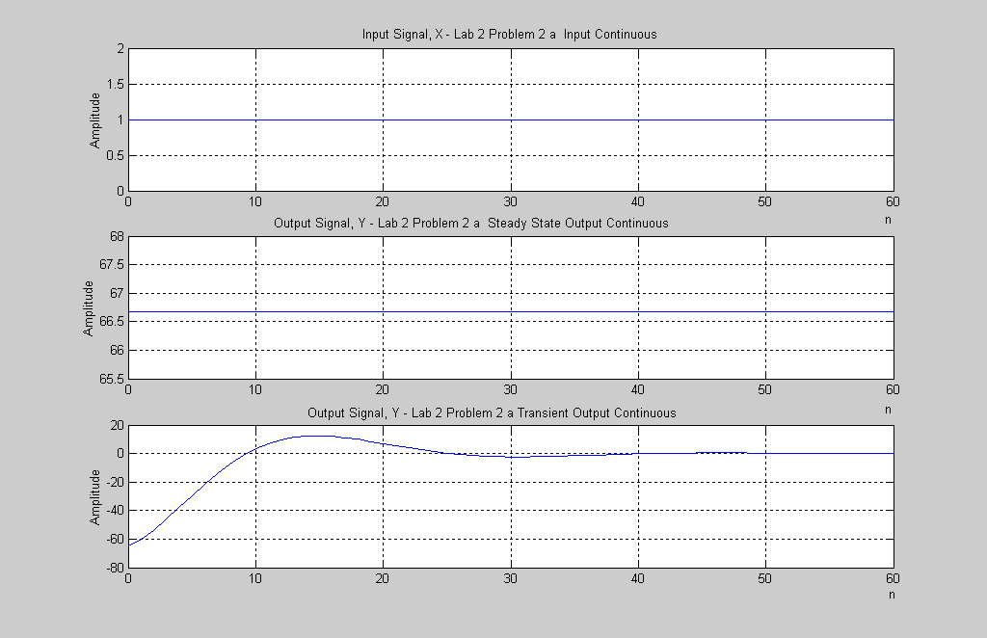

c)
We did part c before b because we had to find the value where the transient stopped to calculate part b. We used a while command to calculate the seperating point, The break point is at vector location 39 or n = 38.
Matlab Code
i =60;
absyss = abs(yss(end));
absytr = abs(ytr)
while (absytr(i) < .01*absyss) %This is one way to find break point
i=i-1;
breakpoint = i;
end
breakpoint % This equals 39 samples so the breakpoint is at n=38.
b)
Part b was performed two ways. First we summed the the the abs^2 terms of the transient response. The second way was to transpose the transient vector and then apply matrix multiplication. Bothways agreed and gave us an answer of 17,018 units of energy.

Matlab Code
%Problem 2b Problem 2B needed to be done before problem 2B
energy = 0;
for i = 1:breakpoint
ytrabs(i)=abs(ytr(i));
energy = ytrabs(i).^2+energy;
end
energy
%The first way to calculate energy is to square the abs values of the ytr and add them all together.
for i = 1:breakpoint
yenergy(i)=ytr(i);
end
yenergyprime=yenergy';
energytotal=yenergy*yenergyprime
%The second way to calculate energy is to transpose the ytr vector and do matrix multiplication.
%Both ways give an energy of 17,018 units

d)
Part d we used two different methods to calculate the impulse response to the system.

Matlab Code
yimp1=diff(y);
n3=n(2:201);
yimp2=impz(b,a,n);
yimp2=yimp2(2:end);
figure(7),subplot(2,1,1),plot(n3,yimp1),grid on
xlabel('n'), ylabel('Amplitude'), title('Output Signal, Y - Lab 2 Problem 2d diff command')
figure(7),subplot(2,1,2),plot(n3,yimp2),grid on
xlabel('n'), ylabel('Amplitude'), title('Output Signal, Y - Lab 2 Problem 2d impz command')
Graph
The graphs below both show the impulse response. Each way was calculated a different way but both show the same graph.
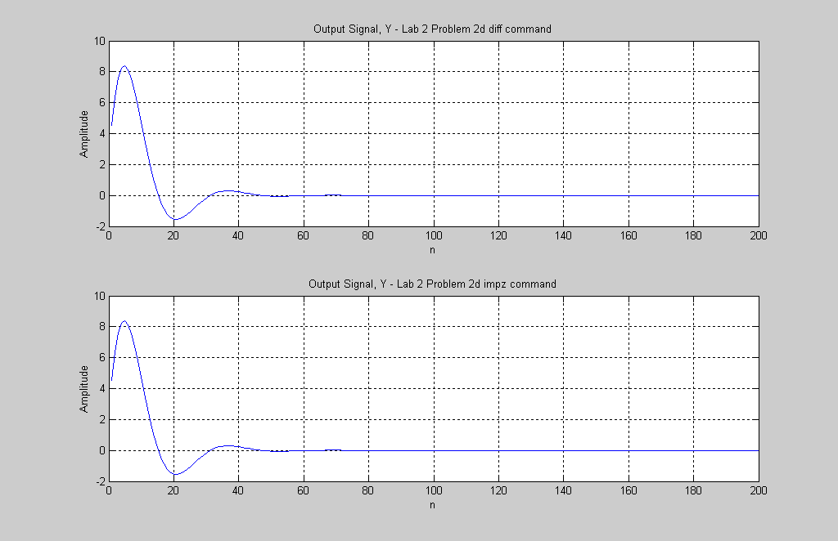

Problem 3:
For problem 3 the input was a sinusoidal function. We had to use the magnitude and phase response to calculate the steady state. Once we had the steady state problem was very close to problem 2.

Matlab Code
clear all
w=.125*pi;
a=[1,-1.765,.81];
b=[2,1,0];
n=[0:200]';
x=2*cos((w*n)+ (pi/3));
y=filter(b,a,x);
wvec=[0:pi/1048:pi]';
h=freqz(b,a,wvec);
mag=abs(h);
phase=angle(h);
figure(8),subplot(2,1,1),plot(wvec/pi,mag'),grid on
xlabel('w/pi, norm. freq.'), ylabel('Amplitude'), title('Lab 2 Problem 3 Magnitude Response')
figure(8),subplot(2,1,2),plot(wvec/pi,phase),grid on
xlabel('w/pi, norm. freq.'), ylabel('Amplitude'), title('Lab 2 Problem 3 Phase Response')
ind=find(wvec==w);
mag_w=abs(mag(ind));
phase_w=phase(ind);
yss=mag_w*2*cos((w*n)+ (pi/3)+phase_w);
ytr=y-yss;
figure(9),subplot(2,1,1),stem(n,x),grid on
xlabel('n'), ylabel('Amplitude'), title('Input Signal, X - Lab 2 Problem 3 Input Discrete')
figure(9),subplot(2,1,2),stem(n,y),grid on
xlabel('n'), ylabel('Amplitude'), title('Output Signal, Y - Lab 2 Problem 3 Output Discrete')
figure(10),subplot(2,1,1),stem(n,yss),grid on
xlabel('n'), ylabel('Amplitude'), title('Output Signal, yss - Lab 2 Problem 3 Steady State Output Discrete')
figure(10),subplot(2,1,2),stem(n,ytr),grid on
xlabel('n'), ylabel('Amplitude'), title('Output Signal, ytr - Lab 2 Problem 3 Transient Output Discrete')
figure(11),subplot(2,1,1),plot(n,x),grid on
xlabel('n'), ylabel('Amplitude'), title('Input Signal, X - Lab 2 Problem 3 Input Continuous')
figure(11),subplot(2,1,2),plot(n,y),grid on
xlabel('n'), ylabel('Amplitude'), title('Output Signal, Y - Lab 2 Problem 3 Output Continuous')
figure(12),subplot(2,1,1),plot(n,yss),grid on
xlabel('n'), ylabel('Amplitude'), title('Output Signal Signal, yss - Lab 2 Problem 3 Steady State Output Continuous')
figure(12),subplot(2,1,2),plot(n,ytr),grid on
xlabel('n'), ylabel('Amplitude'), title('Output Signal, ytr - Lab 2 Problem 3 Transient Output Continuous')

Graphs
The following graphs will show the magnitude and phase response. Next we will show the input, output, transient and steady state both in discrete and continuous time.
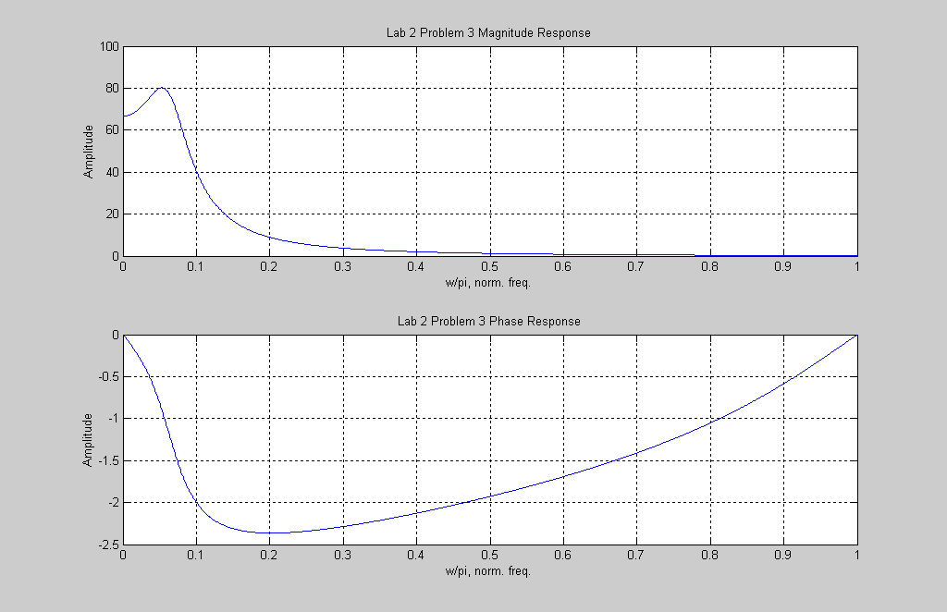

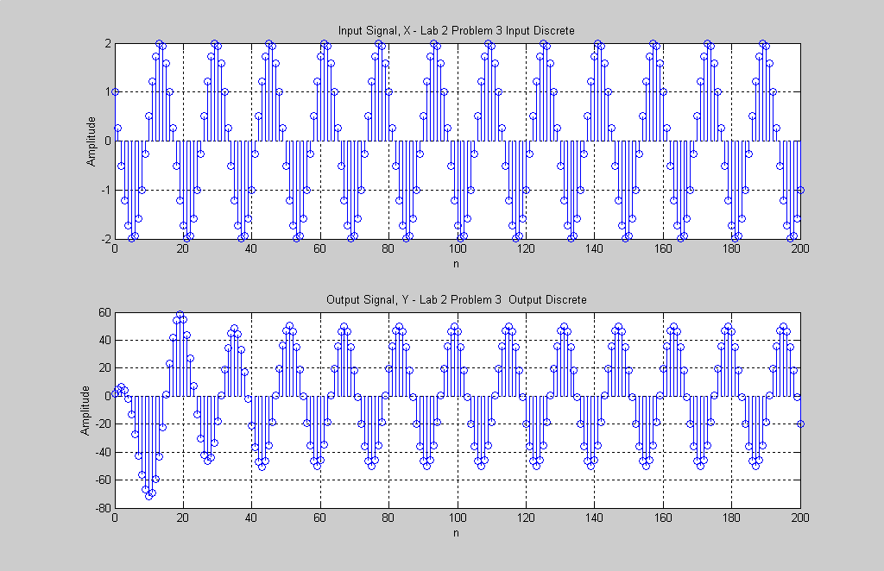

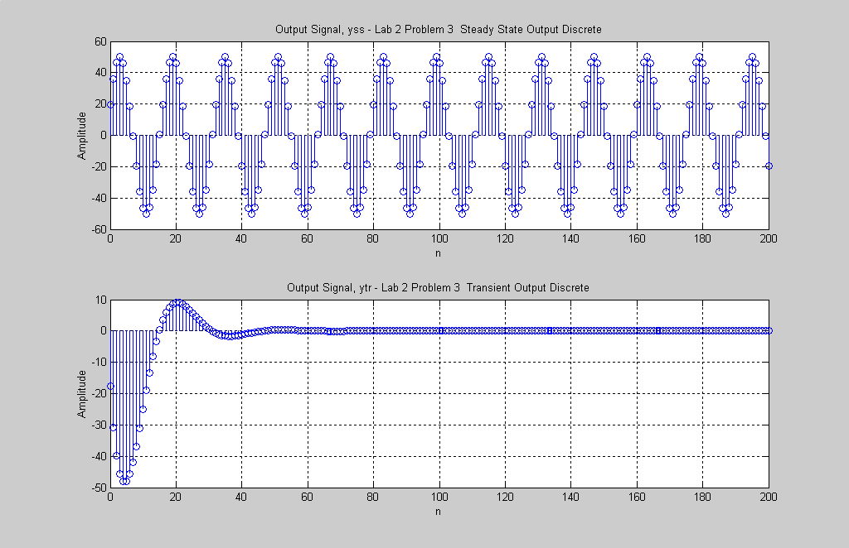
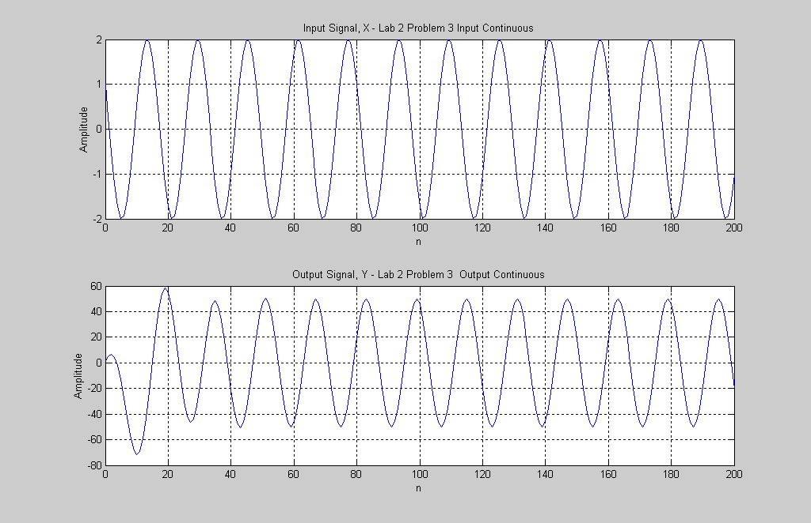

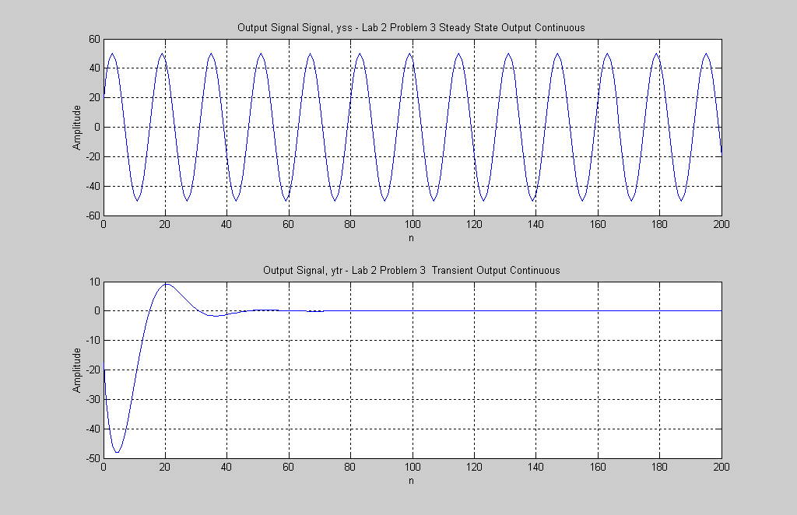
c)
Again we had to find the location where the transient stops before doing part b. We found that the transient stopped at n = 43.

Matlab Code
i =100;
maxyss = max(yss);
absytr = abs(ytr)
while (absytr(i) < .01*maxyss) %This is one way to find break point
i=i-1;
breakpoint = i;
end
breakpoint %breakpoint equals 44 so n = 43
b)
We found the energy to be 17,557 units of energy.

Matlab Code
n=[0:90]';
ytrfinal = ytr(1:91);
yssfinal = yss(1:91);
figure(13),subplot(2,1,1),stem(n,ytrfinal),grid on
xlabel('n'), ylabel('Amplitude'), title('Input Signal, ytr - Lab 2 Problem 3 ytr final Discrete')
figure(13),subplot(2,1,2),stem(n,yssfinal),grid on
xlabel('n'), ylabel('Amplitude'), title('Output Signal, yss - Lab 2 Problem 3 yss final Discrete')
figure(14),subplot(2,1,1),plot(n,ytrfinal),grid on
xlabel('n'), ylabel('Amplitude'), title('Input Signal, ytr - Lab 2 Problem 3 ytr final continuous')
figure(14),subplot(2,1,2),plot(n,yssfinal),grid on
xlabel('n'), ylabel('Amplitude'), title('Output Signal, yss - Lab 2 Problem 3 yss final continuous')
energy = 0;
for i = 1:breakpoint
ytrabs(i)=abs(ytr(i));
energy = ytrabs(i).^2+energy;
end
energy
%The first way to calculate energy is to square the abs values of the ytr and add them all together.
for i = 1:breakpoint
yenergy(i)=ytr(i);
end
yenergyprime=yenergy';
energytotal=yenergy*yenergyprime
%The second way to calculate energy is to transpose the ytr vector and do matrix multiplication.
%Both ways give an energy of 17,557 units

Graph
Below we show the yss and ytr graphs both in discrete and continuous time.
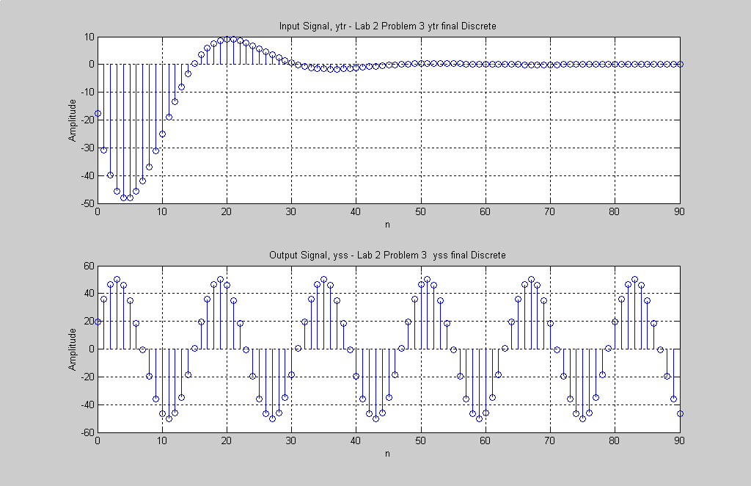

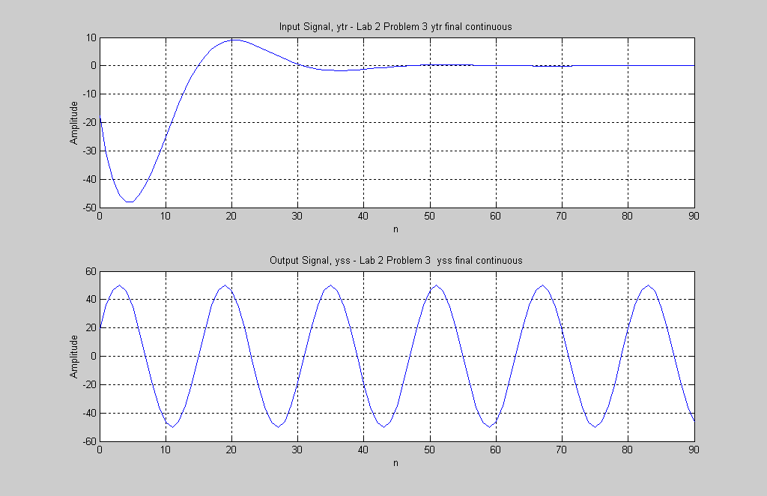

Conclusion
In this lab we figured out how to graph difference functions. Also we learned how to write loops to tell us where the transient and steady state meet up. The last main focus of this lab was to figure out a way to calculate the energy of a signal. We found more than one way to calculate the energy of a signal and also how to figure out where the transient and the steady state meet.

