

LAB#2 SOLVING DIFFRENCE EQUATIONS

Hung Nguyen

Tan Nguyen

Minh Le

Dr. Selim Awad

Due date: 06/11/03
SPRING/SUMMER 2003

University of Michigan – Dearborn

HONOR CODE:

We have neither received nor given aid in the presentation of this report.

Signatures:

- Consider the following difference equation:
y(n) = - 0.9 y(n-2) + 1.2 x(n) + 2.4 x(n-l) + 1.2 x(n-2).

  - Calculate the output y(n) by hand for x(n) = ™(n). What is this response called?
X(n)=δ(n)
H(n)= - 0.9 h(n-2) + 1.2 δ(n) + 2.4 δ(n-l) + 1.2 δ(n-2)
Therefore,
Y(n)= - 0.9 y(n-2) + 1.2 δ(n) + 2.4 δ(n-l) + 1.2 δ(n-2)
Solve y(n) for n=0,1,2,3,…,n
Y(0)= - 0.9 y(-2) + 1.2 δ(0) + 2.4 δ(-l) + 1.2 δ(-2)=0+1.2+0+0=1.2
Y(1)= - 0.9 y(-1) + 1.2 δ(1) + 2.4 δ(0) + 1.2 δ(-1)=0+0+2.4+0=2.4
Y(2)= - 0.9 y(0) + 1.2 δ(2) + 2.4 δ(l) + 1.2 δ(0)=-0.9(1.2)+0+0+1.2=0.12
Y(3)= - 0.9 y(1) + 1.2 δ(3) + 2.4 δ(2) + 1.2 δ(1)=-0.9(2.4)+0+0+0=-2.16
Etc..

Ans: The response is called the impulse response since the input signal is the delta function, δ(n), also known as the impulse signal.

  - Use Matlab to verify the response. First, program the difference equation. Second, use the command "filter" to check your results. Plot the input and output responses versus n.

%lab2
%#1b
clear;
a0=1;
a1=0;
a2=0.9;

b0=1.2;
b1=2.4;
b2=1.2;

a=[a0,a1,a2];
b=[b0,b1,b2];

n=[0:50]'; % a column vectors
x=zeros(size(n));
index=find(n==0);
x(index)=1;

y=filter(b,a,x);

subplot(2,1,1)
stem(n,x,'b')
grid
xlabel('n')
ylabel('Amplitude')
title('X(n)= impulse Signal input')

subplot(2,1,2)
stem(n,y,'r')
grid
xlabel('n')
ylabel('Amplitude')
title('Y(n) - Impulse Response')

Matlab Results:

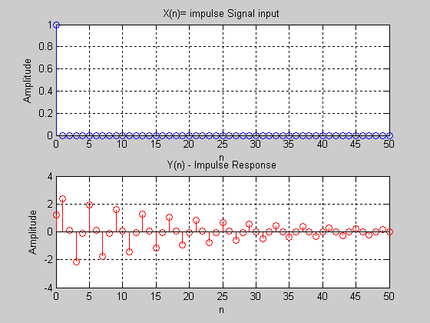

(c) Find and plot the response of the system to a unit-step signal.
Hint: Plot just 60 points for simplicity.
Matlab Code:

%lab2
%#1c
b=[1.2,2.4,1.2];
a=[1,0,0.9];
n=[0:60]';
x=ones(size(n));
y=filter(b,a,x);
subplot(2,1,1)
stem(n,x)
grid on
xlabel('n')
ylabel('Amplitude')
title('input signal,x')
subplot(2,1,2)
stem(n,y,'r')
grid on
xlabel('n')
ylabel('Amplitude')
title('Output signal, y')

Matlab Results:

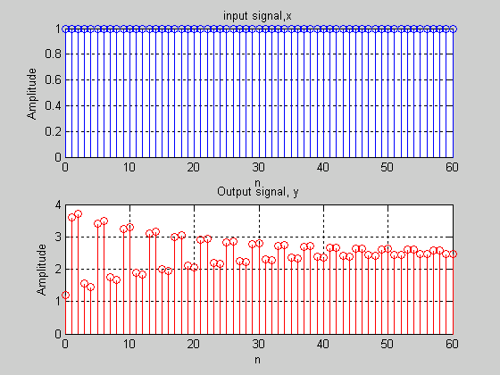
Note: By plotting only 60 points for simplicity, only a portion of the Transient Response is observed. Each of the outputs have not yet reached steady state.

(2) For the system given by the difference equation:
y(n) – {1.8 cos(π/16)} y(n-l) +0.81 y(n-2) = 2 x(n) + x(n-1), find the step response (i.e., x(n) = u(n)). Use
a long enough section of the input signal so that the output from the filter is nearly constant. Plot the step
response and determine the constant level G0 as n → ∞.

Ans: The constant level of G0 (yss) as n→∞ was calculated at 67.6309
- Determine the transient response yt(n) = y(n) - G0 and plot it for 0 < n < 50.
- Find the energy of the transient response.
Ans: E = 17,598 joules
- After how any samples does the output reach steady state?
Ans: after approximately 41 samples the steady state response will be reached
- Since the unit impulse signal ™(n) is just the first difference of the step signal u(n), use the command "diff" to find h(n) (impulse response). One must note that the “diff” command reduces the size the vector by one.

Matlab Code:
%lab2
%#2
clear;
b=[2, 1, 0];
a=[1, -1.8*cos(pi/16), .81];
n=[0:50]';%' --> a column vector
x=ones(size(n));
y=filter(b,a,x);
yss=y(end)
ytr=y-yss;
energy=0;
for i=1:length(n)
energy=energy+(ytr(i))^2;
end
energy
Nss=0;
UpBoundary=1.01*yss
LowBoundary=0.99*yss

for g=1:length(n)
count=0;
ans=y(g);
count= count+1
end
%samp=find(n==.01*yss);
%stdstate=y(indn)
yimp1=diff(y);
length_yimp1=length(yimp1)
length_y=length(y)
n1=n(2:51);
yimp2=impz(b,a,n);
yimp2=yimp2(2:end);
subplot(3,2,1)
plot(n,x);
xlabel('n');
ylabel('Amplitude');
title('Lab 2, #2, x(n)=u(n)')
grid on;
subplot(3,2,2)
plot(n,y);
xlabel('n');
ylabel('Amplitude');
title('Lab 2, #2: Output signal, y')
grid on;

subplot(3,2,3)
plot(n,yss,'x');
xlabel('n');
ylabel('Amplitude');
title('Lab 2, #2: Steady state response, yss')
grid on;

subplot(3,2,4)
plot(n,ytr);
xlabel('n');
ylabel('Amplitude');
title('Lab 2, #2: Transient response, ytr')
grid on;
subplot(3,2,5)
plot(n1,yimp1);
xlabel('n1');
ylabel('Amplitude');
title('Lab 2, #2: Impulse Resp. using diff, yimp1')
grid on;
subplot(3,2,6)
plot(n1,yimp2);
xlabel('n1');
ylabel('Amplitude');
title('Lab 2, #2: Impulse Resp. using impz, yimp2')
grid on;

Nss=0; %code to find Nss
stop=0;
ytr
Upper= 0.01*yss
Lower=-0.01*yss
for i=1:length(n)
if (ytr(i)<=Upper & ytr(i)>=Lower) & stop==0
Nss=i;
stop=1;
elseif (ytr(i)>Upper & stop==1)|(ytr(i)<Lower & stop==1)
Nss=999;
stop=0;
end
end
Nss

Matlab Results:

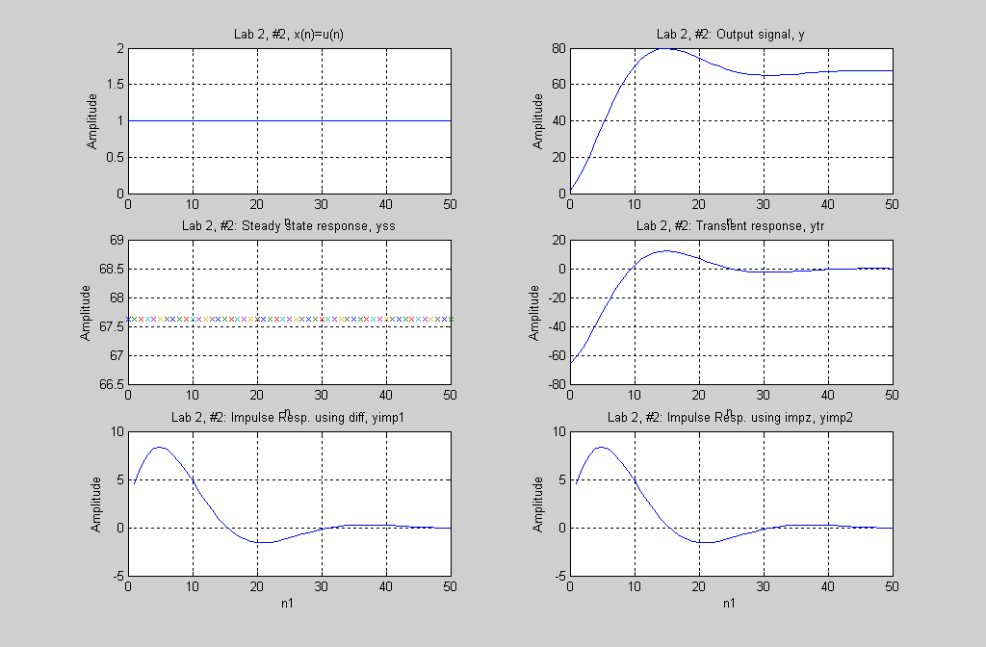
yss = 67.6309
energy = 1.7598e+004
length_yimp1 = 50
length_y = 51
Upper = 0.6763
Lower = -0.6763
UpBoundary = 68.3072
LowBoundary = 66.9546
Nss = 41

(3) For the system described by the following difference equation:
y(n) = 1.8 cos(π/16) y(n-l) - 0.81 y(n-2) + 2 x(n) + x(n-1),
(a) Find and plot the response of the system to the input x(n) given by:
x(n) = 1.5 cos(0.125πn - π/4) u(n).
(b) Determine the steady state output and hence find the transient response.
(c) After how any samples does the output reach steady state? Plot the transient response. Ans: Nss = 26 samples

Matlab Code:
%lab2
%#3
clc;
clear;
a0=1; a1=-1.8*cos(pi/16); a2=0.81;
b0=2; b1=1; b2=0;

a=[a0,a1,a2]; %y (output) coeffiencents of difference equation
b=[b0,b1,b2]; %x (input) coeffiencents of difference equation
w=pi/8;
wvec=[0:pi/1048:pi]';
n=[0:200]';
H=freqz(b,a,wvec);
x=1.5*cos(pi*n/8 - pi/4); %unit step

y=filter(b,a,x);
mag=abs(H);
phase=angle(H);

subplot(7,1,1);
plot(n,x, 'b');
grid ;
xlabel('n');
ylabel('Amplitude');
title('Input signal, x1');

subplot(7,1,2);
plot(n,y, 'r');
grid;
xlabel('n');
ylabel('Amplitude');
title('Output signal, y: Unit Sinusoidal Response');

subplot(7,1,3);
plot(wvec/pi,mag, 'b')
grid;
xlabel('n');
ylabel('Amplitude');
title('Magnitude Response')

subplot(7,1,4)
plot(wvec/pi,phase, 'g')
grid;
xlabel('Normalized Frequency,w/pi');
ylabel('Angle in Radians');
title('Phase Response');

index=find(wvec==w);
mag_w=abs(mag(index))
phase_w=phase(index)

yss=zeros(size(n));
yss=mag_w *1.5*cos ((pi*n)/8-pi/4 + phase_w); %Steady State
ytr=y-yss;

subplot(7,1,5);
plot(n,yss, 'r');
grid;
xlabel('n')
ylabel('Amplitude')
title('Steady State Response ');

subplot(7,1,6)
plot(n,ytr, 'r')
grid;
xlabel('n');
ylabel('Amplitude');
title('Transient Response ');
%general form-finding the boundary of transient/steady state response

Nss=0; stop=0; test_plus=0.01; test_minus=-0.01;

for i=1:length(ytr)-1
if test_minus<=ytr(i+1) & ytr(i+1)<=test_plus & stop==0
Nss=i;
stop=1;
elseif (test_plus<ytr(i+1)) | (test_minus>ytr(i+1)) & stop==1
Nss=0;
stop=0;
end
end
Nss
subplot(7,1,7);
plot(n,ytr, 'b');
axis([73 78 -0.01 0.01]);
grid;
xlabel('n');
ylabel('Amplitude');
title('Transient Response ');

mag_w =24.9476

phase_w =-2.2165

Nss = 26

Matlab Results:

