Introduction:

In this mini design project some of the fundamental concepts of processing wave files in Matlab are introduced.

The wave file used in this project was recorded using Windows Sound Recorder with the following settings:

Format = Pulse Code Modulation
Sampling Rate = 22,050Hz
Bits per Sample = 16
Recording Mode = Mono.

The contents of the wave file is a male voice saying the phase “We were away”, drawn out so that the vowel /IY/ in “We” and the diphthong /eI/ in “away” both have significant duration.
A diphthong is a gliding monosyllable that changes from one vowel and to another. It will be shown later that both vowels and diphthongs are Quasi-Periodic.
Question #1

In this section of matlab code, the wave file, which is contained in the array Y, is played back and plotted verses samples (n).

figure(1);
playsnd(Y, FS, WAVBITS); % Play Orginial wave
plot(Y); % Plot Y verse Smaples
title('Orginial Wave Data');
xlabel('Samples n'),ylabel('Amplitude');
nsamples = length(Y)

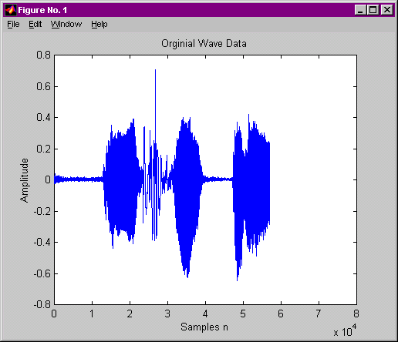

Number of samples = 75988
Question #2

In this section of code, the time array, t, is created and the signal plotted verses time (t) in msec.

n = [0:nsamples-1];
figure(2);
t = n / FS; % time
duration = max(t) % duration of signal in msec
plot(t,Y);
title('Orginial Wave Data');
xlabel('t Secs'),ylabel('Amplitude');

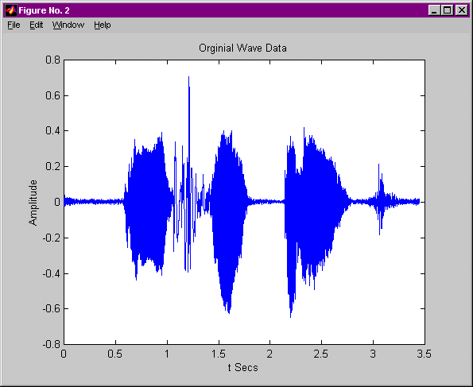

The duration of the signal is 3.4461 msec

Question #3

Here the original signal is reduced to a sample rate of 11,025 Hz, half of the original sampling rate, using the Matlab command DECIMATE. DECIMATE filters the signal with an eighth order Chebyshev type 1 lowpass filter with cutoff frequency .8*(FS/2)/R, before resampling. Where R is a positive integer passed to the function. The signal is then plotted verses time.

pause(5);
figure(3);
Ydec = decimate(Y,2); % Half as many samples
FSdec = FS/2; % Half the sample rate
playsnd(Ydec, FSdec, WAVBITS);
ndecsamples = length(Ydec) % Number of samples in new signal
ndec = [0:ndecsamples-1];
tdec = ndec / FSdec; % time for new signal
plot(tdec, Ydec);
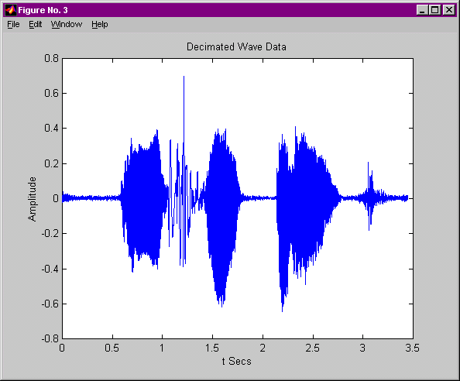
title('Decimated Wave Data');
xlabel('t Secs'),ylabel('Amplitude');

Number of samples = 37994
figure(4);
plot(Ydec); % Plot new signal verses samples
title('Decimated Wave Data');
xlabel('Samples n'),ylabel('Amplitude');

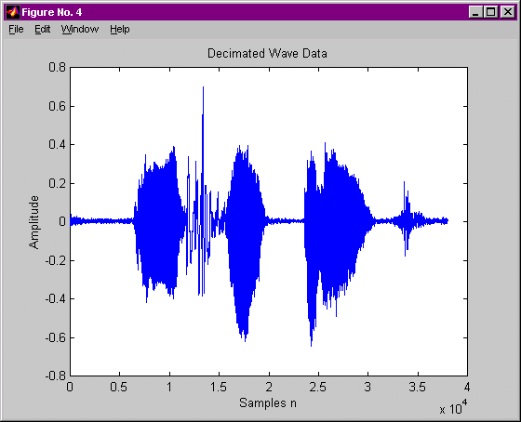

Question #4

Voice max frequency is 5000 Hz.
Sampling frequency most be at least twice the highest frequency sampled
Since 11,025 is greater then 2*voice max freq. then no lose of data occurs

Any signals greater then 5512.5 Hz sampled will not be appropriate.
Examples: CDs
Question #5

It is desirable to have the noise eliminated from the beginning and end of the signal. If a point is selected at the beginning of the signal then the data (noise) before it can be removed, same for the end point. The Matlab function GINPUT uses the mouse to select X number of points from the graph. If X = 2, then the 2 points are select the signal can be can shortened to the data between the 2 points. This code block does just that.

display('Select two end points to remove noise');
[xcoord, ycoord] = ginput(2);
xcoord = round(xcoord);
xcoord = sort(xcoord);
Z=Ydec(xcoord(1):xcoord(2));
nshortsamples = length(Z)
figure(5);
plot(Z); axis([0,nshortsamples,min(Z),max(Z)]);
title('Shortened Wave Data');
xlabel('Samples n'),ylabel('Amplitude');

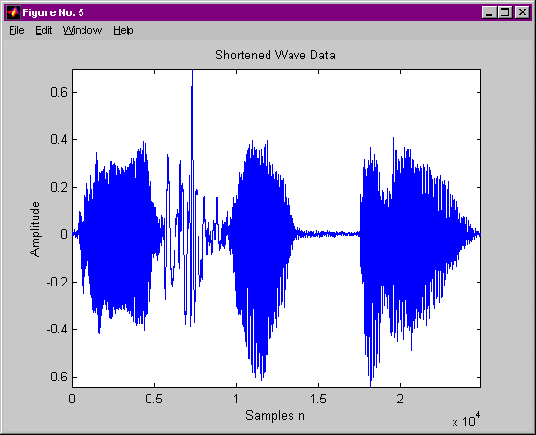

Number of Samples = 24886

Question #6

This code block saves the edited signal to a wave file called we_away_11025.wav not correct file name and plays the signal.

wavwrite(Z, FSdec, WAVBITS, 'we_away_11025');
pause(3);
playsnd(Z, FSdec, WAVBITS);

When compared to the original, the High Frequency Noise seems to be Removed.
No other differences can be perceived.
Question #7

Again using GINPUT to select 2 points, the /IY/ utterance from “We” was selected from the signal and saved to the array IY, which was plotted verses samples.

[xcoord, ycoord] = ginput(2);
xcoord = round(xcoord);
xcoord = sort(xcoord);
IY=Z(xcoord(1):xcoord(2));
figure(7);
plot(IY);
title('IY Data');
xlabel('Samples n'),ylabel('Amplitude');
pause(3);
playsnd(IY, FSdec, WAVBITS);
nIYsamples = length(IY)

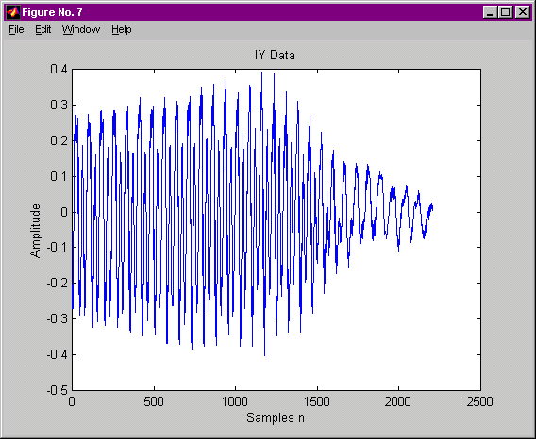

Number of Samples = 2409
Question #8

Zooming in on the /IY/ signal, it can be seen that the signal looks quasi-periodic. This is because of the opening and closing of the

zoom
display('Select zoom in on IY to select quasi period');
pause;
[xcoord, ycoord] = ginput(5);
xcoord = round(xcoord);
IY_per_n(1) = abs(xcoord(1)-xcoord(2));
IY_per_n(2) = abs(xcoord(2)-xcoord(3));
IY_per_n(3) = abs(xcoord(3)-xcoord(4));
IY_per_n(4) = abs(xcoord(4)-xcoord(5));
IY_per_n_avg = mean(IY_per_n)
IY_per_t_avg = IY_per_n_avg / FSdec
IY_freq_avg = 1 / IY_per_t_avg

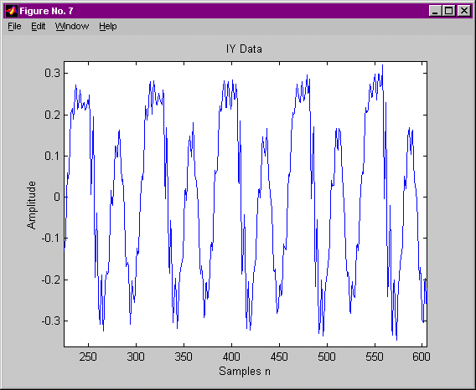
Duration of /IY/ (in samples) =

75.2500

Duration of /IY/ (in seconds) =

0.0068

/IY/ frequency (Hz) =

146.5116

Question #9

The diphthong /eI/ from “away” was selected from the signal using the GINPUT function. The new signal was saved into array eI.

figure(9);
plot(Z);
[xcoord, ycoord] = ginput(2);
xcoord = round(xcoord);
xcoord = sort(xcoord);
eI=Z(xcoord(1):xcoord(2));
plot(eI);
title('eI Data');
xlabel('Samples n'),ylabel('Amplitude');
pause(3);
playsnd(eI, FSdec, WAVBITS);
neIsamples = length(eI)

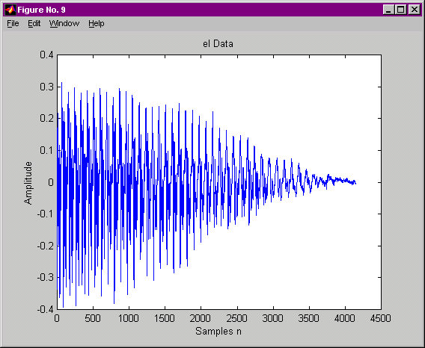

Number of Samples in /IY/ = 4034

Question #10

Using the zoom function in Matlab, it can be shown that the signal is quasi-periodic.

zoom
display('Select zoom in on eI to select quasi period');
pause;
[xcoord, ycoord] = ginput(5);
xcoord = round(xcoord);
eI_per_n(1) = abs(xcoord(1)-xcoord(2));
eI_per_n(2) = abs(xcoord(2)-xcoord(3));
eI_per_n(3) = abs(xcoord(3)-xcoord(4));
eI_per_n(4) = abs(xcoord(4)-xcoord(5));
eI_per_n_avg = mean(eI_per_n)
eI_per_t_avg = eI_per_n_avg / FSdec
eI_freq_avg = 1 / eI_per_t_avg

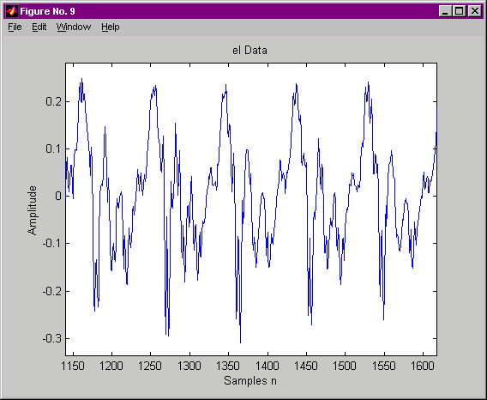
Duration of /eI/ (in samples) =

91.5000

Duration of /eI/ (in seconds) =

0.0083

/eI/ frequency (Hz) =

120.4918

Conclusion:

From this project it was shown that the maximum frequency is 5,000 Hz and that the 11,025 Hz sampling rate is significant. The vowel and diphthongs were proven to be Quasi-Periodic. Techniques for removing noise and selecting speech items by hand were applied.

The following Matlab functions were introduced:

- wavread - used to read a wave file into an array.
- wavwrite – used to write a array to a wave file.
- playsnd – Plays a given vector.
- decimate – reduces the signal to a lower sampling rate
- ginput – selects N number of points from a graph using the mouse.

