Vladi Gergov
History 102
Professor Clark
December 5, 1999

Changes in Western Attitudes Toward Death

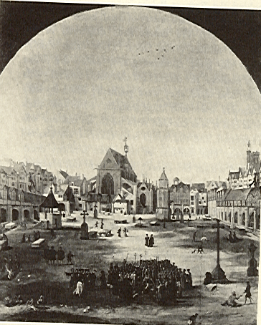
Death is the only constant in the world. It is the variables and the ways that we as human beings view death that have changed over time. Phillippe Aries a French writer describes these views and variables in his book called Western Attitudes Toward Death. He classifies these changes and/or attitudes toward death under four distinct categories. These categories are Tamed, One’s Own, Thy, and Forbidden Death each having its own period in time.
Tame death being the first of the four and starting at around the year seven hundred where death was a ritual organized by the dying person himself. Death was a public ceremony where the dying man’s chamber became a place to be entered freely. It was a necessity that parents, friends, and neighbors be present during his final moments. In this chamber the dying person prepared for passing to eternity by praying and laying in such a way that his head faces east, toward Jerusalem and his arms stretched forming a cross.
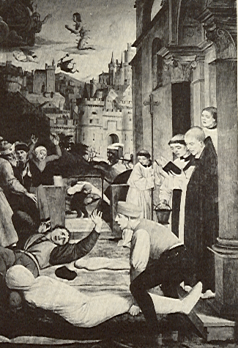
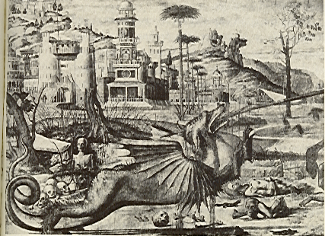
One’s own death, the second classification is a gradual and subtle modification of tame death in which few things experience any change. Like in tame death the dying person is still in control of the ritual. Death is still a public ceremony and everyone is welcome to attend. The major changes during this period starting at around twelve hundred are four in number. First major change was the portrayal of the Last Judgment at the end of the world. Second change was the displacing of the Last Judgment at the end of the world to the end of each life. In particular the Last Judgment wood take place in the bedchamber around the deathbed. In that moment of death there is a struggle between the forces of good and evil who are fighting for possession of the dying man’s soul, and he watches this battle as an impartial witness, though his soul is the prize. Third major change was the appearance of the cadaver in art and literature at that time period. This was due to the horror of physical death. Aries uses sixteenth-century poetry and art to prove this (41). Lastly the return of funeral inscriptions and certain personalization of the tombs. This change was due to the desire to preserve the identity of the tomb.
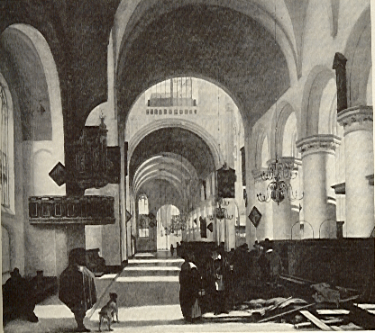
Thy death, the third attitude toward death is a period around the sixteen hundreds where views of death dramatically changed. A person was less concerned with his death than with the death of the other person. This inspired “in the nineteenth and twentieth centuries the new cult of tombs and cemeteries and the romantic, rhetorical treatment of death” (56). During this time death was greatly associated with love. Aries gives many examples of this, one being the paintings of Hans Baldung (56). Death was compared to a sexual act, which tears man from his daily life. Here the evidence is J. Rousset (57). Death had become neither obsessive nor frightening it remained familiar and tamed. Death soon passed into a description of being admirable in its beauty which many authors wrote about like Mark Twain and Bronte (58). Another great change concerns the relationship of the dying and their family. Until the eighteen-century death was the concern of the dying therefore it was up to each person to express his ideas, feelings, and wishes in a form of a will. Then a second major change occurred in which the will was reduced to a legal act that distributed wealth. Proof for this can be found in Michel Vovelle writings (64). In the Middle Ages mourning had become a distinctive part of the ritual. This suggested that the survivors accepted the death of another person with greater difficulty than in the past. Also change in burial ground occurred. The accumulation of the dead within the church became intolerable and the flooring of churches, which were saturated with cadavers, constituted a violation of the dignity of the dead.
The last classification is forbidden death in which death and all notions of death change dramatically. Death becomes shameful and forbidden. First the avoidance of the dying for society’s sake and the sake of those close to the dying person. This was brought upon because of the ugliness of the dying and the presence of death in the midst of happy life. Nothing had changed in the rituals of death but in the displacement form the home to a hospital. No longer was the dying person in control of the ritual it was the doctors and nurses around him. Examples of this can be seen in Geoffrey Gorer’s writing. This notion of interdicting death in order to preserve happiness was born in the United States around the twentieth century.
The attitude toward death has changed because of the way religion has affected mans way of thinking. In the past religion was deeply rooted in the people. Toady science has replaced religion in many ways. One of which is the answer and explanation to questions. How we look for an explanation to questions and try to gather facts and come to our own conclusions not just “take your word for it”. Why do we die is a question answered by religion and science but what happens after we die is only answered only by religion. The fear that comes from not being able to answer that question with scientific proof has changed our attitudes toward death over time.

