Final Project Report

IMSE 381L – Fall 2002

Professor: Dr. Yubao Chen

Lab Proctor: Jeremy Winters

Group: Tuesday Group # 3

Members: Brian Romack, Adam Lepczek, Vladi Gergov, Brandon Harris



RESISTOR TESTING AND QUALITY ASSURANCE ROBOT WORK CELL

Table of Contents
Objective: 3
Method: 4
Problems Encountered: 5
Instructions: 6
Safety Instructions: 7
Hardware List: 9
Electrical Schematic(s): 10
Pictures of Project: 11
Partner Evaluations: 17
Program Code: 18

Objective:

To design, build, program and troubleshoot a robotic system to select resistors from a delivery tray, move the resistor to a testing station, test the resistor, and classify based upon the resistance value of the resistor into one of 3 bins.

Method:

The resistors are delivered to the robot in a delivery tray with the resistors spaced equally. The delivery tray is loaded into the robots work cell before the robot is started.
When the robot is started by depressing the start button on the control panel, the robot moves to pick up the first resistor. This is handled in the main program entitled “FINAL”.
To pick up the resistor, we chose to use an electro magnet. The output from the controller is sent through a 12 VDC coil relay to switch on 110 VAC current to the coil mounted on the end of the robots wrist. This causes the resistor to be pulled up onto the robots end effectors. Program execution moves to the “GETRE” subroutine to pick up the resistor.
After picking the resistor up, the robot moves to the testing station. The testing of the resistor is done in the program entitled “TESTR”. The test circuit consists of a circuit which is operated by dual reed relays (See Circuit Schematic). Depending upon the resistance of the resistors, inputs # 6 and 7 will indicate the resistance range of the resistor using the following truth table:

Input 6 Input 7 Destination Bin Resistance Value
0 0 Reject Bin 10K ohms
1 0 Bin # 1 1K ohms
1 1 Bin # 2 10 ohms

The program will set the variable CHECK equal to the correct destination bin number for the resistor (4 for the reject bin). Program execution returns to the FINAL program.

Depending on the result of CHECK returned from the program TESTR, program execution will flow to the BIN1, BIN2, or REJEC program to drop the resistor into the correct bin. When the resistor is dropped into each of the bins, a proximity sensor is used to count the number of resistors placed into this bin for Quality Assurance purposes. After dropping the resistor (turning off the power to the electromagnet), the robot returns to the starting position if there are still resistors to be tested. After completing all of the resistors, program execution stops, and the operator may reload the delivery tray and start another sort routine.

There are two Emergency Action programs. One is for the Door Switch, called “DOORO”, to detect if there are any plant personnel in the work cell of the robot while it is operating. The other program is to stop execution if the Emergency Stop button is pressed, called “ESTOP”. For safety reasons, both of these outputs must remain in the ON position for robot operation to continue. This assures that if a wire is cut or broken, the robot will stop execution, assuring a failsafe operation.
When the appropriate switch is opened, either the ESTOP or the DOOR SWITCH, program flow moves to the appropriate program. Once here, a message is sent to the display, robot execution is stopped, and the alarm enunciator is turned on. The operator is asked whether they wish to resume operation. The program will continue to jump to the emergency programs until the door is closed, or the problem is fixed. If continue is selected, then the robot begins operation where it was previously stopped. If stop is selected, all robot actions are terminated and program execution stops.

Problems Encountered:

One of the first problems encountered was making an electromagnet that would pick up a resistor the same way each time. After some testing, a 120 VAC coil was settled on. This would give us problems which did not show up until final testing though. Because the coil was Alternating Current, the resistor would vibrate in the end effector. This caused problems when trying to test for the presence of the resistor in the end effector and when testing on the circuit tester. The idea of testing while in the end effector was abandoned after many attempts at holding the resistor steady finally worked, but we ran into further problems with the higher resistance resistors.
The higher resistance resistors were so high that the Robot Controller could not detect their presence. This led to the development of a test circuit for the presence of the resistor. This did not go well, and in the interest of time, the idea was dropped.
Another big problem was the recording of points. We first set up the points after the robot was homed, but it had been used after the home command was used, so that the points were off by a bit. But even after homing the robot and setting the points, after some use, the points drifted. And from day to day, the home position did not seem to be exactly the same. We marked the table and the layout on our board so that the same positions would be set up each time, but there were still some inaccuracies. In fact, if the program doesn’t work properly during the demo, this will be the problem. In the future, we would have picked a system were accuracy required is not that great. The wire-thin resistors are too small for this application.

Instructions:

- First, at the ACL load menu, load the program called “FINAL.CBU”
- Type RUN FINAL
- Load the delivery tray with resistors. They must be long enough to be supported by the side rails. The front of the delivery tray should be aligned with the alignment mark on the board (they are both marked with light blue dots). To verify the location of the delivery tray, have the robot go to position 22 (the first resistor) and then to position 29 (the last resistor)
- Make sure the bins are all empty. Place them on the appropriate positions marked on the board.
- Put the test circuit on the board in the correct position, also marked on the board.
- When you are ready to start the process, press the Green Start Button on the Control Panel (the computer screen will display the message “Press the start button to begin the testing routine…”
- The robot will get the resistors and test them, one at a time, until all eight are tested.
- Program will stop executing when complete. If you wish to restart and test another tray, go to Step 2 above and continue with the next set of resistors.

Safety Instructions:

First and foremost, never reach into the robot work cell when the robot is in motion. If it is ever desired to enter the work cell while the robot is operating, use the Estop procedure, as listed below. There are safety interlocks to prevent operation when the cell is in operation, as described below.

- Gate Safety Interlock
It is dangerous to be within the work cell while the robot is in operation. In order for the controller to know when there are people who have entered the work cell, there is a safety interlock on the entry gate to the robot work cell.
The safety interlock is a magnetically operated micro switch. For safety reasons, the switch is a normally closed type of micro switch. This is a failsafe technique of ensuring the safety of the work cell. The circuit will go open if the gate is opened, OR if the wire were cut or disconnected. If this had been a normally open switch, if a wire worked loose or was cut, the gate could be opened and the robot controller would not know this, allowing potential injury to the person or persons entering the work cell.
The system works like this: If the gate is opened, the micro switch will open. The controller detects this open circuit, and if the program is executing, a TRIGGER command has been set up so that program flow will stop and transfer to the DOORO program.
In the DOORO program, the robot motion is stopped by the use of the SUSPEND command. The alarm light is activated, alerting the person who opened the gate to know that they are not following correct procedures. A message is sent to the screen asking the operator if they would like to continue execution at the point it was stopped, or if they would like to abort program execution.
If abort is chosen, by pressing the “S” key, the STOP command is used to stop program execution and the robot is stopped where it last was. There are no further operations at this point. If it is desired to run again, you must start over at STEP 2 in the instructions. It is not necessary to reload the tray if it is not empty…the robot will skip over the positions in the delivery tray that do not have resistors.
If continue is chosen, AND the gate is closed, then the robot will start at the same point it stopped at by use of the CONTINUE command.

- Emergency Stop Safety Interlock
There are times when an operator, or any other person who sees a problem, will want to stop execution. To facilitate this, there is an ESTOP located on the control panel (labeled red with a STOP label above it).
The safety interlock is a simple switch. For safety reasons, the switch is a normally closed type of switch. This is a failsafe technique of ensuring the safety of the work cell. The circuit will go open if the button is pressed, OR if the wire were cut or disconnected. If this had been a normally open switch, if a wire worked loose or was cut, the button could be pressed and the robot controller would never receive the signal, allowing potential injury to the person(s) or equipment, or for whatever reason the button was pressed for.
The system works like this: If the button is pressed, the switch will open. The controller detects this open circuit, and if the program is executing, a TRIGGER command has been set up so that program flow will stop and transfer to the ESTOP program.
In the ESTOP program, the robot motion is stopped by the use of the SUSPEND command. The alarm light is activated, alerting the person who pressed the button to know that the signal was received and that the robot is stopping all operations. This is NOT a true Estop, because power to the robot was not stopped, only the program execution was stopped. A message is sent to the screen asking the operator if they would like to continue execution at the point it was stopped, or if they would like to abort program execution.
If abort is chosen, by pressing the “S” key, the STOP command is used to stop program execution and the robot is stopped where it last was. There are no further operations at this point. If it is desired to run again, you must start over at STEP 2 in the instructions. It is not necessary to reload the tray if it is not empty…the robot will skip over the positions in the delivery tray that do not have resistors.
If continue is chosen, then the robot will start at the same point it stopped at by use of the CONTINUE command.

Hardware List:

- 2 Relays, 12 VDC coils, 120 VAC 3Amps contact rating
- 4 Relay, 120 VAC coil, 120 VAC 3 Amps contact rating
- 2 reed relays and 1 1k ohm resistor for circuit
- 3 10 ohm resistors, 3 1k ohm resistors and 3 10k ohm resistors for testing
- 1 Magnetic Door switch
- 3 Proximity Sensors
- 1 AC magnetic inductance coil (for resistor pickup)
- 1 end effector body with metal contact detection arms
- 1 control Panel enclosure
- 2 Buttons, one for start and one for stop, with labels
- 1 Revolving Beacon light
- 4 Cardboard bins
- 1 Resistor Delivery Cart
- Resistors, assorted
- 1 Proximity Sensor
- Wooden table, split, with railings and wire mesh
- Related wiring, contact blocks, termination blocks, etc

Electrical Schematic(s):
Figure 1
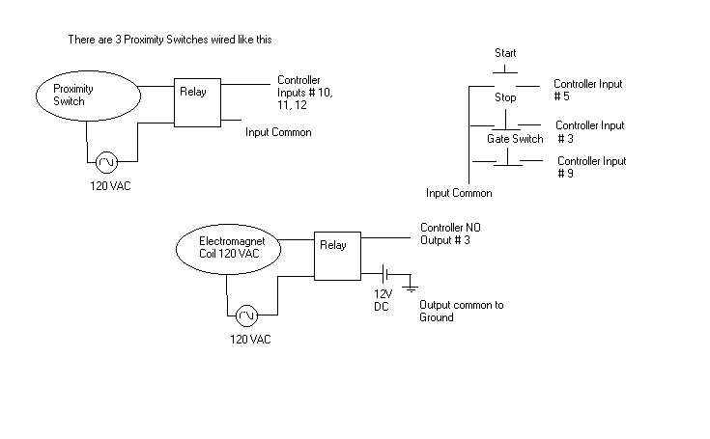
Figure 2
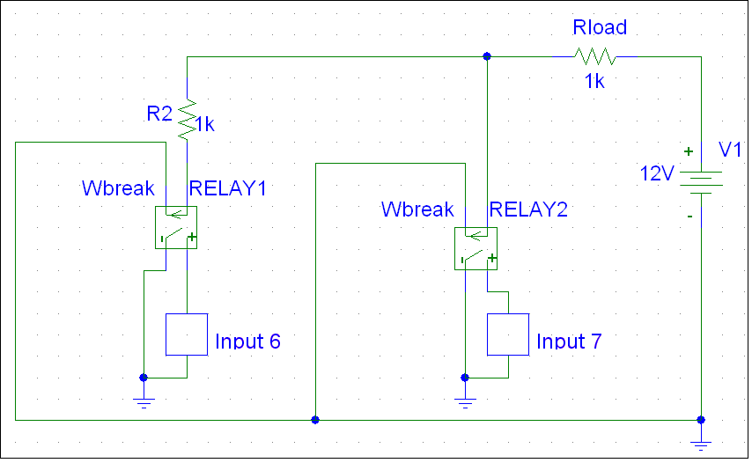

Pictures of Project:

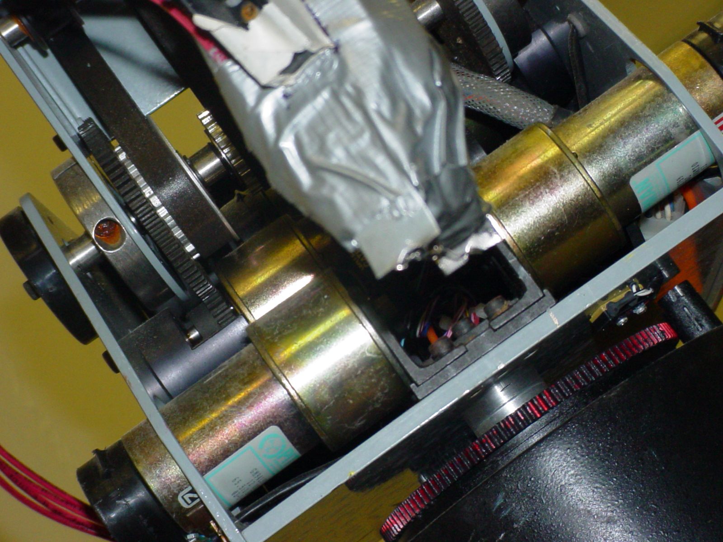
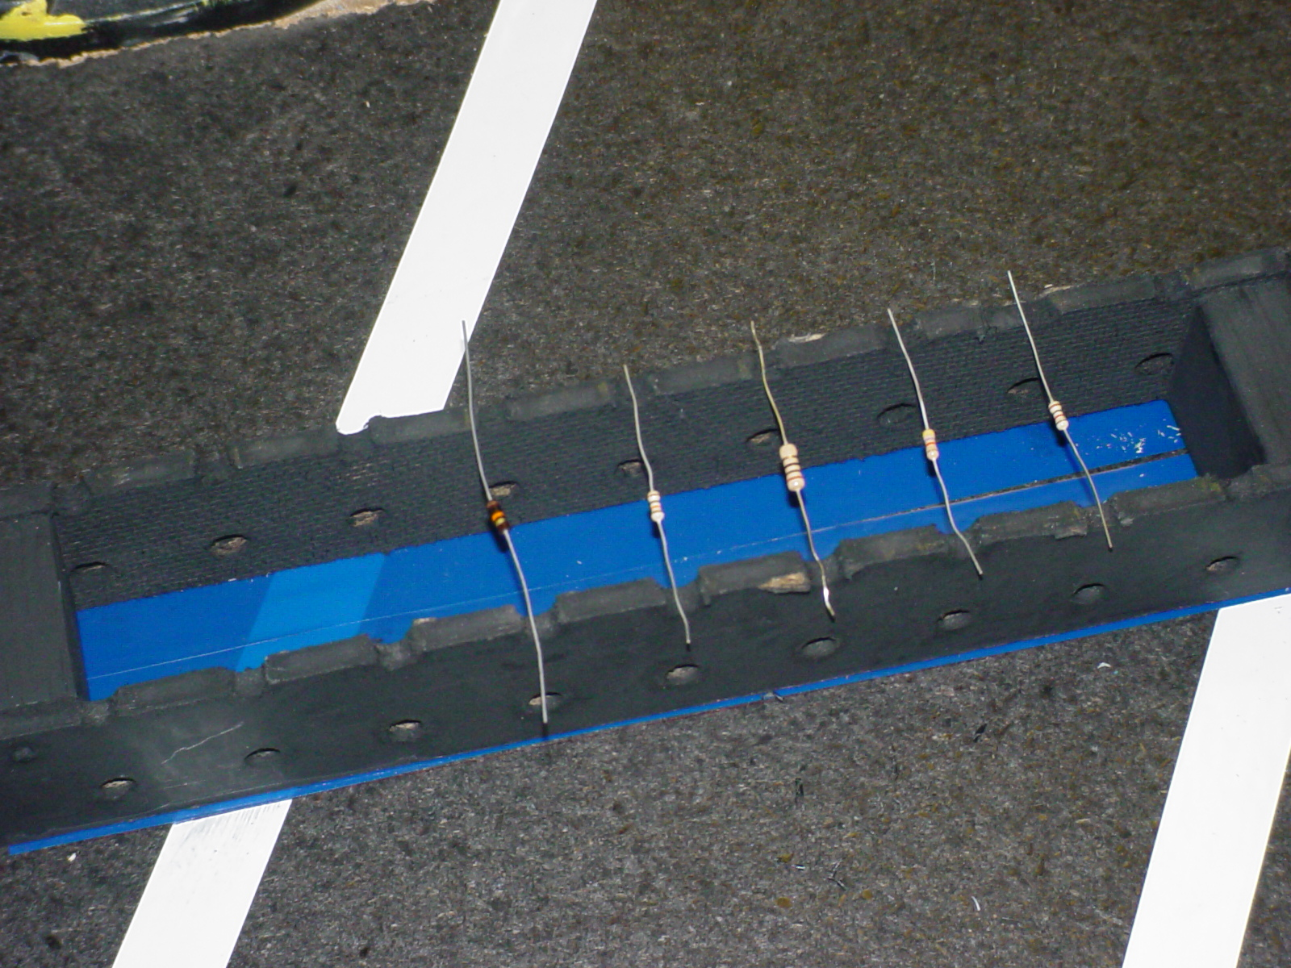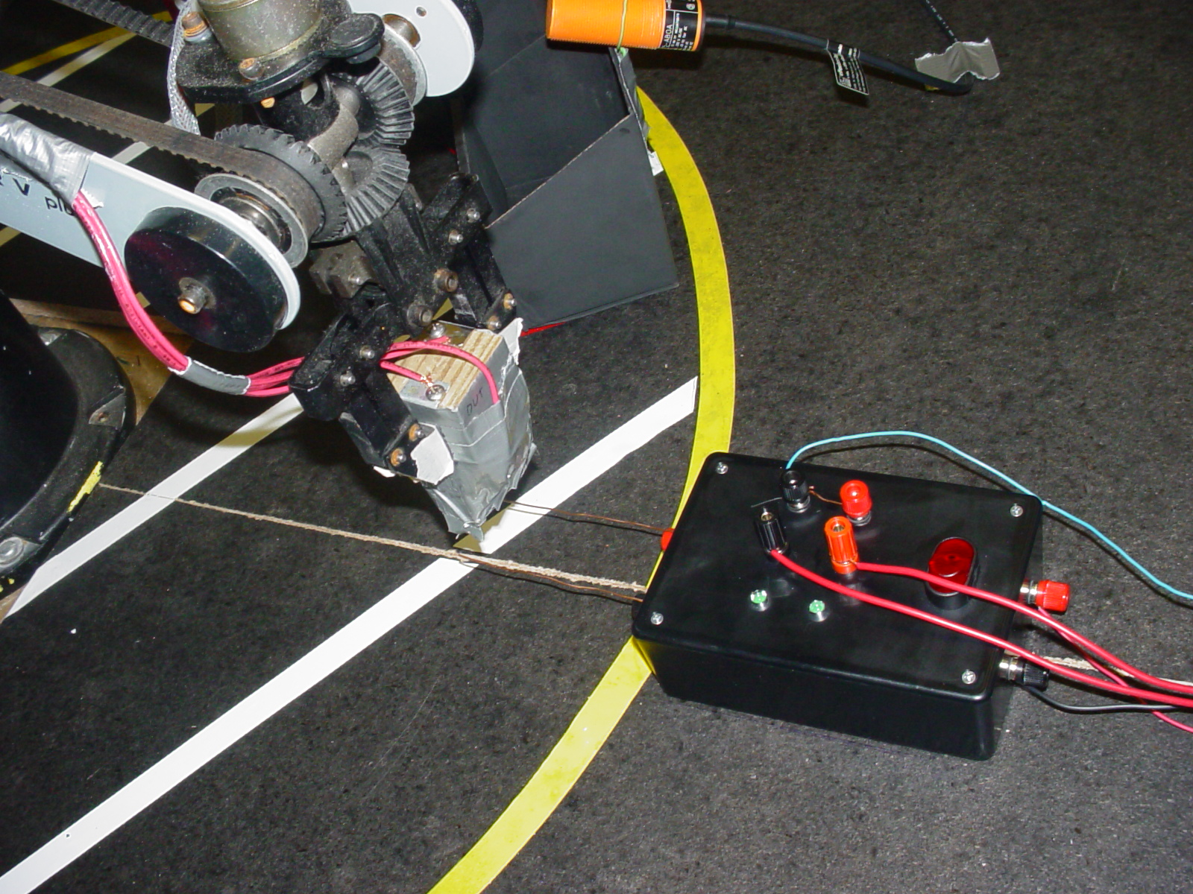

Partner Evaluations:

We split the work up into different parts and assigned people to work on these parts. This way, we could make better use of our time in the computer lab. Due to some of our schedules, we fell behind after missing some of the lab periods. We have all contributed to the project and it went well.

Program Code:

$v 1 RPOS 0
$v 2 A 0
$v 3 = 0
$v 4 ONE 2
$v 5 COUNT 2
$v 6 CHECK 1
$v 7 BIN1C 24
$v 8 BIN2C 13
$v 9 BIN3C 14
$l 10 REJECB 13
$v 11 REJEB 1
$l 12 USRINESTOP 115
$v 13 USRIN 115
$v 14 REJCT 0
$v 15 TOTRE 2
$v 16 REJP 0
$v 17 B1CT 0
$v 18 B2CT 0
$p 1 1 0 0 0 0 0 0 0
$p 2 1 20 3904 8145 -13635 -1076 1076 0
$p 3 1 21 4142 7549 -5696 -1143 1141 0
$p 4 1 23 -8251 9629 -12035 1505 3607 0
$p 5 1 22 -9153 9676 -11969 1505 3607 0
$p 6 1 11 -6085 4659 -8453 747 3226 0
$p 7 1 33 4368 10705 -7031 -1403 1084 0
$p 8 1 44 4368 12932 -7382 -1403 1084 0
$p 9 1 24 -7484 9744 -11957 1246 3486 0
$p 10 1 53 9244 9596 -7031 -1110 791 0
$p 11 1 63 9244 10315 -7837 -1110 791 0
$p 12 1 70 13234 9596 -7031 -1110 791 0
$p 13 1 71 13234 10585 -7990 -1110 791 0
$p 14 1 75 16987 9596 -7031 -1110 791 0
$p 15 1 76 16987 10210 -8088 -1110 790 0
$p 16 1 80 20871 8855 -7682 747 3226 0
$p 17 1 81 20871 10147 -9442 747 3226 0
$p 18 1 25 -6766 9791 -11816 1027 3282 0
$p 19 1 26 -6060 9864 -11648 929 3097 0
$p 20 1 27 -5334 9861 -11648 799 2933 0
$p 21 1 28 -4949 10032 -11323 567 2861 0
$p 22 1 29 -4354 10367 -10813 520 2910 0
$p 23 1 30 -4173 9529 -12216 384 2932 0
$p 1 2 00 0 0 0
$pr 1 MAIN
$pr 2 FINAL
$pr 3 GETRE
$pr 4 TESTR
$pr 5 BIN1
$pr 6 BIN2
$pr 7 REJEC
$pr 8 ESTOP
$pr 9 DOORO

PROGRAM MAIN
*********************

END

PROGRAM FINAL
*********************

* THIS IS THE MAIN PROGRAM
SET COUNT = 1
* THIS VARIABLE IS THE RESISTOR NUMBER
* BEING TESTED
SET REJP = 0
* THIS IS THE REJECTED % VARIABLE
SET TOTRE = 0
* THIS IS THE TOTAL # OF
* RESISTORS TESTED
SET REJCT = 0
SET B1CT = 0
SET B2CT = 0
* THESE ARE ALL TOTALS FOR
* EACH OF THE BINS
PRINTLN "Program is initialized."
PRINTLN
PRINTLN "Press the start button"
PRINTLN "to begin the testing"
PRINTLN "routine..."
WAIT IN[5] = 1
* Wait for the operator to press
* the start button.
* COUNT IS THE RESISTOR
* CURRENTLY TESTING
LABEL 3
TRIGGER ESTOP BY IN 3 0
* THIS IS THE ESTOP ROUTINE
TRIGGER DOORO BY IN 9 0
* THIS IS THE WORKCELL GATE SWITCH
LABEL 2
MOVED 11
GOSUB GETRE
IF COUNT > 8
GOTO 6
ENDIF
* GET THE RESISTOR
GOSUB TESTR
* TEST THE RESISTANCE OF RESISTOR
* AND SET VARIABLE 'CHECK'
* EQUAL TO THE BIN # TO SEND TO
IF CHECK = 1
GOSUB BIN1
ENDIF
IF CHECK = 2
GOSUB BIN2
ENDIF
IF CHECK = 3
GOSUB BIN3
ENDIF
IF CHECK = 4
GOSUB REJEC
ENDIF
IF COUNT > 8
LABEL 6
PRINTLN "All resistors have been tested."
PRINTLN
PRINTLN "Out of " TOTRE" resistors,"
SET REJP=100 * REJCT
SET REJP=REJP / TOTRE
PRINTLN REJP"% were defective."
PRINTLN "Bin 1 had " B1CT
PRINTLN "Bin 2 had " B2CT
PRINTLN "Reject bin had " REJCT
STOP
PRINTLN
ENDIF
SET COUNT=1 + COUNT
PRINTLN
PRINTLN
GOTO 2
END

PROGRAM GETRE
*********************

PRINTLN "Picking up Resistor # " COUNT
LABEL 1
IF COUNT > 8
GOTO 5
ENDIF
IF COUNT = 1
MOVED 22
ENDIF
IF COUNT = 2
MOVED 23
ENDIF
IF COUNT = 3
MOVED 24
ENDIF
IF COUNT = 4
MOVED 25
ENDIF
IF COUNT = 5
MOVED 26
ENDIF
IF COUNT = 6
MOVED 27
ENDIF
IF COUNT = 7
MOVED 28
ENDIF
IF COUNT = 8
MOVED 29
ENDIF
SET TOTRE=1 + TOTRE
SET OUT[3] = 1
* Out[3] turns on the Electromagnet
MOVED 11
LABEL 5
END

PROGRAM TESTR
*********************

PRINTLN "Moving to Testing station."
MOVED 33
MOVED 44
* Here is where we test the resistor and
PRINTLN "Testing resistor..."
* Delay while awaiting the result
DELAY 200
IF IN[6] = 0
IF IN[7] = 0
SET CHECK = 4
ELSE
SET CHECK = 1
ENDIF
ELSE
SET CHECK = 2
ENDIF
MOVED 33
END

PROGRAM BIN1
*********************

PRINTLN "Resistor # " COUNT" is a 10"
PRINTLN "ohm resistor."
PRINTLN "Placing in Bin # 1"
MOVED 53
MOVED 63
DELAY 200
IF IN[10] = 1
SET B1CT=1 + B1CT
ENDIF
SET OUT[3] = 0
* Turn off the electromagnet and drop res
MOVED 53
END

PROGRAM BIN2
*********************

PRINTLN "Resistor # " COUNT" is a 10k"
PRINTLN "ohm resistor."
PRINTLN "Placing in Bin # 2"
MOVED 70
MOVED 71
DELAY 200
IF IN[11] = 1
SET B2CT=1 + B2CT
ENDIF
SET OUT[3] = 0
* Turn off the electromagnet and drop res
MOVED 53
END

PROGRAM REJEC
*********************

PRINTLN "Resistor # " COUNT" is OUT"
PRINTLN "OF RANGE - REJECTED."
PRINTLN "Placing in REJECT BIN"
MOVED 75
MOVED 76
DELAY 200
IF IN[12] = 1
SET REJCT=1 + REJCT
ENDIF
SET OUT[3] = 0
* Turn off the electromagnet and drop res
SET REJEB=REJEB + 1
MOVED 53
END

PROGRAM ESTOP
*********************

PRINTLN "THE ESTOP WAS PRESSED ! !"
SET OUT[4] = 1
SUSPEND FINAL
PRINTLN
PRINTLN "Press 'C' to Continue"
PRINTLN "Press 'S' to Abort"
GET USRIN
* Wait for operator to enter
* either continue or abort
IF USRIN = 99
CONTINUE FINAL
SET OUT[4] = 0
ENDIF
IF USRIN = 115
SET OUT[4] = 0
STOP
ENDIF
TRIGGER ESTOP BY IN 3 0
CONTINUE FINAL
END

PROGRAM DOORO
*********************

* This is the Subroutine which
* executes when the gate for
* the workcell opens
PRINTLN "THE GATE WAS OPENED ! !"
SET OUT[4] = 1
SUSPEND FINAL
PRINTLN
PRINTLN "Press 'C' to Continue"
PRINTLN "Press 'S' to Abort"
GET USRIN
* Wait for operator to enter
* either continue or abort
IF USRIN = 99
CONTINUE FINAL
SET OUT[4] = 0
ENDIF
IF USRIN = 115
SET OUT[4] = 0
STOP
ENDIF
TRIGGER DOORO BY IN 9 0
CONTINUE FINAL
END
(END)

