1. Introduction
In modern era, machine vision systems are playing an important role in the manufacture of products. Cost benefits can be realized with this technology through the reduction of personnel and more expedient and accurate quality inspections. Machine vision systems require suitable lighting conditions that will produce the best image with respect to feature contrast. Certain applications in industry require the ability to precisely control these lighting conditions efficiently and effectively. The lighting toolbox is a compilation of hardware and software applications designed to meet a variety of machine vision lighting needs. If a machine vision system cannot perform its function effectively due to inadequate lighting conditions, bad parts may leave a plant costing a company time and money. The objective of the lighting toolbox project is a remotely controlled machine vision lighting system.
Three separate lighting controllers were chosen to meet the broad requirements installed systems typically need. Some applications require close inspections. An LED ring light system was built for this purpose. A four-channel incandescent lighting system was also implemented for other applications. The fluorescent lamp controller addresses applications requiring a large aspect ratio, such as an automobile windshield. The feature that makes this system unique is the ability to control the intensity of each system via the Internet. The user is provided with an actual picture of the viewing area while performing intensity adjustments. This system can be accessed from any ordinary personal computer that has an Internet connection.

2. Problem Statement
The project requirement is to design and implement three lighting control systems for typical machine vision applications. The first requirement was an incandescent lighting control system.
The design and implementation of a four-channel incandescent lamp controller was a challenge since this would be a high-powered lamp controller in the order of 200-250 watts. An efficient design was needed to minimize heat dissipation and provide good power efficiency. The requirement was that each channel be capable of controlling the intensity of a 50-watt halogen lamp. Each channel would have a range of control from full brightness to completely off. The intensity would be regulated via digital control through an imbedded system. An analog input channel on the embedded controller will monitor the voltage across each lamp and adjust the duty cycle needed to maintain the set point. MOSFET drivers will switch the lamp load. The design will condition these drive signals so that minimal heating occurs within the MOSFETS. The slew rate for the on and off transition time must be kept to a minimum. High current wiring techniques and good component cooling methods will be incorporated for this design.
The LED light controller will use a regulated 12 VDC power supply capable of delivering 50 watts at full load conditions. A MOSFET switch will also be implemented in this design. The control circuitry will operate mostly at TTL levels. Control circuits exist within the main controller to allow remote and local operation to be switched manually at the device. Status signals returned to the embedded controller will consist only of power supply voltage monitoring. Since LED's require a precise operating voltage, the integrity of this voltage needs to be monitored closely. A failure of the series pass regulator could produce damaging voltages at the output. An external warning indicator will signal the user when an excessive voltage exist and that the ring light head should not be plugged into the controller or should be disconnected quickly. The PWM signal will be generated by the embedded controller or can be internal generated by a local oscillator. The switching logic will be TTL only. Some CMOS or transistor logic may be required to interface the MOSFET driver to the TTL PWM signal. A high-performance comparator will be used to implement the over voltage detection logic. A strobing feature will be implemented to take trigger signals from an external source and send them back to the embedded controller where they will be modulated onto the PWM signal. This feature will also be available while operating the device in local mode. The ring light head contains an array of LEDS that will be modulated in parallel. Simple current limiting resistors are used for 12 VDC operation since the power supply is regulated.
The fluorescent controller, whose specific purpose will be applications with large aspect ratios, will operate at 40 KHz or more. The intent of this design is to make the lamp dimmable via the remote embedded system. An application specific integrated circuit (ASIC) will be implemented. International Rectifier provides such an IC. The range of control for this system is 5% to 100% of maximum brightness. This circuit will use an AC to DC conversion then a DC to high frequency AC conversion. The first conversion will provide a DC supply with a potential of about 300 V. A unique type of PWM signal generated by the ASIC will control the current to the lamp thus controlling the brightness. A half bridge controlled by the ASIC will supply the signals to the lamp during startup and normal operation. The circuit also contains a safety feature that turns off the high voltage should the lamp be unplugged by the user. Another key element in the fluorescent design will be an attachment that contains a circular fluorescent lamp inside a box with a diffuser on top (a shadow box) for back-illumination applications. The whole system should require no more than 50 Watts of power to operate. Conventional circuit board techniques will be used to construct this system except for the high voltage areas where techniques will to enhance safety.
All three controllers will be assembled in their own enclosures and be no bigger than a desktop computer. The embedded controller will be much smaller and require less power to operate. It uses PC-104 system technology and will run a LINIX operating system. An IO adaptor board attached to the PC-104 will provide the PWM signals for the three controllers and provide monitoring for the various status conditions. The controller will also provide the Internet interface to the system via it’s own internal NIC card. A WEBCAM will also be implemented as an aid to the user to adjust lighting adjustments via Internet control. Note that the embedded system can only control one lighting system at a time with the current design. No plans exist to do otherwise.

2.1 Tasks Assigned to Each Team Member

The design and implementation of the incandescent lamp controller was assigned to Nick Sitarski. Nick’s responsibilities included the design of the 200-watt four-channel lamp controller and computer interface. This system is a custom design. This task presented challenges since this system requires high-powered components and high current wiring techniques.
The design and implementation of the LED light controller was assigned to Blaine Thompson. Blaine’s responsibilities include the design of an LED light controller similar to those commercially available. This system is also a custom design. The challenging aspect of this task exists in fabricating a ring light assembly comparable to those commercially available and a strobing feature.
The design and implementation of the Fluorescent lamp controller was assigned to Brandon Harris. Brandon’s responsibilities included the design of a fluorescent light controller similar to those commercially available. The challenging aspect of this task exists in dimming the lamp down to 5% without the lamp extinguishing. Brandon’s responsibilities also include construction of a finished product that meets all the specified requirements of the design.
The embedded controller system design and implementation was assigned to Vladi Gergov. Vladi’s responsibilities include the installation and configuration of the PC-104 computer with a Linux based operating system. This system is the heart of the Internet control feature and also requires a WEB CAM for viewing area. Vladi’s responsibilities also include synthesis of the PWM signals for the lighting sub systems, including the regulation of the incandescent lamp controller.
The WEB page design and implementation was assigned to David Chronicle. David’s responsibilities included the implementation of a WEB page on the embedded controller, which will allow the user to control the lighting parameters of the applicable system. This user interface must send the appropriate commands to the embedded system as well as provide a simple user-friendly interface.

3. Design Choices and Performance Criteria

As with any design project, there were a number of design choices that had to be made. Some of the choices were trivial, whereas other influenced critical aspects of the project. The decisions made were based various criteria, such as performance requirements, hardware limitations, and time constraints.
The design choices for the lighting control systems were primarily driven by the requirements of the applications. The incandescent lighting controller being a high-powered low-voltage DC supply met the requirements for a switching type power supply. A series pass type power supply would be too inefficient thus generating a lot of heat. Since a computer would be required for the Internet control feature, the computer could perform the switching functionality.
The design choices for the LED lighting system were straightforward. LED’s cannot tolerate surges in voltage or current. These parameters must be carefully controlled. Also, the power requirements for this controller are much lower, on the order of 50 watts. Therefore a regulated series pass type power supply is suitable. Since the PWM signal must also be modulated with a strobe signal and a simple computer interface is required, TTL logic was implemented for ease of design. Standard TTL circuits can efficiently drive the computer interface cable being short in length.
The fluorescent lamp controller being a very complex design was best suited for an ASIC device. This chip greatly reduced parts count and could be implement within the time and budgets constraints of the project.
The embedded system hardware choice was the PC104 technology. The small rugged size fit the requirement for portable equipment as well as operation in a potentially harsh environment. Some machine vision systems are installed in plants were vibration and heat must be considered. The PC104 does not have a hard drive and can better tolerate these conditions. Linux was chose for the operating system due to stability and low resource requirements. This equipment may be installed in a hard to get to environment therefore reliability issues must be considered.

4. Design

4.0 Details of Design

Hardware Design:
The design of the project can be split between the hardware and software aspects. The hardware block diagram of the system is presented below in Figure 1. It provides an overview of every major hardware component in the system and how they are connected. In addition, it provides an indication of how a user interacts with the system.

Figure 1: Hardware Diagram




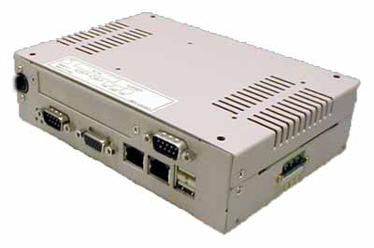
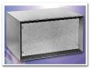
Client
Server
Web Cam
Incandescent Controller
LED Controller
Fluorescent Controller
Internet
Halogen Lamps
LED Ring Light
Ring Light
Tubular Light

Figure 2

As shown in the logical schematic the incandescent system consists of several components. Each component and or signal will be explained as follows:

- Center Tap Power Supply
  - The power supply takes in 120 volts (rms) AC and converts into an unregulated 13 volts to 18 volts DC. Each of the other circuits has a voltage regulator, if required, to obtain the required voltage of the circuit. The main power supply schematic is shown below.

Figure 3

- PWM Generator & Local / Remote Switch
  - The system has an option to operate in a local or remote fashion. When the switch is turned in the local directions the corresponding channel operates in local mode. The switch is in remote mode, the system uses the PWM signal from the micro controller. The 40 KHz Local PWM generator is shown below:

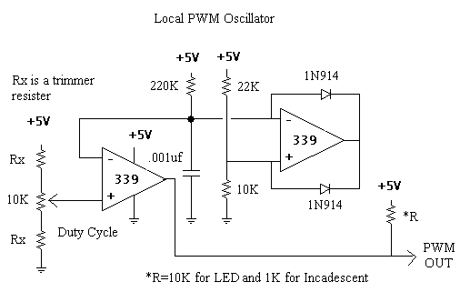

Figure 4
LPF & MOSFETs
  - The PWM signals feed the MOSFETs, which are connected to the low pass filter. The low pass filter is used so that the lamps see a pure DC component and not a PWM signal. This was achieved although there is a slight (in the100 mVolt range) ripple across the lamps; it is not a problem because the incandescent lights naturally act as a low pass filter. The result is the machine vision system sees a constant light level light. The schematic for the MOSFETs and the LFP is shown below:

Figure 5
Signal Conditioner
  - Finally there is a signal conditioner. In local mode, the voltage across the lamps in not regulated. The original plan for the project was to have the computer monitor the lamp voltages and automatically adjust the duty cycle of the PWM signal to maintain a constant voltage across each lamp. Although the hardware is in place, software support was not available. To be compatible with a normal analog to digital board the signal conditioner scales the voltage monitored across the lamps to a 0 - 5 V output. A typical differential amplifier was used in the scaling; a quad four op-amp (LM348N). The scaling circuit schematic is a follows:

Figure 6

Note: For each of the laps there is a separate signal conditioner, PWM generator, MOSFET, and filter.
LED Light Controller

The LED light controller consists of a 50-Watt power supply circuit, some switching logic, an alarm circuit, and a computer interface. The power supply is a linear type utilizing a 12 VAC (RMS) transformer and a series pass type regulator. The bridge rated at 25 A with a 100 Volt PIV rectifies this AC voltage.
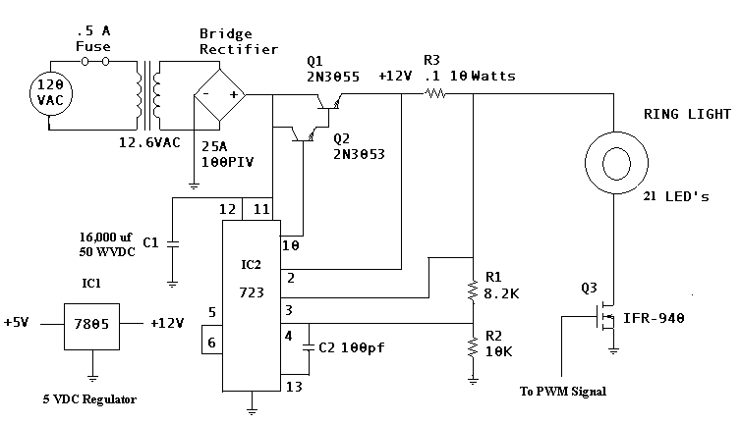

Although the continuous operating current is substantially lower than the 25 Amp rating, high current surges can exist when initially powering on the circuit. The large

Figure 9

Since the capacitor appears as a short circuit when initially charged and the time constant can be up to half a second or so, a larger than nominal current rating should be considered. A 6A bridge probably would have worked but the extra margin of safety didn’t cost extra. The capacitor was selected based on minimum ripple requirements, size, and cost. Since, the case was donated the added performance of a larger capacitor whose size was substantially large could not be cost justified. The series pass transistors consist of Q1 and Q2. The2N3053 is a driver transistor with a collector current rating of about 500mA. The maximum drive current out of the regulator IC1 is about 140mA. This transistor reduces the drive current requirements from IC1 substantially. Better regulation
can be achieved with a cooler operating chip. The 2N3055 handles the brunt of the load. It is rated at about 115 Watts and is a power semiconductor designed for these types of operating conditions. Although the free air dissipation is high enough to handle a switching load of 6 Amps a 30-watt heat sink was employed to extend the operating temperature of the system as a whole.
Frequency compensating capacitor C2 was added to reduce the gain at high frequencies to prevent any oscillations from occurring. The regulator is basically a small control system consisting of an amplifier, a voltage reference, and a feedback loop. An error signal is calculated from the voltage at IC1 pin 3 and the internal voltage reference, a 6.2 VDC zener diode. This error signal is amplified and is used to adjust the output at pin 10. R1 and R2 create a voltage divider that sets the output to the desired operating voltage. The empirical formula is: Vo≈7((R1+R2)/R2). Resistor R3 is part of the current limiting feature; the voltage across it is monitored y IC1 and is proportional to the current flowing through it. When this threshold voltage is reached the IC1s output is shut down. This value is calculated from the empirical formula: I_{sc}≈(0.66/R_{sc}).
The next design challenge is the TTL to MOSFET driver circuit. This was probably one of the most challenging aspects of this design since both devices operate at different voltages. The MOSFET requires a higher gate voltage for cool efficient operation than the 4-5VDC typically. An interposing transistor worked quite well. The 680-ohm resistor provided enough current to switch to MOSFET on quickly at full load current. The 2N3904 transistor was biased to operate in saturated mode to turn off the MOSFET. Testing up to this point utilized several different methods including open collector technology. As the switching load increases, so does the Miller Effect capacitance seen between the Drain to Gate. This changes the switching current requirements dramatically. The simple bipolar interface worked best.

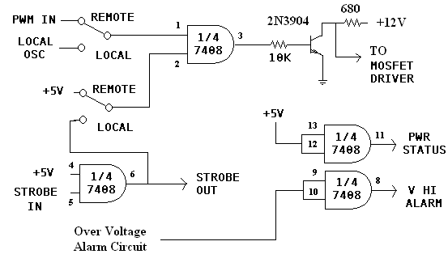

Figure 10

A DPDT switch is used to steer the MOSFET gate between the internal PWM oscillator and the PWM signal received from the remote computer. The other gates of the 7408 were used to provide TTL level outputs for the embedded controller. A +5VDC output is provided for power supply health status along with the over voltage alarm.
The over voltage alarm circuit was incorporated to monitor the output voltage should it exceed 12VDC. This is required since LEDs have a tight operating voltage tolerance. An external panel warning light was also incorporated to alert the user of a malfunction and not to plug the ring light into the unit.
The strobing signal is also sent back to the embedded system for future functionality through software control. It was initially proposed at the beginning of the project to provide a method to filter out a discrete amount of strobe signals giving the system user the ability the ability to trigger on let say ever fourth sample for inspection. Due to time and economic restraints this feature could not be implemented.
The over voltage alarm circuit uses a high performance LM-339 comparator. This chip was chosen since it is of a single supply type and has a very broad operating voltage,
from 3-32 VDC. Two were need since one is connected to the input of a 7408 TTL gate. When the exterior panel LED was tied directly to where the output is attached to the input leakage current would keep the LED lit, therefore a second comparator had to be used to drive both the LED and the TTL gate separately. The 15K pull-up resistor was required so no hanging inputs were present when the LM-339 switched off.
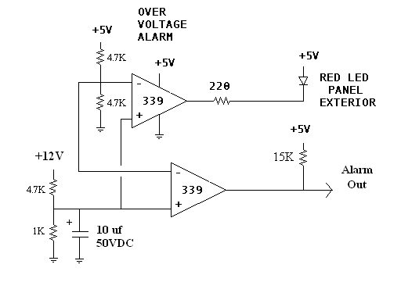

Figure 11

A capacitor had to be added to the reference leg across the 1 K resistor to provide extra filtering. When higher current loads were switched the ripple was enough to cycle the LM-339 on and off. This little fix worked quite well.
The final circuit in the LED light controller was added later in the project first to allow testing since the hardware was completed in advance of the software. This feature worked so well it was incorporated into the final design. This circuit gives both the Incandescent and LED light controllers the ability to operate in stand-alone mode. The circuit utilizes the LM-339 comparator, one as a saw tooth generator and the other as a comparator. The saw tooth generator has a period set by the .001uf capacitor and the 220K resistor. When the capacitor charges to the threshold voltage set by the 22K and
10K voltage divider, the output goes low thus discharging the .001uf capacitor to start the cycle again. The saw tooth signal goes to the comparator whose threshold voltage is set by the 10K potentiometer. How quickly the output turns on during the ramp cycle is proportional to the pulse width seen at the output, which in turn determines the duty cycle. The operating frequency of this circuit is about 40 KHz, which is ideal for machine vision applications.
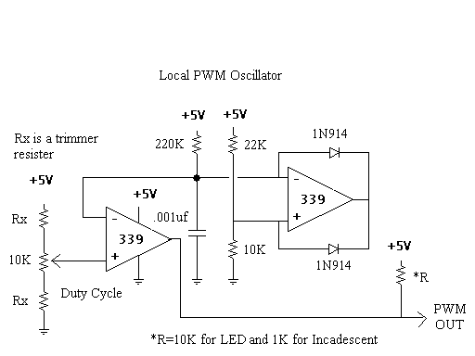

Figure 12

The ring light head was the most challenging to design and build due to its compact size and high lumen output requirements. 3000 MCD (micro candela) LEDs were used, 21 total. Several configurations for the current limiting resistors were evaluated and the best method turned out to be a parallel configuration. Since LEDs require about 2.0VDC minimum to turn on, the best range of control was achieved by operating them in parallel. Since 6 in series would have required 12VDC just to turn them on. A dark field illuminator was first attempted but no suitable method could be found to mount the LEDs at the critical 45-degree angle. Therefore a prototype circuit board was cut into a circle and components were mounted. This circuit was housed in a package made from plastic pipe. A 2” hole in the center provides an access port for the camera.

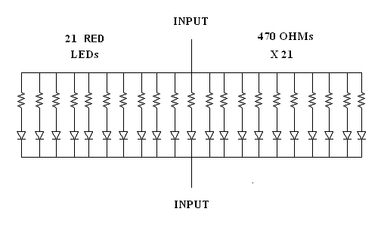

Figure 13

Total light output (In Lumens)

Solid angle of LED beam is first calculated as follows: 20°/2 = 10° and cosine of 10° is 0.0985 and 1 - 0.985 is 0.015. Next multiply by 2π to get 0.095 steradians. This value multiplied by 3.0 cd (MCD/1000) is .285 lumens per LED. So then 21 * .285 is 5.985 lumens total on an area of about 12 in².

Fluorescent Controller

LED lighting of large aspects is not efficient due to cost. Incandescent light is no problem with large aspects, but it is a warmer type of light. This means that it contains more red light and less blue light than a fluorescent light. For glass and plastics, blue rich light is better than a warmer light because you can see more details and it is easier to spot faults, cracks or imperfections. This makes fluorescent light ideal for inspecting windshields or other types of plastic and glass.
The design requirements for the fluorescent system were high frequency operation, frequency independent dimming and remote operation. Taking into consideration time constraints, a prototype configurable electronic ballast was used. The main reason this was selected was because it has the ability to be dimmed with a DC voltage ranging from 0.5 – 5 V. This would make it ideal for local or remote operation. The figure below is the schematic for the actual ballast used.

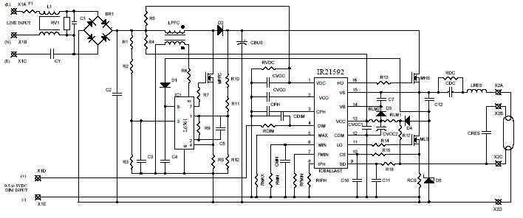

Figure 17

To illustrate how the circuit operates, a block diagram is given below. First, the line voltage is conditioned with an EMI filter. It is then to DC and applied to a power factor correction circuit. This part of the circuit is responsible for stepping up and regulating the DC bus voltage. It consists of a special type of transformer, called a pulse transformer; a MOSFET, diode, inductor and the L6561 IC to regulate the voltage as well as keep the power transfer as efficient as possible. The next section of the diagram is the output stage, which is controlled by the IR21592 IC. The output wave shape is created using two power MOSFETS. This half bridge configuration, when controlled by the IR21592, creates the necessary wave to power the fluorescent bulb.

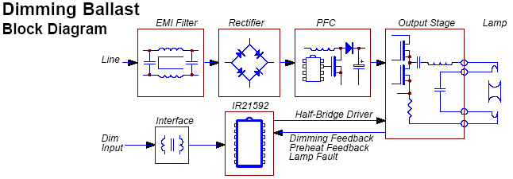

Figure 18

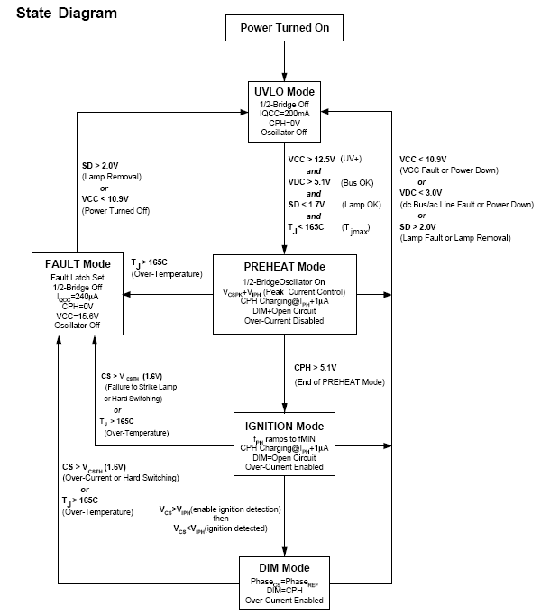

Figure 19: IR52192 State Diagram

The prototype electronic ballast allows you choose the parameters of operation for the fluorescent bulb. These parameters include bulb wattage, bulb diameter, min/max operating frequency, min/max percentage of dimming, preheat time, maximum current, max voltage and ignition voltage. After the parameters are decided upon, several equations are used to calculate component values. These components, such as resistors, capacitors and inductors; are used to affect the operation of the ballast, and fluorescent bulb. These components mainly tie in with the ballast IC input and output pins, but some of the components also tie in with the power factor correction circuit. Based on the parameters selected, the fuse value and bridge rectifier voltage rating could also change.
The equations used for specifying the component values for the ballast are difficult and time consuming to carry out by hand, so some design software was used to aid the process. This software was created by International Rectifiers to help calculate the values of the components. The component values below were calculated with the design software for a 32W, T8 fluorescent bulb. The frequency of operation was set to 51 KHz and dimmable down to 10% brightness.

Qty | Type | Value | Rating | Tolerance | Reference
1 | X2 Capacitor | 0.22uF | 275VAC |  | C1
1 | DC Bus Capacitor | 22uF | 250V |  | CBUS
1 | Capacitor | 220pF | 25V |  | CCS
1 | Capacitor | 0.1uF | 400V |  | CDC
4 | Capacitor | 0.1uF | 25V |  | CMIN | CVCC1 | CBOOT | CSD
1 | Capacitor | 0.27uF | 25V |  | CPH
1 | Resonant Capacitor | 0.01uF | 1500V | 5% | CRES
1 | Snubber Capacitor | 1.5nF | 630V |  | CSNUB
1 | Capacitor | 4.7uF | 25V |  | CVCC2
1 | Capacitor | 0.01uF | 25V |  | CVCO
1 | Y Capacitor | 2.2nF | 250VAC |  | CY
1 | Bootstrap Diode | 600V | 1A |  | DBOOT
2 | Bridge Diode | 1000V | 1A |  | DBRIDGE1 | DBRIDGE2
1 | Charge Pump Zener | 17V | 500mW |  | DCP1
1 | Charge Pump Diode | 1N4148 |  |  | DCP2
1 | Fuse | 2A | 250VAC |  | F1
1 | Dimming Control IC | IR21592 |  |  | IC BALLAST
1 | Common-mode Line Filter | 2x10mH | 0.3A |  | L1
1 | Differential-mode Line Filter | 470uH | 0.3A |  | L2
1 | Resonant Inductor | 2.1mH | 2.3 Apk | 5% | LRES
2 | Half-Bridge MOSFET | IRF720 |  |  | MHS | MLS
1 | Current Sense Resistor | 0.82 Ohm |  | 1% | RCS
2 | Resistor | 100K Ohm |  |  | RDC | RSD
1 | Resistor | 5.1K Ohm |  |  | RDIM
1 | Resistor | 39K Ohm |  | 1% | RFMIN
2 | Resistor | 20 Ohm |  |  | RHO | RLO
1 | Resistor | 1K Ohm |  |  | RLIM1
2 | Resistor | 10 Ohm |  |  | RLIM2 | RLIM3
1 | Resistor | 12K Ohm |  | 1% | RMAX
2 | Resistor | 27K Ohm |  | 1% | RMIN | RIPH
1 | Resistor | 1M Ohm |  |  | RPU
1 | Resistor | 270K Ohm | 400V |  | RSUPPLY
1 | Varistor | 470V |  |  | RV1
1 | Resistor | 1M Ohm | 400V |  | RVAC
1 | Resistor | 130K Ohm |  |  | RVDC

Figure 21

The dimming of the fluorescent light is achieved by sending a 0.5V-5V signal to an input pin on the IR21592. 5V corresponds to full brightness, and 0.5 V corresponds to the dimmest. Although the ballast is capable of dimming to 1 % brightness, it has been set to be dimmable to 10% and no lower. As you begin to dim the circuit, more and more current is drawn through the filaments of the bulb. At levels below 10% dimming, it may be possible to reset, or power cycle, the ballast because of the over-current protection feature built into the ballast IC. To illustrate what it would be like to calculate a parameter by hand, the equation to calculate the minimum and maximum brightness is seen below. To configure the ballast to dim to a minimum of 10% and a maximum of 100%, calculations had to be made using the equation below.
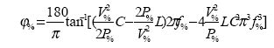

This calculation, and others used in specifying the requirements of the ballast are difficult to carry out by hand, which is why the design software was used to aid the process.

A type of phase interference achieves dimming the fluorescent light. The current can be modified to be anywhere from -90 to 0 degrees out of phase with the voltage that strikes the filaments. 0 degrees corresponds to maximum brightness. -90 degrees is used during preheat mode. This is done to lower the voltage to such a point that it will not ignite the filaments. Igniting a fluorescent bulb without preheating it can break the bulb as well as diminish the life of the bulb. To illustrate this, a figure is included below.

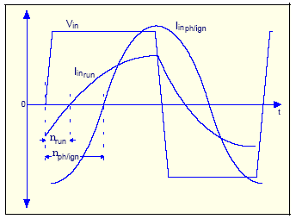

Figure 22

The fluorescent system control box contains the electronic ballast, a 5 V regulated power supply in conjunction with a potentiometer, and a low pass filter to convert the PWM signal from the embedded computer to an analog DC voltage. The schematic of the 5V power supply is illustrated below.
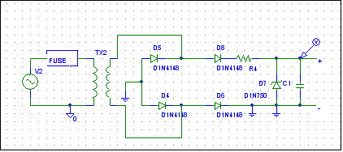
Figure 22

The transformer on the 5V power supply steps the voltage down to approximately 12.3V. This voltage is then rectified by the bridge diode configuration. The resistor helps limit current and allows the proper voltage to be dropped across the zener diode. The diode regulates the voltage to be approximately 5VDC. This voltage is then used with the potentiometer to adjust voltage between 0.5V and 5V. This voltage is read in by the dimming inputs on the ballast.
The ballast is protected by a 1.5 A slow blow fuse. The fuse is easily changeable because it is mounted right on the box. There are two modes of operation, remote and local. When operating in local mode, it is possible to control the brightness of the fluorescent lights on site, with a knob that controls a potentiometer. When the knob is turned, it adjusts the potentiometer, which in turn affects what voltage the dim input sees. If operated in remote mode, the potentiometer will not affect the dimming of the light. Instead, it will be controlled by a PWM signal, which is conditioned by a low pass filter. By making the cut off frequency 1 Hz, it is converted to a pure analog DC value. This is seen at the dim input to the ballast and controls the brightness of the bulb.

Embedded Computer / Software

After receiving the embedded computer the first thing that needed to be done was the installation of an Operating System. There are two choices for an Operating System, Microsoft Windows Variants or GNU/Linux. Windows software needs to be licensed which costs money. Windows also needs a significant amount of resources ( RAM, Processing Power, Storage space, etc.. ) which is not good for embedded applications. Windows is generally speaking a more unreliable and insecure Operating System. GNU/Linux on the other hand is an OSS/FS ( Open Source Software / Free Software ) which allows users the freedom to run the program(s) for any purpose, to study and modify the program(s), and to redistribute copies of either the original or modified program(s) without having to pay royalties to previous developers. GNU/Linux also has one of the smallest footprints for an operating system which is perfect for embedded applications. GNU/Linux is one of the most reliable, best performing, and flexible Operating Systems available. The choice was simple GNU/Linux was the perfect match with its speed, small footprint, and flexibility for an embedded computer. Now the that the Operating System was chosen the next step was to decide on an GNU/Linux distribution which is a pretty tough choice considering that there are more GNU/Linux distributions then GNU/Linux users. After doing extensive amount of research the choices were reduced to Redhat GNU/Linux, SuSe GNU/Linux, LFS GNU/Linux ( Linux From Scratch ), Gentoo GNU/Linux, and finally Debian GNU/Linux. For the comparison of all these distributions some features will have to be explained beforehand. Package management is an important feature of a distribution because in the OSS/FS world developers usually provide only the source code of their software. This source code is what is used to make the executable binary(ies). Now there are two options one is download the source code and use a compiler like gcc to compile and install the software or download a binary package that was pre-compiled by someone else and made it into an installable package. This package is basically a compressed archive of all the files generated by the compilation of the software's source code, instructions on where to put each file, and what other packages this package depends on. Packages can be compiled for different processor architectures like i386, i686, RISC, etc. and with different compiler optimizations. Once you have packages on the system dependencies come into play. Dependencies are requirements/conflicts resulting from software package installations. For example the apache web server package needs the glibc package and that package needs other packages etc. Dependencies can be handled good or bad depending on the distributions package manager. Redhat and SuSe are rpm binary distributions, which means that they use rpm ( Redhat Package Manager ) for their software packaging. This is a disadvantage because rpm does not handle package dependencies well. The packages are compiled for the i386 standard hence not optimized so that they are compatible with most x86 architectures. Both distributions are also very bloated and require a lot of storage space with the default install. On the plus side both distributions are commercially used, have a lot of support and have been extensively tested. The next distribution LFS or Linux From Scratch is really just a project that provides the user with the steps necessary to build their own custom GNU/Linux distribution. This will yield the most customized operating system for the embedded computer but it will also require extensive amount of time and testing. Gentoo GNU/Linux is related to LFS due to its package management system called portage which instead of using pre-compiled binary packages it downloads the source code of every program, compiles it while also resolving all the dependencies needed by that program and then records the details of the process in a world file which can then be used to uninstall and track software. Unfortunately this process takes a lot of processing power and is not the best idea when using an embedded computer unless the compilation is distributed to other machines on the network. Debian GNU/Linux combines the best of both worlds and therefore was chosen for the distribution on the embedded computer. Debian has a very good package manager called dpkg and has also the ability to make packages from source therefore squeezing every bit of performance for certain applications. Debian base install is very light weight taking up only around 130 MB of space. The base install involves configuring your hardware via kernel modules, partitioning you storage device(s), formatting the partition(s), installing the kernel and base system packages and some other minor configurations like time zones, keyboard layout, and network settings. The partitioning scheme used was a small 24 MB boot partition to hold the kernel and boot loader ( lilo ), around 256MB for a swap partition, and the rest for the root file system. The file systems chosen for each partition also required some research. EXT3 was chosen for the boot partition because the journal file which is used to keep track of writes is small in size. EXT3 is also widely used and recovery tools support it well. ReiserFS 3.6 was chosen for the root partition because it has a huge performance superiority over all the other file systems when operating on small file sizes and that is very useful if using a disk on chip flash device or a slow laptop hard drive. After the file systems were formatted the standard kernel and base system were installed. The embedded computer was now running Debian GNU/Linux. Next its time to compile and configure the custom Linux kernel. After downloading the source code from kernel.org two kernel source code patches were applied. The first being the preemptive patch which adds a far greater degree of real-time responsiveness to the standard Linux kernel, by reducing interrupt latencies while kernel functions are executing. The second was the low latency patch which basically does the same thing in a different way. Both of them ( figure 23,24 ) combined yield maximum scheduler latency value of 1.5ms compared to the stock kernel value of 232.6ms. Scheduler latency which is defined by webster.com to be "the interval between stimulus and response". In the context of the Linux kernel, scheduler latency is the time between a wakeup (the stimulus) signaling that an event has occurred and the kernel scheduler getting an opportunity to schedule the thread that is waiting for the wakeup to occur (the response). For an embedded computer this is really important and was one of the priorities. The reduced latency means that interrupts from the 37e12 i/o controller can be serviced faster. After the kernel patches were applied to the source code it was further optimized for the specific hardware of the embedded computer, compiled and installed on the boot partition. Now that the core of the GNU/Linux system was finished the next step was installing the necessary software packages. This includes apache ( used for web server ), dhcpd-server ( used for a DHCP server ), shorewall ( used for a firewall/router ), webcam ( used for webcam image capture ) and php ( used as a scripting language ). Apache and php are used to host the xhtml/css/php content which is the front end for the lighting toolbox. DHCPD ( Dynamic Host Configuration Protocol Daemon ) is used to provide the local network clients connected to the box with IP's in the same range as what the web server is running on. Shorewall is a very customizable firewall script and since security of the embedded computer is a priority a firewall is a must. Webcam was used to capture images from the camera via the usb device. All the above required configuration to meet our specific needs the most important being apache which had to be configured such that it only initially starts one process and gradually spawns more as requests to the web site increase until it reaches five and then refuses all request as to not bring the whole system down. Finally the embedded computer is ready for our front end. The front end is coded in CSS ( Cascading Style Sheets ), XHTML ( Extensible Hypertext Markup Language ), PHP ( PHP Hypertext Preprocessor ), and C. XHTML is a reformulation of HTML 4.0 in XML 1.0. XHTML is a new language for building web pages that has recently been proposed as a W3C Recommendation. CSS style sheets when attached to documents describe how the document is displayed or printed therefor changing the style or look of a web page only requires to change the style sheet. PHP is an open source, server-side, HTML embedded scripting language used to create dynamic web pages. The C program was the medium used for the website to directly interface to the 37e12 digital i/o board. The front end combined all of the above to provide a modular and dynamic web site which controlled the three lighting systems.

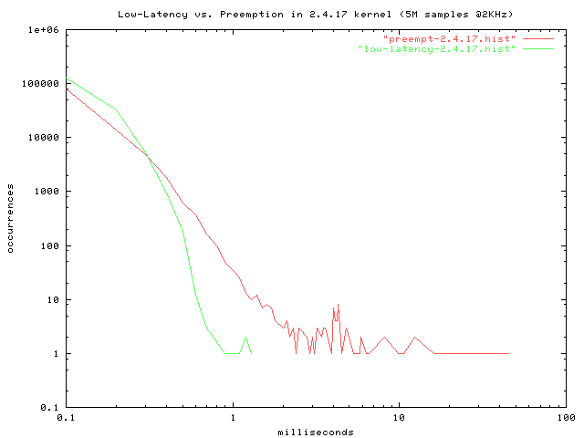
figure 23
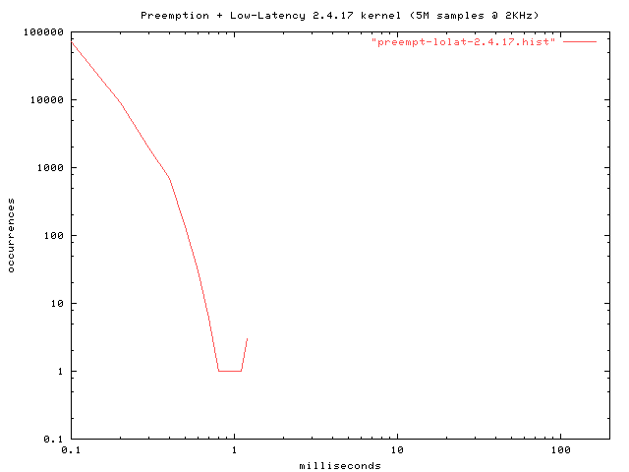
figure 24

Software Design Flow Chart:

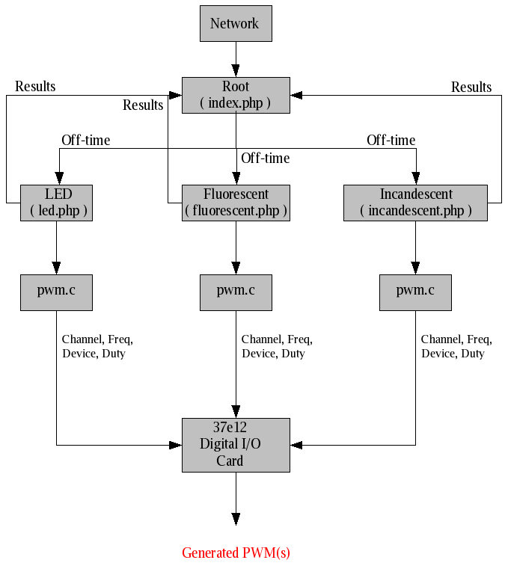

Figure 22

4.1 Design Tasks for Each Team Member

Nick Sitarski’s Design Tasks
Nick Sitarski spent the first semester of the project testing and evaluating the techniques for switching the high current halogen lamps. Nick had to design and construct a 20 A power supply to facilitate testing of the MOSFET switching circuits. Since no power source was available with this current rating. The wiring connections were difficult to implement on a prototyping board due to the high currents present. A great deal of time was spent on a design that would switch the MOSFET drivers fast enough to minimize heating effects. Several methods were evaluated with the most efficient was implemented. Wire size and fusing requirements were also evaluated during this first semester.
Due to the method of regulation, a signal conditioning circuit had to be designed and implemented. This circuit would measure the voltage across the lamp and provide a TTL level signal back to the computer.
A suitable method for assembling these components into an enclosure was challenging. Two fans were installed to provide a good amount of cooling to increase the reliability of the system.

Blaine Thompson’s Design Tasks

Blaine spent the first semester designing a 50 watt regulated 12 VDC power supply and MOSFET switch. A 12V 50-watt lamp was used to simulate the LED ring light. A local PWM oscillator was designed and built to test the circuit and was later incorporated into the final design. A test circuit was developed for over-voltage detection as well as a TTL to MOS interface. By the beginning of the second semester, a complete system was designed and installed into a commercially available enclosure.
An evaluation of commercially available LED lighting assemblies revealed a design around with 20 high output LED’s would be required. No vendor was willing to donate any assemblies or parts and the cost of purchasing a single unit was beyond the economic constraints of the project. An assembly had to be built by hand from scratch. This would prove to be the most challenging task of the LED light controller system.
The computer was straightforward since an effort had been made early in the project to develop a TTL to MOS interface.

Brandon Harris’s Design Task’s

Brandon’s first semester consisted of lots of research on the Internet to understand the complex operating characteristics of fluorescent lamps. Since his task was to develop a fluorescent lamp dimmable from 5% to full brightness for a machine vision application, a sophisticated solution would be required. A family of ASIC devices made by International Rectifier that would perform these functions was identified. Brandon had to integrate this ASIC to a computer interface and provide a local control as well. The fluorescent lighting section of the project consist of a shadow box, which is an enclosure with a 32W fluorescent ring light bulb, and a 48 in. straight 32–40 W fluorescent bulb. This device had to have frequency independent dimming and automatic restart, features which are readily available within this circuit. Minimal circuit modifications were required to get the ASIC to work in this application.
Brandon’s second semester task’s included integrated testing with the computer interface and the design, assembly, and testing of the circuit within a suitable enclosure.

Vladi Gergov’s Design Task’s

Vladi’s task was to develop the Linux platform for the lighting system. The Linux box is the brain of the Lighting Toolbox Internet interface. It will control pulse width modulation signals, along with providing health status, voltage status, console operation, and web service. The signals to the components are sent out of the digital I/O module, which will handle A/D conversions and the I/O of these signals. The box’s Ethernet and web server program will handle the control data from the Internet, through a user interface.
Vladi’s first semester task consists of purchasing and configuring the required hardware for the embedded system. Vladi had to build a daemon to run on the Linux operating system that will handle data IO. The next task was to build an I/O program that handles data traffic. This is the traffic between the digital and analog I/O controllers and the Linux operating system the next task was the capture of the web cam images and export to the web page.
The most challenging aspect of the software design turned out to be the interface between the HC12 interface card and the Linux operating system. To be specific the, XHTML 1.0/CSS 2.0/PHP4 with GNU/Linux integration, followed by the Linux Kernel 2.4.5 Patching/Configuration/Compilation.

David Chronicle’s Design Task’s

David’s first semester was spent assisting Vladi with system integration, research, and GNU/Linux installation of the embedded system components. David’s specific tasks did not start until second semester in which David stared working on the web page design.
A simple user-friendly design was required that would provide the capture video of the surveillance area and lighting subsystem control. The design for the systems controls was modularized according to function to facilitate future software maintenance.
The captured video screen shot and it’s associated command history log proved to be David’s most challenging task to implement.

4.2 Final System

4.3 Socio-Economic Issues

4.3.1 Detailed Cost Analysis

The lighting toolbox is intended to be sold as an integrated system. The system was deigned for simultaneous multiple sub-system operation. Therefore the cost analysis with concentrate on a total system cost as opposed to a detailed analysis of each system sub component.

Incandescent system

The total R&D will not be charged to the first customer therefore each Incandescent System will be sold for $2,900 ea including minor modifications. Expectations are to sell 20 units per year totaling $58,000.00 in sales; however, material for 20 units will be $14,166.40. Assembly for each unit will be 10 hours at $15 per hour equaling $150.00 per unit; this totals $3,000.00 per year. R&D expenses will be recovered within the first year of production.

Material cost associated with design on Incandescent system

Labor cost associated with incandescent system design

LED System

Each LED system will be sold for $2,600, which will include minor modifications. Expectations are to sell 20 units per year totaling $52,000.00 in sales; however, material for 20 units will be $8360.00.
Assembly for each unit will be 10 hours at $15 per hour equaling $150.00 per unit, this totals $3,000.00 per year. R&D will be paid for within first year.

Material cost associated with design on Incandescent system

Labor cost associated with LED system design

Fluorescent System

Total R&D will not be charged to the first customer. Each fluorescent system will be sold for $2,900, which will include minor modifications. Expectations are to sell 20 units per year totaling $58,000.00 in sales; however, material for 20 units will be about $10,757.40. Assembly for each unit will be 10 hours at $15 per hour equaling $150.00 per unit; this totals $3,000.00 per year. R&D will be paid for within the first year.

Material cost associated with design on Incandescent system

Labor cost associated with LED system design

Embedded System

The first 20 units will be priced higher to recoup R & D losses. Each micro controller System will be sold for $2,000.00. Expectations are to sell 40 units in the first year, which would be $80,000, less materials ($16,000) and labor ($3,000). This would give $61,000, minus R & D of ~$11,000, would give us a net profit of $50,000. Every lighting system sold needs a Micro controller to function properly.

Labor cost associated with Embedded System design

Total System Cost

 | LED | Incandescent | Fluorescent | PC104 | Total
Labor | $150.00 | $150.00 | $150.00 | $840.00 | $1,290.00
Materials | $418.00 | $73.32 | $537.87 | $800.00 | $1,829.19
Cost | $568.00 | $223.32 | $687.87 | $1,640.00 | $3119.19
Retail | $2,600.00 | $2,900.00 | $2,900.00 | $2,900.00 | $11,600.00

These numbers are based on R&D cost being recovered over a period of one year or after 20 units have been sold. Assuming each system can be assembled simultaneously, total system manufacture time would be approximately 12 hrs. The Linux box having the highest assembly time at 12 hours each, and only 10 hours each for the lighting controller sub systems, the Linux box is the most labor intensive. Other methods currently exist to drive this labor cost down such as mirroring the flash memory with a hard drive for production.

4.3.2 Economic Benefits and Societal Impact
One benefit of this system economically can be realized through reduced labor cost. The high cost associated with employee benefits along with the reliability of human inspectors is an area that is easy to improve. Higher quality products can result with automation. A machine vision sensor can detect flaws faster and more accurately than a person can. Although the Lighting Tool Box is not a complete machine vision system, it is an important subsystem.
Another economic benefit is the reduction of warranty issues due to poor quality parts leaving factories. The public will benefit from cost savings and higher quality products.
A societal impact can be seen through the application of a system such as this one in a hazardous area. The ability to make adjustments to a process without having to send people into an area such as this would potentially reduce the risk of injury thus increasing the safety of workers at these types of facilities.

4.4 Safety Issues

All Systems are enclosed within metal enclosures to conform national electrical Safety Codes. These electrical codes specify that all hazardous voltage must be confined within a UL rated enclosure. These hazardous voltages are dangerous to humans and every effort has been taken so that they are not directly accessible to the user. A placard has been place on the cabinet exterior to warn service personal of hazardous voltages inside. Insulated connecters have been used with heat shrink tubing covering these connections. All systems are fused to ensure short circuit protection. There are no significant ignition sources inside the enclosures and they are noncombustible. The enclosures are grounded to further reduce the potential for an electrical shock. Should a 120 VAC line potential contact the metal enclosure from inside the grounded case with provide a return path thus open circuiting the line fuse.

5. Test Results and Discussion
An integrated system test was performed Friday February 9, 2004. The results of the testing were satisfactory with some minor exceptions. The results of the test is listed in table 1.

Test Results
Local operation of lighting controllers was satisfactory. However, the range of control could be improved.
All three lighting controllers performed satisfactory via Internet control. Regulation of lamp brightness could not be tested for Incandescent controller. Software not complete.
For correct Fluorescent system operation the embedded controller must be isolated from ground. Fluorescent controller uses line operated power supply.

Table 1: Summary of Test Results

Conclusions

6.1. Executive Summaries

Nick Sitarski
The incandescent lighting system would be used when total aspect illumination is required for a machine vision application. Four 35-watt halogen light bulbs can be placed around an object that a camera is looking at. Each light’s intensity can be controlled locally or remotely via the Internet.
This system uses a linear power supply. The intensity of each light is controlled via a PWM signal. Within the system there are four local PWM generators running at 40 KHz. As the PWM signal changes an enhancement mode MOSFET switches the lamp on and off. As the MOSFET is switching it is through a low pass filter. Although the lights act as a low pass filter, and may not have needed an additional low pass filter, it was decided to use a low pass filter in order to get as close to a DC value across the lamps as possible. The light’s voltages have a slight ripple (in the 100 millivolt range). Due to no feedback control, a slight loading affect can be seen when operated in local mode.
When in remote mode the user adjusts the intensity of each lamp via the Internet. Once the user has the light at the correct intensity the microcontroller reads the voltage across the lamp and stores it. As the line voltage changes the microcontroller compares the voltage across each lamp to the stored value for each lamp. The microcontroller then adjust each of the four PWM signals to maintain the desired voltage across each lamp, in effect the microcontroller acts as a voltage regulator when operating in remote mode.

Blaine Thompson
The LED system is ideal for close proximity viewing. The PWM (pulse width modulated) intensity control provides a large range of control and efficient use of power. Some LED light controllers (currently in production) operate the LEDs at twice or more their current rating, by strobing (a pulse width typically of 100uS). Although this system does not have a way to adjust the operating current, it does have a manual strobing feature. A higher-powered commercially available ring light can be plugged directly into this controller, as long as it doesn’t consume more than 50 Watts of power. This controller is comparable in function and performance to those commercially available on the market.
The light head can be exchanged with another having a different chromatic spectrum or field of view. This gives the applications engineer considerable flexibility in obtaining the best possible image. Contrast ratio is important when performing software analysis on a captured image. The ability to control these parameters precisely, allows the system to find faint features in the product being inspected.
Since the primary goal of this project was to demonstrate the feasibility of precisely controlling lighting parameters over the Internet this project should be considered a success. All three light controllers functioned satisfactory via Internet control with a few exceptions. Except for the custom hardware developed for the lighting controllers, all the computer and Internet equipment was standard off the shelf products widely available.
Every manufacturing process is driven by quality and cost of production. This system enhancement can reduce cost through better quality control and the labor savings. It could allow an engineer to make lighting adjustments at a remote site half way around the world. One must consider the impact a new technology such as this could make in the machine vision lighting industry.
An extensive survey of this technology on the Internet identified no company is currently manufacturing products of this nature. The technology has been proven and is cost effective to implement, so the results are very positive.
Brandon Harris

The fluorescent illumination system in conjunction with the embedded Linux server and web cam, is used for wide-aspect ratio analysis and other types of flaw analysis. A fluorescent ring light application would be used with a shadow box, or a straight fluorescent bulb would be used. With the shadow box application, products could be passed above the ring light, creating a shadow. If there is a crack or hole in a product, light will emit through, exposing the imperfection. With the straight fluorescent bulb application, wide aspect-ratio flaw analysis can be done. The visible light emitted from the fluorescent light is rich in the blue spectrum, making it easier to detect imperfections. The lighting systems can be operated in two ways, remotely or locally. When operated remotely, the Internet will be used and a web page GUI will be the control interface. This provides the flexibility to control the operations of the box without having to be at the actual job site. When operated locally, all aspects of the fluorescent control box are controlled physically on site. This includes dimming, which will be physically adjustable on the control box.
The fluorescent light control box consists mainly of the prototype electronic ballast, which is completely programmable, making it possible to control the start up time, starting current, operating current, power, dimming amount of the light and frequency. The ballast also has automatic restart, over-temperature shut down and brownout protection. With the high efficiency of the fluorescent bulbs, and a power factor of 0.99 of the electronic ballast, it is ideal for low cost operation. The ballast will have to be configured for optimum performance of the machine vision application.
The dimming is controlled by an analog voltage of 0-5VDC. To affect dimming, phase shifting is used. Deconstructive phase shifting will cause it to dim, and when it is completely in phase, it will be at full brightness. The dimming can be controlled remotely via a PWM signal from the Linux server, or locally using a potentiometer and a regulated 5VDC power supply contained within the control box.
The fluorescent lighting control system benefits both industry and society. It saves industry money with low power consumption and low maintenance costs. Society benefits with higher quality products.

Dave Chronicle

The embedded controller is used to handle the communication between the Linux box and the lighting hardware. It is responsible for PWM signals, A/D conversion, and health status. These signals control the intensity of the light, the power regulation, and the operability of the lighting systems, respectively. It has dedicated PWM and A/D channels built onto the board for these applications.
The Linux box has control over it via programs written in C/C++. The Linux box is a small CPU system with a hard drive, Ethernet, a keyboard, and a mouse. In the design it is controlled either by command prompt operation at the computer itself, or via a web server that can issue commands to the Linux box to execute certain PWM and A/D programs. The web service can also take pictures via a web cam, which is used in lieu of an actual machine vision camera. The Linux box operates on a custom Linux build that was optimized for industrial usage, keeping its memory footprint down and its reliability up. The use of Linux over other operating systems was an easy choice because of Linux’s large user support groups, its modularity, its great stability, and its zero cost.
The Linux box is connected to the Internet or network via a CAT-5 Ethernet cable. This allows the user to make changes anywhere in the world to the lighting system. This also provides an easy to use web interface that is user friendly and allows instant PWM changing with the input of the desired value. The size of the entire Linux box and microcontroller is less then one cubic foot. This allows it to fit conveniently in an industrial environment, allowing it to be kept away from possible EMC problems.

Vladi Gergov

The control for the three lighting systems LED (Light Emitting Diodes), Incandescent, and Fluorescent is achieved with a small-embedded computer based on the PC/104 standard. This embedded computer operates at three hundred MHz and includes an on-board digital input/output expansion card designed around the Motorola HC12 micro-controller. Motorola's HC12 micro-controller provides the embedded computer with control over a multitude of digital/analog inputs and outputs. The input/output card is manipulated via a C program running on the GNU/Linux operating system. The C program configures the HC12 with PWM (pulse width modulation), frequency, and channels. PWM off time is determined by the user and is entered from a form on the embedded computer's website corresponding to each lighting system. The website in turn calls the C program via PHP script with the given light system variable, channel variable, frequency constant, and off-time variable. The corresponding lighting system then receives the synthesized PWM signal from the HC12 and corresponding lamp brightness is produced. Next the PHP script saves the previous screen shot of the lighting conditions and the previous values for the lighting system modified and PWM values modified, after which a new screen shot is taken of the current lighting conditions. The new home page is then dynamically generated to display “before” and “after” lighting conditions and “before” and “after” light system/off-times used. Then the website is ready to get new off-time values for the whole process to begin anew. This “remote control” process is the underlying idea for the entire design project. This is a very useful application that can save considerable cost by removing the need for an on-site engineer/technician if there is a problem and adjust the system periodically. The initial cost of the system will be high but the system will soon pay for itself and begin to reduce costs.

Appendix XXXX Incandescent System

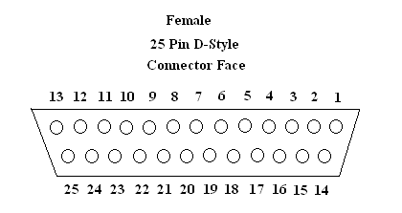

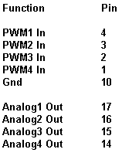

Figure 7

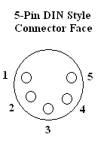
Figure 8

Appendix XXXX LED System

Figure14

For LED light output Pin-1 is +12VDC and Pin-5 is connected to the MOSFET.

Figure 15

For strobe input – Pin2 is Signal In and Pin-4 is Signal GND. Pin-3 is +5VDC.

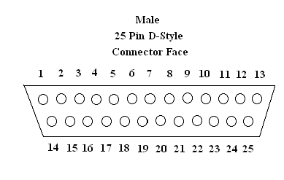

Figure 16

Function Pin

PWM In 3
Gnd 4
Strobe Out 2
Alarm Out 5
Pwr(+5V)Health 20

Appendix XXXX Fluorescent System

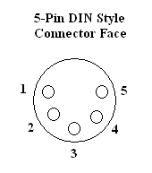
Figure 22

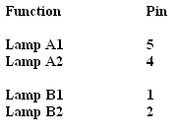

Figure 23

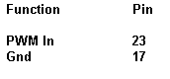

References

www.emacinc.com
www.linux.org
www.linuxfromscratch.com
www.ee.washington.edu/circuit_archive
www.keyance.com
www.nerlite.com
www.phoeniximaging.com
www.advancedillumination.com
www.oemagazine.com
www.whatis.com
www.sylvania.com
www.stancor.com
www.irf.com
www.howstuffworks.com
www.debian.org
www.thekrib.com/Lights/fluor-tech.html

