As shown in the logical schematic the incandescent system is made of several signals and components. Each component and or signal will be explained as follows:

- Center Tap Power Supply
  - The power supply takes in 120 volts (rms) AC and converts into an unregulated 13 volts to 18 volts DC. Each of the other circuits has a voltage regulator, if required, to obtain the required voltage of the circuit. The power supply was designed to be 240 watts; however, the transformer fell short of the spec and could only maintain 200 watts. The main power supply schematic is shown below.

- PWM Generator & Local / Remote Switch
  - The system has an option to operate in a local or remote fashion. There is a switch that goes between the local and remote PWM signals. When the switch is turned in the local directions the corresponding channel operates in local mode. On the other hand it the switch is in remote mode the system reads in the PWM signal from the microcontroller. The 40 KHz Local PWM generator is shown below:

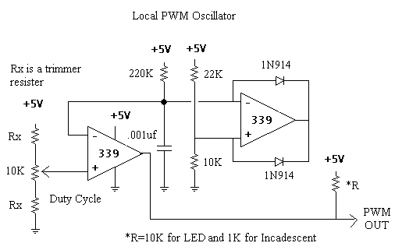

- LPF & MOSFETs
  - The PWM signals feed the MOSFETs, which are connected to the low pass filter. The low pass filet is used so that the lamps see a pure DC component and not a PWM signal. This was achieved. There is a slight (in the100 mVolt range) ripple across the lamps. The ripple, however, is not a problem because the incandescent lights naturally act as a low pass filter. The result is the machine vision system has a pure DC signal going across the light. The schematic for the MOSFETs and the LFP is shown below:

- Signal Conditioner
  - Finally there is a signal conditioner. In local mode, the voltage across the lamps in not regulated. The original plan for the project was to have the computer monitor the lamp voltages and automatically adjust the duty cycle of the PWM signal to maintain a constant voltage across each lamp. The hardware is in place, however, the software and computer did not get this working. To be compatible with a normal analog to digital board the signal conditioner sets the voltage across each lamp to be between 0 and 5 volts. A typical differential amplified was used in the scaling. The chip used was a quad four op-amp (LM348N). The scaling circuit schematic is a follows:

Note that for each of the laps there is a separate signal conditioner, PWM generator, MOSFET, and filter.

