
ECE 498 Progress Report
Professor Shridhar
Professor Zhao
Fall 2003

Lighting Tool Box

Blaine Thompson
Brandon Harris
Vladi Gergov
Dave Chronicle
Nick Sitarski

Advisor: Professor Miller

Table of Contents

Table of Contents.……………………………………………………….……………….. 1
Problem Statement….………………………………………………………..................... 2
Fluorescent Lighting………………………………………………………..................…. 4
Task Assignment…………………………………………………………………. 4
Schematics……………………………………………………………………..… 4
Progress Made…………………………………………………………………… 5
Tasks Remaining…………………………………………………………………. 6
Incandescent Lighting………………………………………………………..................... 6
Task Assignment…………………………………………………………………. 6
Progress Made……………………………………………………………………. 7
Schematics……………………………………………………………………….. 8
Tasks Remaining…………………………………………………………………. 9
LED………………………………………………………………………………………. 9
Task Assignment…………………………………………………………………. 9
Progress Made……………………………………………………………………10
Tasks Remaining…………………………………………………………………11
Linux Box………………………………………………………………………………..12
Task Assignment…………………………………………………………………12
Progress Made……………………………………………………………………12
Tasks Remaining………………………………………………………………... 13
Appendix A – Original Proposal…………………………………………………………14
Appendix B – Revised Proposal………………………………………………………... 17
Appendix C – Proposal Changes……………………………………………………….. 24
Appendix D – References………………………………………………………………. 24

Problem Statement
In an era of modern technology the use of cameras is increasing every day. Every camera has optimal lighting conditions that will produce the best image. Certain applications in industry require precise control over these lighting conditions. Different lighting methods are required for each application. The Lighting Toolbox is a compilation of hardware and software applications designed to meet most of your lighting needs. If a machine vision system cannot perform its function effectively due to in-adequate lighting conditions, bad parts may be allowed to leave a plant costing a company time and money.

As future engineers all group members feel goals should be set high. An ideal project would be worthy of a patent and have a use in industry. Although such a perfect system is not common in a senior design our goals will be set to this highest level of perfection.

This project will design and implement a four-channel incandescent lamp controller; each channel will be capable of controlling the intensity of a 50-watt halogen lamp. Each channel will have a range of control from full brightness to completely off. The intensity set point will be regulated via an embedded controller. The lamp voltage will be monitored by an analog input channel on the embedded controller. The controller will adjust the width of the pulse accordingly to maintain that set point. MOSFET drivers will switch the lamp loads at the PWM frequency. The design will condition these drive signals such that minimal heating occurs within the MOSFETS. Also, transient voltages to the lamps will be minimized by the incorporation of an inductor / capacitor circuit. This circuit will be a high power circuit with a power supply capable of delivering 200 watts at full capacity. High current wiring techniques and component cooling methods will be incorporated into this design. An additional temperature monitoring circuit will also be implemented to prevent overheating which may damage some internal components.

The LED light controller will be a regulated 12 VDC power supply capable of delivering 50 watts at full load conditions. A MOSFET switch will also be implemented in this design. The control circuitry will operate mostly at TTL levels. Control circuits exist within the main controller to allow remote and local operation to be switched manually at the device. Status signals returned to the embedded controller will consist only of power supply voltage monitoring. Since LED's require a precise operating voltage the integrity of this voltage needs to be monitored closely. A failure of the series pass regulator could produce damaging voltages at the output. An external warning indicator will signal the user that damaging voltages exist and that the ring light head should not be plugged into the controller or should be disconnected quickly. The PWM signal will be generated by the embedded controller or can be internal generated by a local oscillator. The switching logic will be TTL only. Some CMOS logic may be required to interface the MOSFET driver to the PWM signal. A high performance comparator will be used to implement the over voltage detection logic. A strobing feature will be implemented to take trigger signals from an outside source and send them back to the embedded controller where they will be modulated onto the PWM signal. This feature will also be available while operating the device in local mode. The ring light head will contain an array of LEDS and will be modulated in unison. A simple current limiting resistor circuit will set the unit for 12 VDC operation.

The fluorescent controller; whose specific purpose will be applications will large aspect ratio's; will operate at 40 KHz. The intent of this design is to make the controller dimmable via the remote embedded system. An application specific integrated circuit (ASIC) will be implemented. An International Rectifier family of products exists to perform these types of functions. The range of control for this system is expected to be from 5% to 100%. Currently technology exists to produce these results but may not be feasible with the type of lamp being used. This circuit will use an AC to DC conversion then a DC to high frequency AC conversion. The first conversion will provide a DC bus with a potential of about 300 VDC. A unique type of PWM signal generated by the ASIC will control the current to the lamp thus controlling the brightness. A half bridge driven by the ASIC will supply all the signals the lamp needs to operate both during startup and normal operation. The circuit also contains a safety feature that turns off the high voltage should the lamp be unplugged by the user. Another key element in the fluorescent design will be an attachment that contains a circular fluorescent lamp inside a box with an opaque lens on top (a shadow box) for transmitted lighting applications. A concern exists whether the circular and tubular lamps will operate satisfactorily from the single fluorescent controller. The whole system should require no more than 50 Watts of power to operate. Conventional circuit board techniques will be use to construct this system except for the high voltage areas where techniques will be in place to minimize this hazard.

All three controllers will be assembled in their own enclosures and should weigh no more that five or ten pounds. These enclosures should be no bigger than a desktop computer. The embedded controller on the other hand will be much smaller and require less power to operate. The embedded controller is centered on the PC-104 system technology and will run a LINIX operating system. The choice for a LINIX operating system was made due to limitation of resources and efficiency required. An IO adaptor board attached to the PC-104 will implement the PWM signals for the three controllers previously mention as well as provide monitoring for the various status conditions. The PC-104 embedded controller will also provide the Internet interface to the whole system via it’s own internal NIC card. A WEB CAM will also be implemented as an aid to the user to set precise lighting adjustments via Internet control. Note that the embedded system can only control one lighting system at a time with the current design. No plans exist to do otherwise.

Fluorescent Lighting – Primary Responsibility Brandon Harris
Task Assignment

The fluorescent lighting section of the project will consist of a shadow box, which is an enclosure with a 32-40 W fluorescent ring light bulb, and a 48 in. straight fluorescent bulb that will range anywhere from 32-40 W when the final design is completed. Both the fluorescent ring light, and the 48 in. fluorescent bulb will be powered by a custom designed electronic ballast. The electronic ballast will include several features such as:

- Quick start up
- Possibly up to 1 % dimmable, however this is not confirmed yet
- Frequency independent dimming using analog voltage from 0.5 to 5 VDC
- Operation range greater than 40 kHz to avoid camera picking up lines, even at 1 % dimming
- Automatic restart
- Brown-out protection
- Over-temperature protection
- Systems will be able to be turned on and off remotely, as well as operated remotely via an embedded linux controller that will have an online user interface
- Linux controller may possibly be able to design lighting schemes for machine vision. For example, making the fluorescent light go from 1 % to 100% power over a certain amount of time while the camera is taking pictures.
- Systems will also be able to be operated locally (however preprogrammed algorithms for lighting schemes may not be possible locally)

Below are the tasks that need to be completed for my end of the project:

- Implement a ballast design based off of IR21592 dimming ballast IC

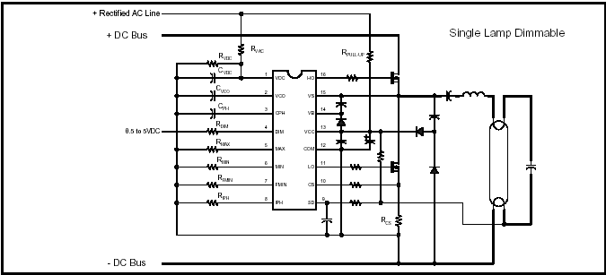

- Design and implement enclosures for shadow box and 48 in. fluorescent bulb
- Communication and interface circuitry
- Design voltage regulator local power supply for 0.5 to 5 VDC dimmer pin input to allow for local operation

Progress Made

- Research – I have been spending the majority of the time researching fluorescent lighting and its application to machine vision. There are several advantages to machine vision. The bulb sizes allow you to do wide aspect ratio lighting, something that would not work well with other types of lighting. Fluorescent lighting is also probably the most efficient in terms of energy conservation and bulb life, next to LED technology. I have also been researching bulb input waveforms and have read research about different types of wave shapes impacting bulb life. I have essentially been focusing on the ballast design and learning the background on fluorescent lighting.
- Dimmable Ballast – I have come across an IC that is used in ballast design and allows several different features. The most important feature is the voltage controlled dimming. I have ordered all the components to design the ballast, however, I am still doing some calculations to program maximum lamp power, ignition, starting and preheat frequencies. The general schematic is done however. A general design worked for 32 W, but trying to attain 40 W for more light. We were able to get it to dim using a DC power supply to the dimmable input pin.
- Enclosures – Enclosures are one of the last steps of my side of the project. There will probably be a box that has the local controller for my lighting. It will also contain the ballast. From here, the fluorescent lights will interface into the ballast controller. The shadow box will probably be constructed with wood and be painted black to avoid reflection. For fluorescent 48 in. bulb, it will most likely be in a typical reflective enclosure to focus the light. Given enough time, may be possible to allow adjustable focus of the light.
- Linux Box Interfacing – The three main things the linux interfacing will be: the remote on-off circuitry interface, the analog voltage pin connected to the linux box and a health status signal to be sent to the computer. It will be able to communicate if the bulb is burnt out, or not working properly. For the remote on-off circuitry, I had and idea to use a MOSFET to allow the system to turn on and off. The linux controller could send a signal to turn the MOSFET on and allow the MOSFET to short the power connection and close the circuit. It will also be easy to connect the pin from the ballast IC to a computer controlled voltage source from 0.5 to 5 VDC. The health status I have not gotten to yet. I believe I will be using comparators however.
- Local Operation Circuitry – For local ON-OFF I will simply use a toggle switch. For local dimmer, I will have to design a voltage regulator that will regulate to 5V, and dim down to 0.5 volts using a potentiometer. Local health status may use an LED to display health codes.
- Circuit Board Fabrication – Circuit board fabrication is one of the last steps. A circuit board fabrication will be used for my final design of my lighting ballast.
Tasks Remaining

I have to work out the bugs in the ballast to design and try to get it to 40 W instead of only 32 W. I also have to finish calculating the frequencies of operation for the fluorescent bulbs. I still have to implement the health status circuitry as well as the communication circuitry. After that is finished, I will have to design an enclosure box that will contain my ballast along with the toggle switches and status LEDs. There is also more research to be done involving machine vision with fluorescent lights.

The remaining time line is as follows:
- By the beginning of the second semester – Final design for the 40W ballast completed. Remote on-off circuitry implemented for linux box.
- January – Hopefully will have dimming working at 1 % and bugs worked out of ballast design.
- February – Focus will be put toward assembling the entire system. At the end of February system testing should be started. Enclosure design completed.
- March – System testing should be completed with improvements implemented, by the middle of March. The latter part of March will be focused to obtaining a finished product and beginning a final report.
- April – April will be used only for finishing a report and giving the final presentation.

Incandescent Lighting – Primary Responsibility Nick Sitarski
Task Assignment

The Incandescent Lighting system is one of the systems contained in the Lighting Toolbox. This system will include four fifty-watt halogen lamps whose intensity can be controlled over the Internet via our embedded server (also a manual control may be added). Each lamp can be set to operate at a unique intensity. The Incandescent Lighting system can be broken down into subtasks as follows:

- Power Supply (Including Fusing)
- Light Controller
- Temperature Sensors
- Communication
- Enclosures (Including Lamp Heads)
- Circuit Board Fabrication

Progress Made

- Power Supply – The power supply is constructed on a breadboard. The transformer was donated by Stancor and the other miscellaneous components were purchased from www.jameco.com, www.bgmicro.com, and www.digikey.com. The power supply works almost as planned, with all four lamps hooked up the voltage is just below the desired value. Currently components are on order to add a boost converter.
- Light Controller – The light controller is designed built and working properly. Currently the controller is implemented on a breadboard and is waiting for completion of the other parts so that the controller may be implemented on a circuit board.
- Temperature Sensors – The temperature sensors are designed and components are purchased. The temperature sensor will be a simple voltage divider between a resistor and a thermistor. A five-volt regulator will have to be made for the temperature sensors.
- Communication – The main advantage of the Lighting Toolbox is that it can be controlled via the Internet. Currently analysis is still under way by the embedded server group members about what type of signal conditioning will be necessary to connect the light controller to the embedded server. Some general designs of signal conditioning circuits are complete; however, this step can not be completed until the exact values that the embedded controller can accept is defined.
- Enclosures – Three of the four light enclosures were donated by Professor John Miller, he should be donating the forth enclosure soon. The enclosure for the light controller was donated by the ECE department electronic lab. Light Enclosures are working properly.
- Circuit Board Fabrication – Circuit board fabrication is one of the last steps. All the circuits must be finalized before circuit board fabrication can be completed.
- General Achievements – All major parts have been ordered and testing has begun. The controller has been simulated using a PWM generator and works properly. As stated in the Power Supply section the voltage level is not as desired when four lamps are hooked up. A boost converter will be the next step in trying to resolve this issue, however, even though the voltage is not at the projects desired level it is at a level that would be acceptable to a machine vision system. As of now the Incandescent Lighting section of the project seems to be ahead of schedule. All major obstacles other than the communication have been overcome. All major components have arrived (either purchased or donated). The most important thing is a large amount of knowledge has been gained by group members. Every problem that we have overcome has been an educational experience.

Schematics

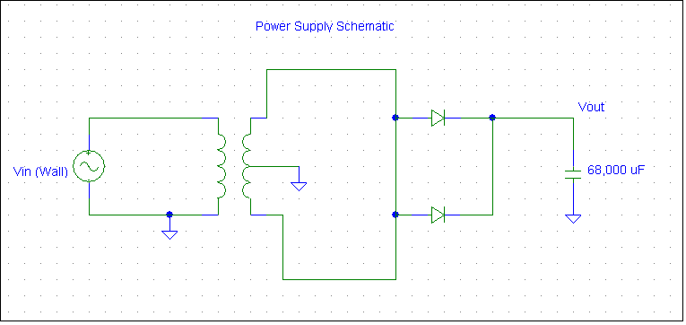

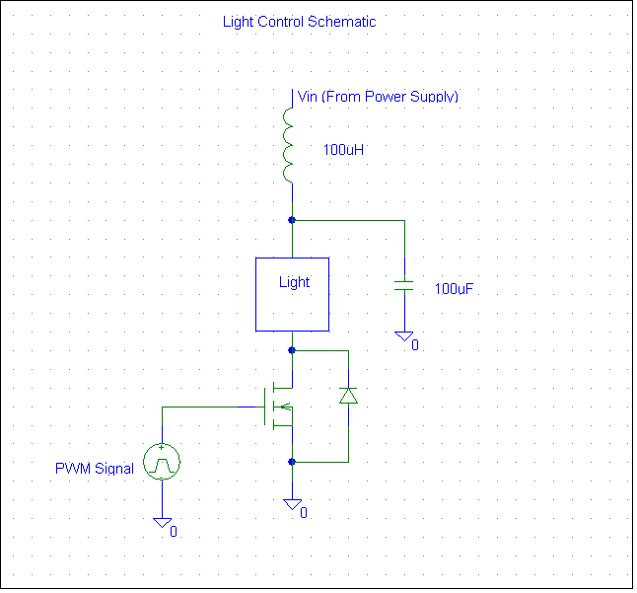

Tasks Remaining

Communication circuits are the last main electrical design necessary, all other circuits are at least in a stage where they could be implemented as is if needed. Only improvements are left on everything except the communication. As mentioned previously a boost converter will hopefully raise the voltage when four lights are hooked up. Final assembly will be a major task. Painting and making the faces to the enclosures will be a time consuming task. While not hard the process of designing and producing PCBs is also a timely process. If time permits, a manual feature will be added to the light controller. The manual feature will give a user the ability to control the light’s intensity manually with knobs so that an embedded controller is not always necessary.

The remaining time line is as follows:
- By the beginning of the second semester - All circuit issues completed other than the communication circuits. Any hardware that can be assembled in final form should be done
- January - Getting the communication circuits and trying to get the controller to talk to the embedded server will be done.
- February – Focus will be put toward assembling the entire system. At the end of February system testing should be started.
- March – System testing should be completed with improvements implemented, by the middle of March. The latter part of March will be focused to obtaining a finished product and beginning a final report.
- April – April will be used only for finishing a report and giving the final presentation.

LED Light Controller- Primary Responsibility: Blaine Thompson

Task assignment

The LED Light controller is one of the Lighting Tool Box systems.
This systems primary function is lighting applications with a close proximity to the viewing area. A concentric ring of LED's will be attach to the periphery of a machine vision camera and will provide a light source whose intensity can be accurately controlled. A strobing feature will also be incorporated. The strobing and intensity effects can be controlled via the Internet and thru local controls. The design and implementation of this system requires that the following tasks be completed.

- Design and implement a 12 VDC Regulated Power Supply with a 4 A capacity
- Design and implement a MOSFET Power Switching circuit for PWM control
- Design and implement a Power Supply failure monitor
- Design and implement a PWM Oscillator for the local mode of operation
- Design and implement a computer interface circuit using TTL logic
- Fabricate a printed circuit board for final circuit design
- Design panel layout for cabinet
- Install finished design in cabinet

Progress Made

- Power Supply - The Regulated 12 VDC power supply has been designed and constructed on a vector board. This design utilizes a series pass type regulator centered on the 723-regulator chip. Some testing has been performed, primarily full load tests. The regulator circuit has performed satisfactorily with regard to load capacity. No load or line regulation tests have been performed. Test criterion needs to be established to evaluate these performance issues for this design. The manufacturer specification for these parameters are for the 723 chip only and may be derated by the addition of the auxiliary components or may not be critical.
- MOSFET switch - The MOSFET switching circuit was installed and tested at full load. No anomalies have been observed. The test is only a simulation of the computer controller and was at the rated PWM frequency of 40 KHz.
- Power Supply Monitor - An untested power supply failure monitor design is complete. This circuit will use a comparator (Type LM-339) to provide a TTL signal to the external 25-pin D connector for the computer interface. An external LED indicator will also be installed to inform the user that the power quality may not be good. Under these circumstances if an LED ring light were plug in it could be damaged.
- PWM Oscillator - A simple circuit for local operation has been designed and will be installed on the board once testing has been completed.
- Computer Interface Circuit - A simple TTL line driver circuit will be implemented to provide quality signals for the MOSFET driver, failure monitor circuit, and strobing control. A preliminary design has been completed and will be installed on the vector board for testing.
- Printed Circuit boards - Currently working with personnel in the power electronics lab to coordinate fabrication of the circuit boards for the Lighting Tool Box LED system. One circuit board will include all the system electronic components excluding those mounted to heat sinks, the second board will hold the LED’s for the external ring light assembly.
- Enclosures - The system enclosure was donated from BUD Ind. The LED ring light head has not yet been procured. A commercially available part could not be obtained so the current strategy is to try to make one. E-mail correspondence has been initiated through a local vendor but no response has been received since then.
- Parts - All major parts for this project were ordered from Jameco Electronics, and Digikey Electronics. All parts have been received. Donations from Stancor Inc (Power Transformer), Bud Ind (Cabinet), and Denso (150 LEDS Red Green and Blue) have been received. No major parts are required to complete this project. Remaining components can be purchased locally or obtained from the Universities Electronics Lab.

Tasks Remaining

The remaining time line is as follows:
- December – Build and test Power Supply Monitor circuit, PWM Oscillator circuit, and Computer Interface circuit in Electronics Lab. Integrate these circuits onto existing vector board. Finish power supply load and line regulation testing requirements. Complete panel layout for cabinet enclosure, then install components in cabinet.
- January - Procure ring light head assembly and associated printed circuit board.
- February – Complete circuit board fabrication controller.
- March - Perform Unit Test and Integrated System Test. Start preparing final report.
- April - Finish final report and presentation materials for final presentation.

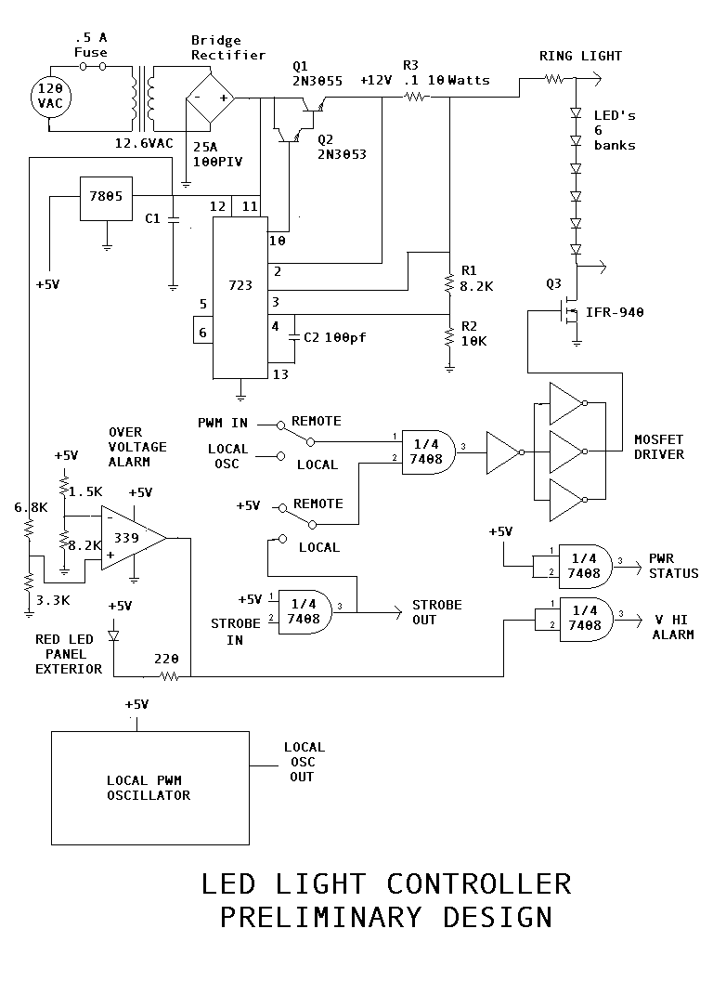

Linux Box - Primary Responsibility: Vladi Gergov and David Chronicle

Task Assignment

The Linux box is the brain of the Lighting Toolbox. It will control pulse width modulation signals, along with providing health status, voltage status, console operation, and web service. The signals to the components are sent out of the digital I/O module, which will handle A/D conversions and the I/O of these signals. The box’s ethernet and web server program will handle the control data from the Internet, while keyboard and monitor access will provide direct control over the system. Subtasks are as follows:

- Build a daemon that can run on the Linux operating system that will handle data as it comes in and leaves.
- Build an I/O program that handles data traffic.
- Direct control through keyboard is first priority in terms of system control.
- Secondary control is through web via a website that will have video capture capability and control of variables such as voltage.

Progress Made

- We received the Linux box from EMAC during the week of 11/21, along with the digital I/O module. This cost around $850, making it the most expensive part of our system. We have contacted EMAC regarding some of the drivers that they have available and found out that their digital I/O drivers are not complete, however we should be able to find some open source drivers in the Linux community.
- We have been doing research on Linux I/O, as a big part of our server is to provide and receive signals to communicate with the hardware components. Research has also been done in Linux daemon creation. The daemon will be our program that constantly waits for input and handles it appropriately. This will be the largest portion of our code.
- We also researched the use of a flash card to store our entire system on. With a flash card we can boot and run extremely reliably, without worrying about hard-drive malfunctions or corrupt data. However, the flash card has a very limited capacity and the usage of the card will be for final demo purposes, as using a conventional hard-drive will be much more convenient during debugging and general use.
- We have developed a general flow-chart that the entire system needs to follow. From our actual work this will change, but the overall system will follow this model.

Tasks Remaining

We need to code an I/O program first, as this will provide all the communication between the server and the hardware. This can provide solid testing for the next phase, which will be the creation of the daemon, which will handle many of the other functions needed, including linking the I/O along with the external adjustments from the keyboard and Internet. Creation of the web site itself will be a fairly easy task, however, having the website directly control the system will be a much harder one. The last task that we will need to do is fully document the software with commenting in the code and a user manual on the operation of the system.

The remaining time line is as follows:
- By the start of second semester we expect a rudimentary I/O program that will be able to do pulse width modulation.
- By the end of January we should have a complete I/O program with a basic daemon running
- By the end of February we should have a complete daemon and fully functional console control of the system
- By the end of March we should have working web control
- April will be devoted to documentation
Appendix A – Original Proposal

Goals of Project:

In an era of modern technology the use of cameras is increasing every day. Every camera has optimal lighting conditions that will produce the best image. Certain applications in industry require precise control over these lighting conditions. Different methods are required for certain applications. The lighting toolbox is a compilation of hardware and software applications designed to meet most of your lighting needs. If a system cannot do what it is supposed to do because lighting conditions are not optimal, bad parts may be allowed to leave a plant costing a company time and money.
As future engineers all group members feel goals should be set extremely high. An ideal project would be worthy of a patent and have a use in industry. Although such a perfect system is not common in a senior design our goals will be set to this highest level of perfection.

Relevant Courses:
Collectively this group has had various courses and work experience that will allow them to complete the goals set forth. One or more group members have had or are currently enrolled in the following relevant courses and or have had the following experience in industry:
- ECE 414 Electronics II
- ECE 317 Signals and Systems
- ECE 415 Power Electronics
- ECE 450 Communications
- ECE 460 Control Systems
- ECE 473 Embedded Systems
- ECE 471 Networks
- ECE 475 Computer Architecture II
- IMSE 381 Robotics
- IMSE 421 Engineering Economy
- ECE 370 Advanced Software Techniques in Engineering
- ECE 319 EMC
- ECE 375 Computer Architecture
- Experience of Control Systems at Fermi
- Experience With Electronic Modules at Denso Corporation
- Experience With Linux Operating System, Including Setup of Customized
Computer Applications Interfacing With Electronic Data Acquisition Systems

Professor Miller proposed the idea of a machine vision lighting system for a senior design project, he has also agreed be our faculty advisor and is an expert in the area of machine vision. Numerous professors at our university are experts in the area of machine vision so help from faculty should be available if necessary.

Preliminary Ideas:

The initial thought is to have three main control systems. The first system will control the intensity of a Fluorescent Lamp operating at a 40 KHZ frequency. This type of light source is best suited in applications requiring lighting with large aspect ratio objects. A second control system will control an LED ring. The LED ring will be composed of RED LED’s assembled in a ring configuration. This light source is useful in close up applications. The third control system uses a DC (Pulse Width Modulation) controlled incandescent lamp. Also we plan on interfacing this system with a PC running Linux through USB port. The embedded controller will provide strobing pulses to the lamp controllers excluding the florescent and also monitor hardware health remotely via a network connection. The software control panel will be accessible from any PC through an Internet connection. We will design the drivers that interface between the external circuitry and the embedded controller. Although everyone in the group will be involved in every part of the project, the majority of work will be divided as follows:

Hardware (Nick Sitarski, Blaine Thompson, Brandon Harris):

Incandescent Lamp Controller
Florescent Lamp Controller
LED Light Ring

Interface to Embedded controller

Software / Linux Based Embedded Controller (Vladi Gergov, Dave Chronicle):

Linux based Embedded Controller
Provide intensity control
Provide strobing features
Remote access
Hardware health monitor
Lamp intensity control

Time Schedule:

- October 2003
  - Have Proposal Approved
  - Finalize Scope of Project
  - Research
- November 2003
  - Begin Initial Designs of All Systems
- December 2003
  - Continue Design of All Systems
  - Order Parts
- January 2004
  - Finalize Design and Bread Board of Project
  - Testing of Breadboard
  - Improvements and Modifications
- February 2004
  - Continue Improvements
  - Have circuit boards Manufactured

- March 2004
  - Final Testing
  - Begin Final Report
- April 2004
  - Finalize Report
  - Demonstration

Cost Analysis:

The biggest cost of the project will be the Linux based embedded controller. One member of the group has a use for such a device after senior design so he has volunteered to purchase the controller. Other costs will be covered by the participants in the group.
Appendix B – Revised Proposal

Goals of Project:

In an era of modern technology the use of cameras is increasing every day. Every camera has optimal lighting conditions that will produce the best image. Certain applications in industry require precise control over these lighting conditions. Different lighting methods are required for each application. The lighting tool box is a compilation of hardware and software applications designed to meet most of your lighting needs. If a machine vision system cannot perform its function effectively due to in-adequate lighting conditions, bad parts may be allowed to leave a plant costing a company time and money.
As future engineers all group members feel goals should be set high. An ideal project would be worthy of a patent and have a use in industry. Although such a perfect system is not common in a senior design our goals will be set to this highest level of perfection.

Relevant Courses:
Collectively this group has had various courses and work experience that will allow them to complete the goals set forth. One or more group members have had or are currently enrolled in the following courses and or have has relevant experience in industry:

- ECE 414 Electronics II
- ECE 317 Signals and Systems
- ECE 415 Power Electronics
- ECE 450 Communications
- ECE 460 Control Systems
- ECE 473 Embedded Systems
- ECE 471 Networks
- ECE 475 Computer Architecture II
- IMSE 381 Robotics
- IMSE 421 Engineering Economy
- ECE 370 Advanced Software Techniques in Engineering
- ECE 319 EMC
- ECE 375 Computer Architecture
- Experience of Control Systems at Fermi
- Experience With Electronic Modules at Denso Corporation
- Experience With Linux Operating System, Including Setup of Customized
Computer Applications Interfacing With Electronic Data Acquisition Systems

Professor Miller initially proposed the idea of a machine vision lighting system for a senior design project; he has also agreed be our faculty advisor and is an expert in the area of machine vision. Numerous professors at our university are experts in the area of machine vision, so help from faculty should be available if necessary.

Preliminary Ideas:

The initial concept for the lighting tool box subsystems was to implement three main controllers. The first controller will modulate the intensity of a Fluorescent Lamp operating at a 40 KHz frequency. This type of light source is best suited in applications requiring lights with large aspect ratio objects, such as automobile windshields. A second control system will control an LED ring light. The LED ring light will be composed of red LED’s assembled in a ring configuration. This light source is useful in close up applications, mainly inspection. The third control system uses a DC (Pulse Width Modulation) controller to vary the intensity of four independent incandescent lamps. Also initial plans include interfacing these systems with a PC running Linux via the parallel I/O port. The embedded controller will provide strobing pulses and PWM (Pulse Width Modulation) signal to the lamp controllers. The software control panel will be accessible from any PC through an Internet connection. This design will include the driver interface between the external light controllers and the embedded system. Although members within the group will participate in all aspects of the project, primary responsibility for completion of each main subcomponent will be divided as follows:

Lighting Subsystem Implementation (Hardware Development)

Incandescent Lamp Controller Primary responsibility - Nick Sitarski
Fluorescent Lamp Controller Primary responsibility - Brandon Harris
LED Light Ring Primary responsibility - Blaine Thompson

Linux Based Embedded Controller (Software Development)

Linux Software
Design / Implementation Primary responsibility - Vladi Gergov
Linux Interface Primary responsibility - Dave Chronicle

Team members are responsible for providing technical support and other related duties as necessary to complete the project in a timely manner. Team member must be available and willing to assist with all areas of project as required.

Time Schedule:

- October 2003
  - Revised Proposal Approved
  - Preliminary Part Inventory Developed
  - Procure Parts
  - Initial Power Supply Design
  - Linux Box Ordered
  - Begin Research Including, Communications Between Hardware and Software
  - Install Linux On Dummy Server
  - Recruit Possible Venders for Donations
- November 2003
  - Finish Power Supply Design
  - Begin Switching / Health Design
  - Continue Procuring Parts
  - Research Flash Memory Card
  - Research Web-Cam With Linux
  - Web-Site Layout Design
  - Start Linux Kernel Design / Start Flash Memory File System
  - Implement Switching / Health Status
  - Linux Kernel Completed
  - Communication Research Completed
  - Web-Site Layout Finalized
  - Begin Programming Daemon
- December 2003
  - Test and Finalize Power Supply Design
  - Design Power Supply PC Board
  - Research Network Configuration
  - Continue Software Development
  - Continue Switching / Health Design Implementation
- January 2004
  - Daemon Completed
  - Switching / Health Implementation Completed
  - Begin Communication / Interface Design
  - Web-Site Completed
  - Panel Layout Completed
- February 2004
  - Communication Implementation Complete
  - Total System Integration Complete
  - Install OS on Flash Memory
- March 2004
  - System Testing
  - Minor Modifications Complete
  - Prepare Final Report
  - Prepare Final Presentation
- April 2004
  - Presentation Complete
  - Final Report Complete
  - Project Demonstration

Cost Analysis:

The design team anticipates most cost will be covered by donations from vendors and a contribution from the University of Michigan – Dearborn Campus. Contributions have already been received from vendors.

Preliminary cost analysis for major project components:
(Categorized by subsystem)

Incandescent Controller

Component | Cost
Transformer | Donated
Misc. components (Semi-conductors, resistors etc.) | $50.00
Circuit Boards | $200.00
Enclosures for Controller / Lamp heads | $100.00
Misc. hardware (Includes connectors) | $20.00
Halogen Lamps ( 4 ea at 35 Watts) | $50.00
Cables | $20.00
Estimated Total | $750.00

LED Light Ring Controller

Component | Cost
Transformer | Donated
Misc. components (Semi-conductors, resistors etc.) | $50.00
Circuit Boards | $200.00
Enclosures for Controller / Lamp heads | $100.00
Misc. hardware (Includes connectors) | $20.00
LED’s ( 150 ea of RGB) | Donated
Cables | $10.00
Estimated Total | $380.00

Fluorescent Lamp Controller

Component | Cost
Transformer | Donated
Misc. components (Semi-conductors, resistors etc.) | $50.00
Circuit Boards | $200.00
Enclosures for Controller / Lamp head | $100.00
Misc. hardware (Includes connectors) | $20.00
40 Watt Fluorescent Lamp | $5.00
Cables | $10.00
Estimated Total | $385.00

Linux Embedded System

Component | Cost
PC 133 Mhz | $750.00
Flash Memory Card | $100.00
Wireless Card | $50.00
USB Development Kit | $100.00
Cables | $10.00
Estimated Total | $1,010.00

Estimated Total Project Cost

Component | Cost
Incadescent Lamp controller | $750.00
LED Light controller | $380.00
Fluorescent Light controller | $385.00
Linux Embedded controller | $1010.00
Final Project presentation materials (Copies, charts, photos, slides, etc) | $150.00
Vendor Contributions | (Unknown)
University Contribution | (Unknown)
Student Contribution | (Unknown)
Estimated Total | $2,625.00

Appendix C – Design Changes

We have kept the basic principle of 3 lighting modules that will connect to a computer. We have also stuck to our original plan of using a 40 kHz signal to control our hardware because it’s a good frequency for us to maintain a nice DC signal. Instead of using just a plain PC, our embedded controller will be a miniature Linux server that will communicate with the hardware via a digital I/O module; this is in place of the USB communication that was mentioned in our first proposal. We have added the functionality of being able to control the hardware from three sources instead of two; console operation at the Linux box, Internet control over the web, and our new one, direct hardware control via the corresponding module. Besides these points, we still have our four main products; the LED light controller, the fluorescent light controller, the incandescent light controller, and the Linux embedded server. These core items have gone virtually unchanged and we see no need on the horizon to do so.

Appendix D – References

www.emacinc.com
www.linux.org
www.linuxfromscratch.com
www.ee.washington.edu/circuit_archive
www.keyance.com
www.nerlite.com
www.phoeniximaging.com
www.advancedillumination.com
www.oemagazine.com
www.whatis.com
www.sylvania.com
www.stancor.com
www.irf.com
www.howstuffworks.com
www.debian.org
www.thekrib.com/Lights/fluor-tech.html

The preceding list is a compilation of the Internet sites reviewed by the team members. These sites contain reference materials and products currently available in the area of machine vision lighting. Team members have reviewed many articles and equipment designs and feel this design proposal is a good representation of the more common systems available and is within the capability of the team member’s expertise.

